PHS3350 Logbook

Ana Fabela Hinojosa ID: 27876594

*“What I cannot create I do not understand” -R. Feynman*

## Week -∞ (25/01/21 – 01/03/21)

I started reading the two text resources suggested by Jesper and Meera (J&M):

* Non-Hermitian Quantum Mechanics by Nimrod Moiseyev
* Making sense of non-Hermitian Hamiltonians by Carl M Bender

Aims:

* Get through the first chapter of N Moiseyev “Non-Hermitian quantum mechanics”.
* Familiarise myself with the motivations behind the non-Hermitian formalism.

25/01/21

Since my goals are so open at this stage; I think a good way to start to understand the topic is to read the first chapter of Moiseyev “Non-Hermitian quantum mechanics”. (NHQM) as thoroughly as possible and attempt each exercise. There are four exercises in this chapter.

Notes on chapter 1.1 of Moiseyev:

#### Different formulations of quantum mechanics

The first part of the chapter revisits the standard formalism of QM and makes emphasis on the association of real valued eigenvalues of operators representing observable quantities. The claim is that QM requires that the operators used to represent observables satisfy a criterion called Hermicity.

“an operator is **Hermitian** if it operates on functions belonging to Hilbert space (**ℌ**) of square integrable functions such that if $f, g$ are square integrable, or have asymptotes which are periodic functions, they satisfy: $〈f|H|g〉 = 〈g|H|f〉^{*}$.” (Moiseyev 3)

28/01

What I understand so far is that apparently Hermicity is not as fundamentally necessary as it has been thought so far. Going ahead and allowing this idea to stick around regardless of the lack of a deeper understanding of Moiseyev’s ideas, it appears that using the NHQM formalism we can study more types of systems!

The standard Hermitian formalism cannot easily (or sometimes at all) explain certain phenomena such as self orthogonality or coalesced degenerate **resonance** states.

I don’t really understand what “resonance states” means at this point. 1

Moiseyev explains that NHQM is useful when system dynamics can be described by some number of resonance states. (?)

#### Exercise 1.1 From (Moiseyev 4)

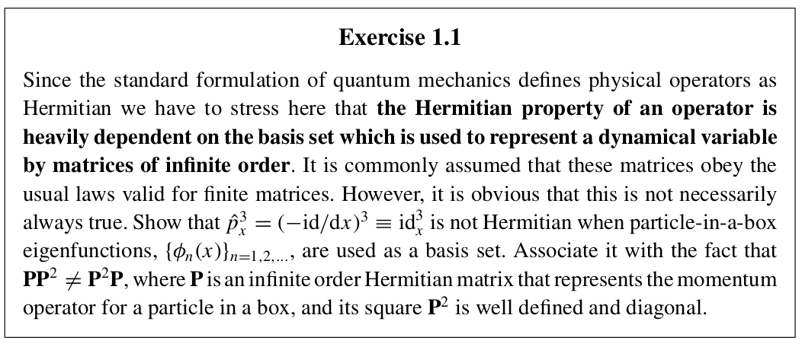

I have no clue of what I am supposed to do.

While googling about Moiseyev I encountered a series of lectures given by him at Technion Israel Institute of Technology this is the playlist link: [Non Hermitian Quantum Mechanics](https://www.youtube.com/playlist?list=PLW3u28VuDAHKr9iUMLHafMD2OejPAE1P_)

03/02/21

I asked Chris about this problem and he suggested that I check the following equality:

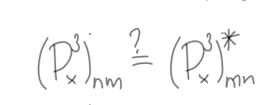

To do this, I have to represent the momentum operator as a matrix, transpose it and conjugate it to verify the equality status of the generic matrix elements.

First I must find the states for a 1D particle-in-a-box.

08/02/21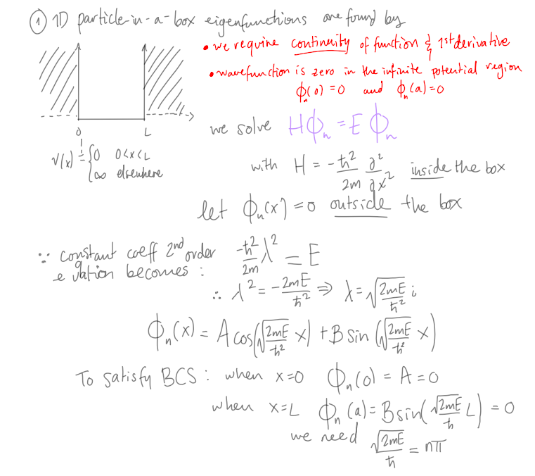

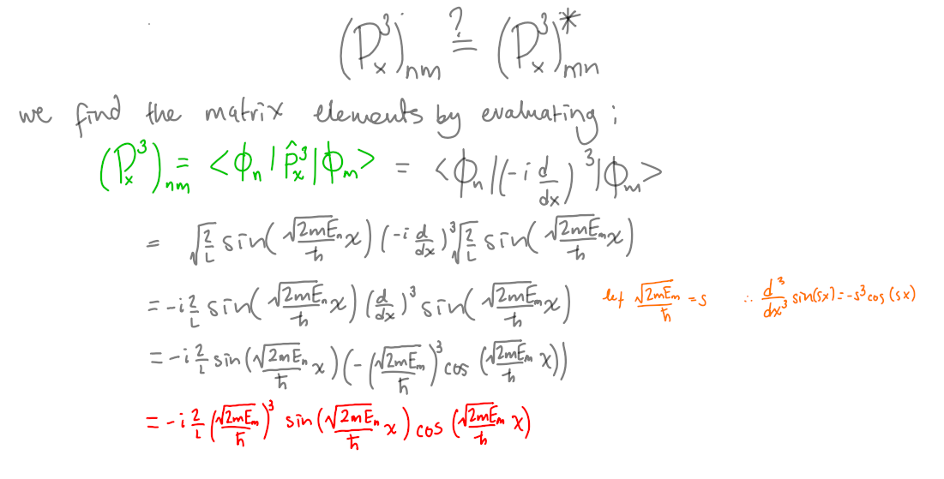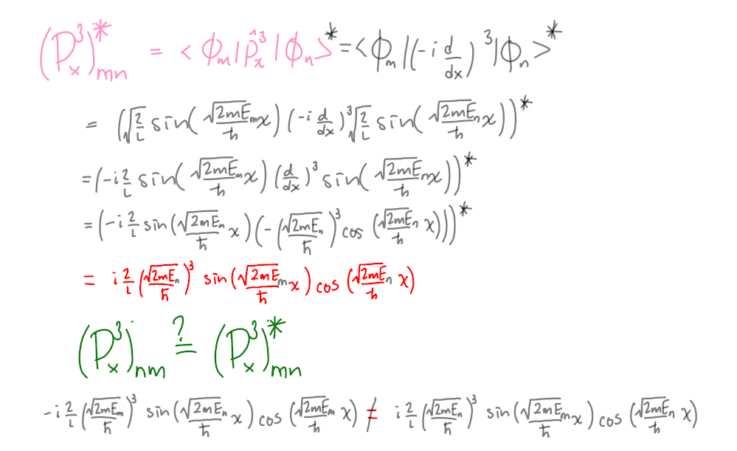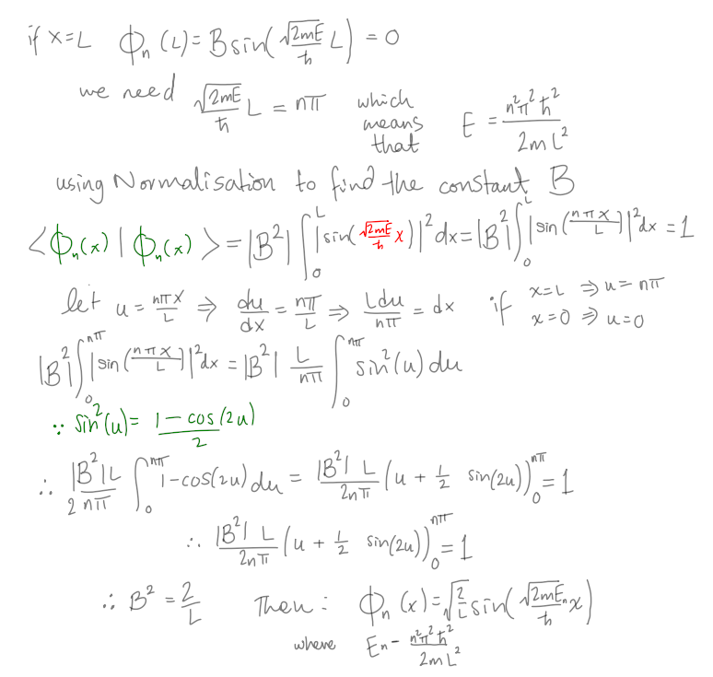

The matrix is non-Hermitian!

10/02/21

Notes on chapter 1.2 and 1.3 of Moiseyev:

#### Sources of non Hermicity

###### Potential terms supporting a continuous spectrum

* Naturally some systems have Non-Hermitian Hamiltonians (NHH). Such Hamiltonians describe open systems such as systems undergoing decay and dissipative processes.

In this section there is a more concise but still general description of so-called **resonance states**. Moiseyev describes resonance states as Metastable states: Metastable resonance states are such where systems have enough energy to break into many non-interacting subsystems but they don’t necessarily do so.

* Metastable resonance states can be manufactured.
* “It is very natural to associate the metastable resonance states of the system with stationary solutions of the TISE with outgoing asymptotes rather than with non- stationary wave packet solutions of the TDSE”(Moiseyev 5)

I think this means that we can use the TISE even in time-dependent resonance problems.

* Resonance states appear in the non Hermitian sector of the domain of Hamiltonian therefore they seem to be well defined in NHQM (associated with a single eigenstate of the Hamiltonian).

28/02/21

###### Complex local potentials

Complex perturbation potential terms Introduced to the Hamiltonian.

Reflection-free absorbing potentials (RF-CAP) are used to avoid no-physical interference effects from reflections on the boundary given the quantisation of space method used in numerical solutions to DEs. (Interactions between a propagating wave packet and the boundary should not actually take place.)

In this section of the chapter Moiseyev mentions NHH which are not related to resonance phenomena, but are NH from the inclusion of purely imaginary external fields. For example”

$V = igx^{3}$ where $g ∈ ℝ$ and the Hamiltonian commutes with:

###### The 𝒫𝒯 symmetry operator

The 𝒫𝒯 symmetry operator:

𝒫 is the parity (space inversion) operator

𝒫x𝒫 = -x and 𝒫p𝒫 = -p

$𝒫^{2}=𝟙$

This operator is linear

𝒯 is the time reversal (complex inversion) operator

𝒯x𝒯 = x, 𝒯p𝒯 = -p and 𝒯i𝒯 = -i

$𝒯^{2}=𝟙$

This operator is antilinear  
 **Hamiltonian H is 𝒫𝒯 symmetric if $H^{𝒫𝒯}=(𝒫𝒯)H(𝒫𝒯) = H$**

#### Exercise 1.2 From (Moiseyev 5)

#### 

No, since we are not measuring the position of the system. (we only measure the momentum of each outgoing subsystem)

Note: The detailed methodology for obtaining the solutions as they appear in figure 1.1 and 1.2 in Moiseyev is not very clear to me. They are supposed to be explained more thoroughly in subsequent chapters.

#### Exercise 1.3 From (Moiseyev 10)

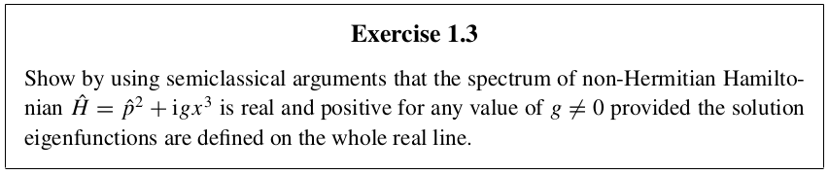

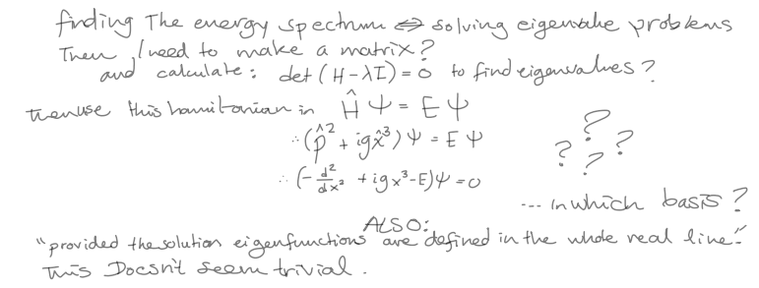

01/03/21

#### Important points:

* NHQM aims to describe time dependent phenomena whilst using the time independent Schrödinger equation.
* There are different origins for non-Hermitian operators.
* NHH can have a real energy spectrum.
* 𝒫𝒯 symmetry operator.
* Don’t panic

## 

## Week 1 (01/03/21 – 07/03/21)

Aims:

1. Solve Exercise 1.3 in Moiseyev
2. Prepare for meeting (week 2) (Show J&M what I have learned so far)

Tasks:

1. ~~Meeting with J&M (Wednesday 14:30)~~

Organise project details (what do I actually need to do?)

1. ~~Attend group meeting~~
2. ~~Start reading: Understanding non-Hermitian Hamiltonians by CM Bender~~

01/03/21

Notes on Making Sense of non-Hermitian Hamiltonians by CM Bender

#### Some of the fundamental axioms of quantum mechanics

Hamiltonian properties:

* Real valued and Bounded below energy spectrum
* Unitary time evolution

Does this axiom imply that QM must always study closed systems? What about dissipative processes? YEP… that’s why Hemicity is a postulate.

* Lorentz covariance and causality  
   I don’t know what this is, I will investigate it
* Hermicity

#### Why are non-Hermitian Hamiltonians not more widely used?

Bender explains that G Barton claims in his 1963 Introduction to Advanced Field Theory (Bender 950)

* NHHs do not have a unitary S-matrix.

An S-matrix relates the initial and final states of physical systems undergoing scattering

Therefore if we don’t have unitary evolution then there is no conservation of probability.

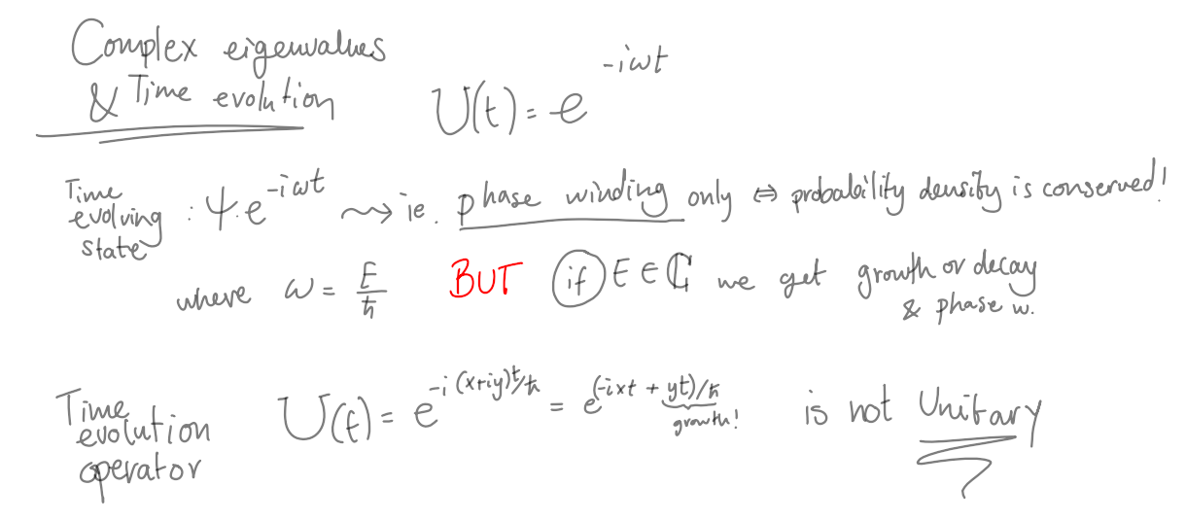

* NHH have complex eigenvalues

But according to NHQM this is not always true!

Some NHH have a subset of real valued eigenvalues.

#### 𝒫𝒯- symmetry as a substitute for Dirac Hermicity

IF a Hamiltonian is $𝒫𝒯$- symmetric ie. $H = H^{𝒫𝒯}=(𝒫𝒯)H(𝒫𝒯)$ then It satisfies $[(𝒫𝒯), H]=0$

03/03/21

MEETING Day!

I had my first meeting of the semester with J&M. We spoke about the tasks I need to fulfil while doing my research. At the moment I don’t think I have a very specific task other than getting familiar enough with NHQM to be able to give them a little talk next week about my current understanding on the topic,  
They suggested I check out one more resource, a paper by Elena Ostrosvskaya’s group. **Observation of non-Hermitian degeneracies in a chaotic exciton-polariton billiard**. I think that the goal here for me is to be to eventually understand the spatially dependent 2x2 Hamiltonian which is non-Hermitian.

04/03/21   
(Bender 955)  
Determining the eigenvalues of a 𝒫𝒯-symmetric Hamiltonian

The $𝒫𝒯$ operator is non-linear. It’s eigenstates may or may not be shared with those of the Hamiltonian.  
If we assume ψ is an eigenstate of both H and $𝒫𝒯$ (Bender 955)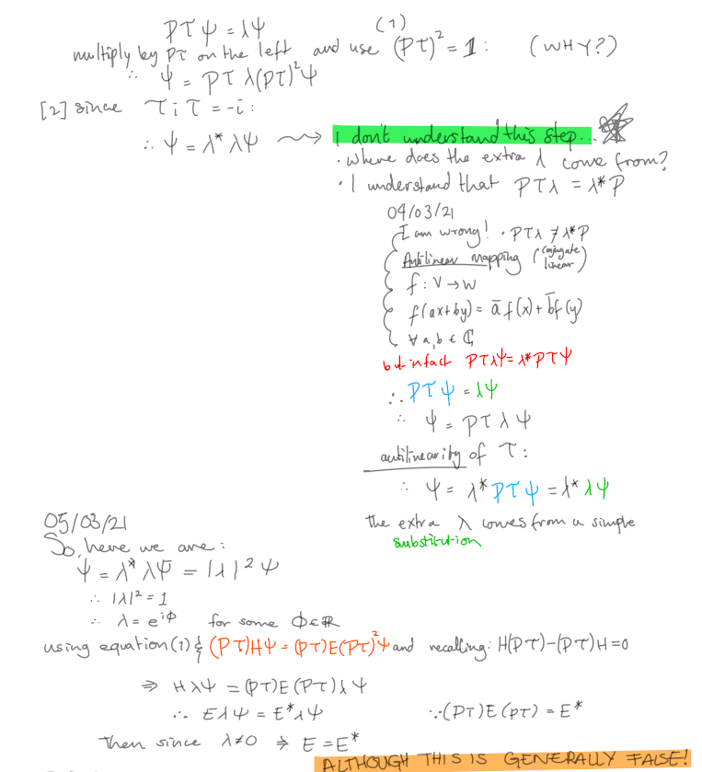

#### Definition: If every eigenfunction of a $𝒫𝒯$- symmetric Hamiltonian is also an eigenfunction of the $𝒫𝒯$ operator then we say that the $𝒫𝒯$- symmetry of the Hamiltonian is unbroken, otherwise the symmetry is broken (Bender 956)

## Week 2 (08/03/21 – 14/03/21)

Aims:

1. Reproduce Fig 1 in Bender
2. Simulate a RF-CAP   
    (Similar to the one presented in video 5 in Moiseyev/Technion youtube series)   
    [01-5 - Numerical needs for non hermitian Hamiltonian](https://www.youtube.com/watch?v=gK9EPOPkaDs&list=PLW3u28VuDAHKr9iUMLHafMD2OejPAE1P_&index=5)

I need to check if aims are adequate by J&M standards.

Tasks:

1. ~~Meeting with J&M (Wednesday 14:30)~~
2. ~~Attend group meeting~~

08/03/21  
Using this definition and the method I learned above I can try to solve exercise 1.3 of Moiseyev: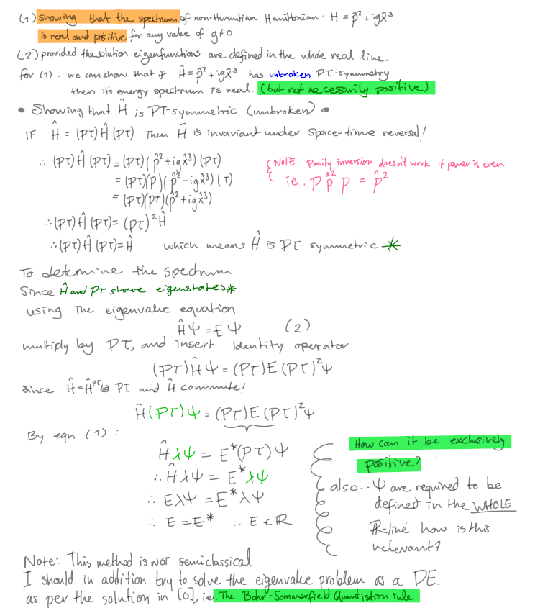

∴We can prove that a $𝒫𝒯$ symmetric Hamiltonian has a real energy spectrum if we prove it’s $𝒫𝒯$ symmetry is unbroken.

In both Moiseyev and Bender there are examples of what could be consider the same type of NHH:

In ex 1.3 of Moiseyev the Hamiltonian is $H= p^{2 }+igx^{3}$ whilst in Bender $H= p^{2 }+x^{2}(ix^{ε})$ where $g, ε ∈ℝ, g ≠0.$ Clearly both parameters are important But Bender emphasises $ε$.

In the caption of Fig 1 in (Bender 952) it is explained that when $ε≥0$ the spectrum is real and positive and the energy rises with $ε.$ The behaviour when $-1< ε<0$ is of finite (but decreasing number of) real eigenvalues but infinite complex conjugate pairs. For $ε ≤ -1$ the ground state energy diverges and there are no real eigenvalues left.

10/03/21

MEETING Day!  
I made some slides to present to J&M to have a guide over what I wanted to say.

These are the slides:  
 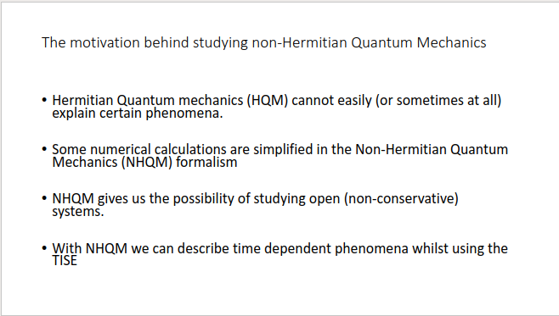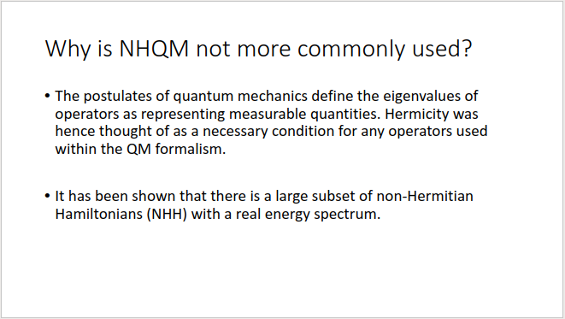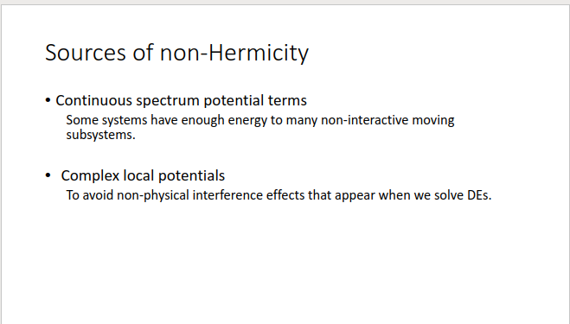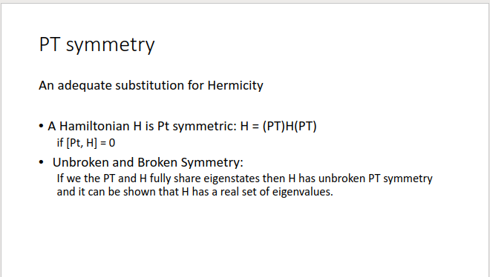

J&M seemed enthused about the progress so far.  
They were happy with my suggestion of having Aims 1 and 2 as my goals for the time being.   
They also suggested I add this to my aims

1. Try to understand E Gao et al.’s (2x2 Hamiltonian)  
   Compare Gao et al. to Bender page 986 to see if comparison is useful.

I will start reading this paper this week and for the time being drop the idea of solving as many of moiseyev’s problems as I can.

13/03/21  
Notes from (Moiseyev 2)  
“The numerical propagation of wave packets is much more simple when taken within the framework  
of the non-Hermitian formalism of quantum mechanics rather than in the standard (Hermitian) formalism. **This is due to the inclusion of a reflection-free complex absorbing potential (RF-CAP)** **in the Hamiltonian which attains non-zero values only in the non-interacting region in the coordinate space where the physical potentials vanish.**This approach enables one to avoid the artificial reflections from the edge of the numerical grid when a finite number of grid points (or a finite number of basis functions) are used to describe a propagated wave-packet.”

#### **Making an RF-CAP simulation**

Requires I construct a wave function with analytically verifiable derivatives.  
I’ll do a propagating gaussian with IC $ψ(x,0)=e^{-(x^{2}/2σ^{2})}e^{ikx}$  
I need:

* an array of x values, k values, and a $σ$ that resolves the gaussian given the array of x.
* The RF-CAP (probably I will try V = $igx^{3}$ given that is an example in Moiseyev)
* The 1D time dependent Schrödinger equation
* 4th order Runge Kutta for time evolution

TODO:

1. ~~Update physunits package~~
2. ~~Make git repo (RF-CAP)~~
3. ~~Read fftfreq documentation~~

First: verify I can plot the stationary wave packet

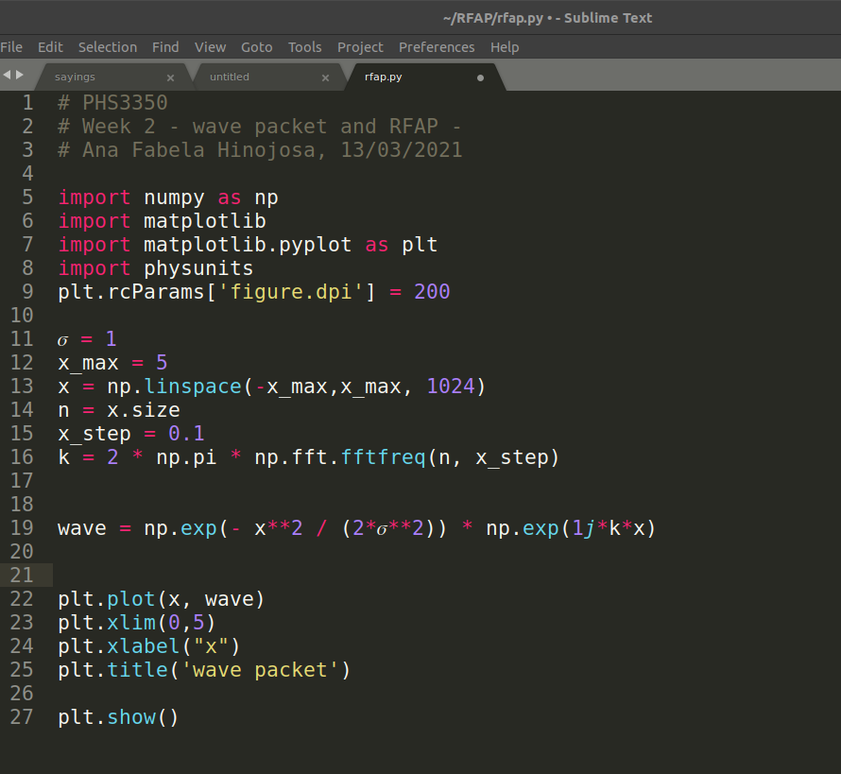

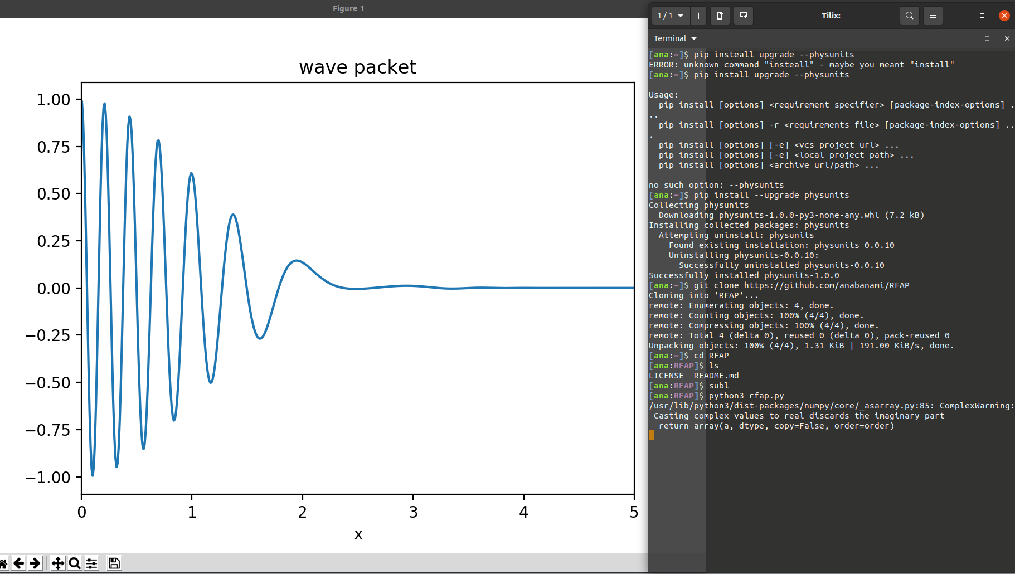

I get this ERROR:

/usr/lib/python3/dist-packages/numpy/core/_asarray.py:85: ComplexWarning: Casting complex values to real discards the imaginary part

return array(a, dtype, copy=False, order=order)

I want to see both the imaginary and real parts of the wave, therefore I googled the error and found a fix

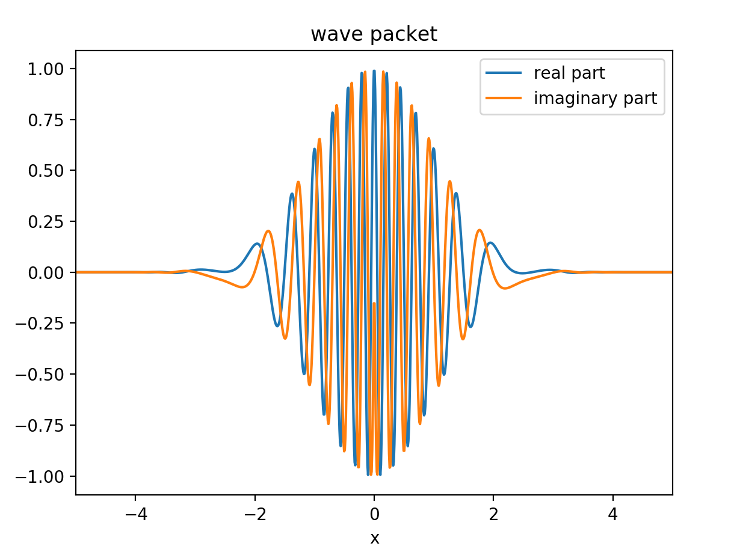

It’s better but the imaginary part looks funny near the origin.

This is what it looks like when I zoom in

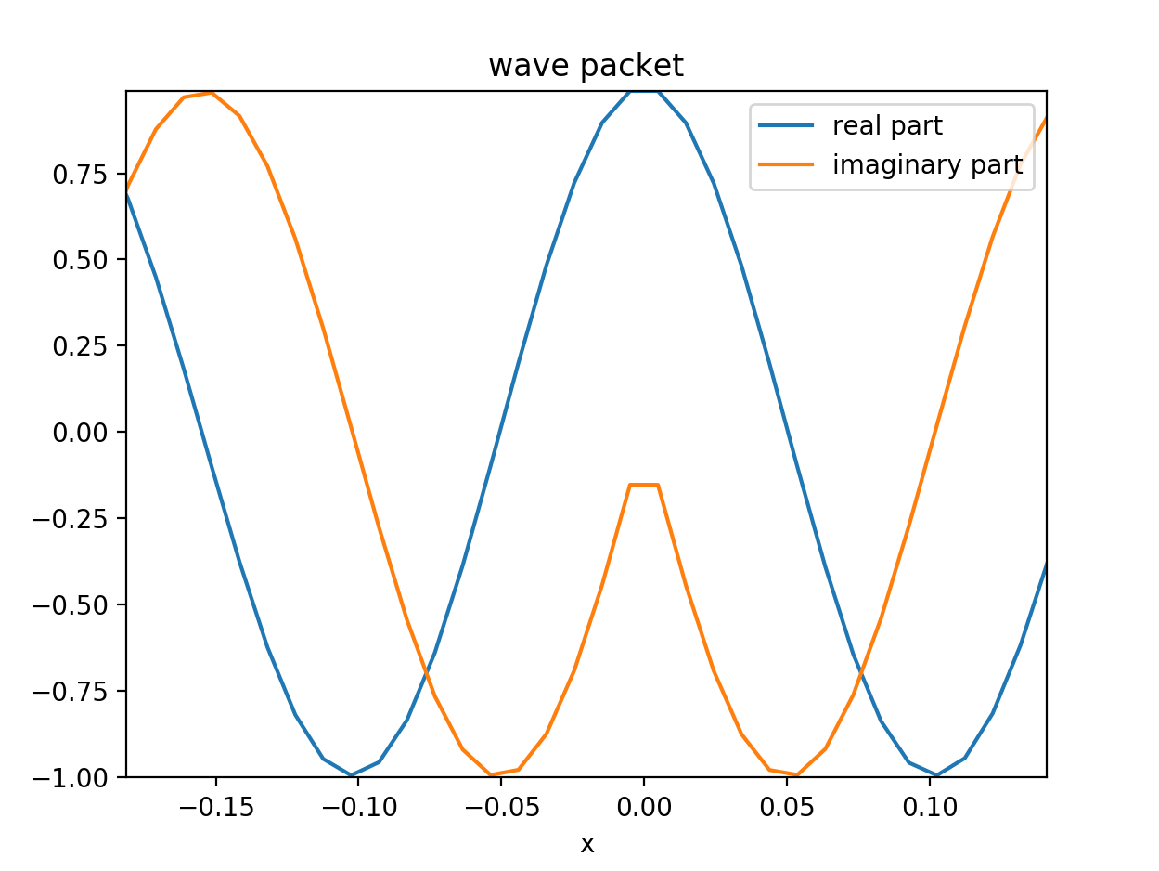

There is a discontinuous derivative near the origin.

It appears that using my k array in the definition of wave = np.exp(- x**2 / (2*𝜎**2)) * np.exp(1j*k*x) is what is causing the issue. I should not use my k array for this step. I should instead define a specific k for the IC.

If I define (by a brave guess) **k0 = 10** # oscillations per unit of space, then the error is fixed.

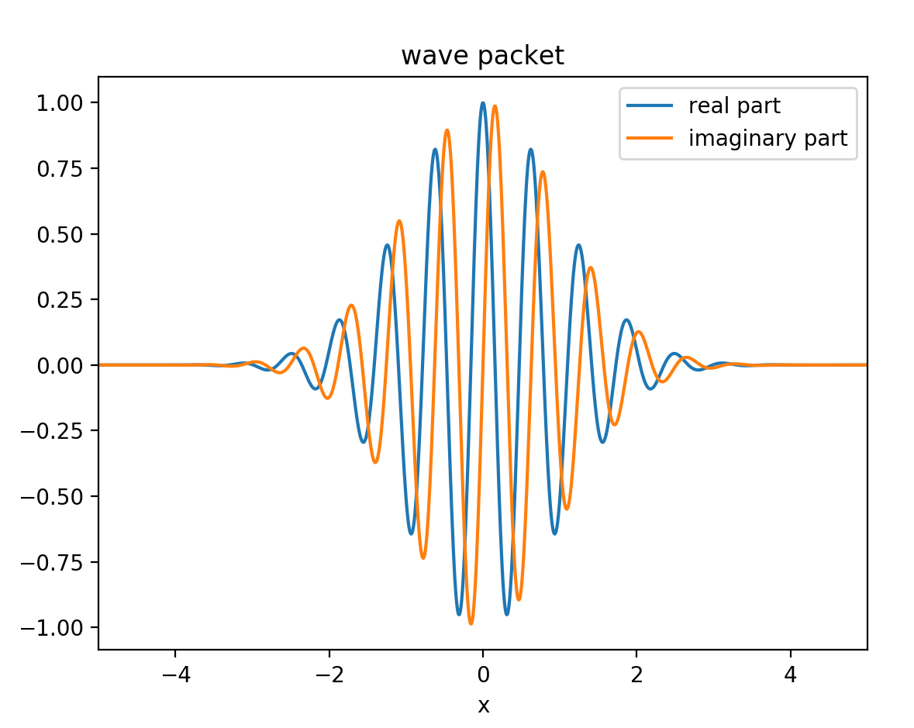

NEXT: The 1D time dependent Schrödinger equation and the RF-CAP (probably I will try V = $igx^{3}$ given that this potential is an example in Moiseyev and Bender) I'll consider a simple case with the parameters as follows:

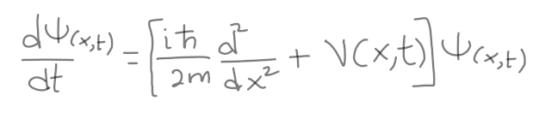 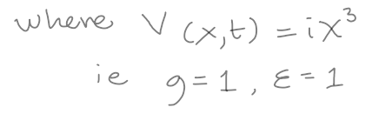

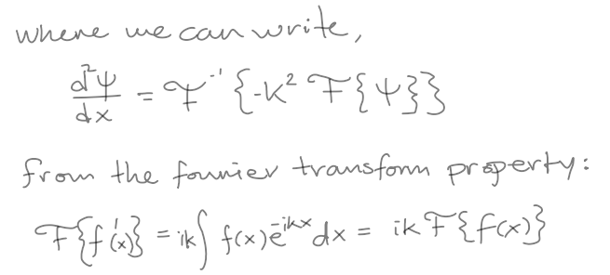

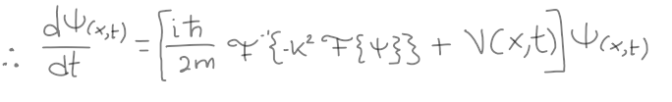

Calculating the FT and inverse FT requires that I import from scipy.fft the functions fft and ifft in my script.  
I define my ODE as:  


Then, I need to define the method of 4th order Runge Kutta for implementing the time evolution of my state.  
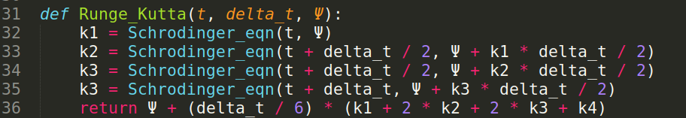  
  
**NEXT: I want to see if it all works!**

**The steps are:  
1. Wrap**  Runge_kutta in a while loop and feed it my initial gaussian wave packet as Ψ.  
**2. FIgure out** HOW BIG is delta_t? My initial guess is 0.01  
**3. Define** hbar and m in the Schrödinger equation to be equal to 1 to test the numerics.  
**4. Later** start guess work for a smaller system (like an electron wave packet or something)  
  
*There is an error in my Schrödinger equation!*  
Because I didn’t expand the factor of (-i/ħ) with the potential term   
Therefore this is the corrected Schrödinger equation I will use in my code.  
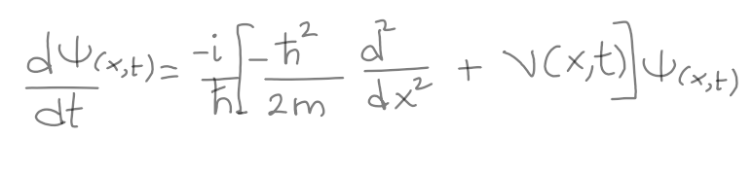  


**The while loop**

I decided to double the x range to make sure that the package had space to evolve and go to zero at the boundary. Therefore x_max = 10

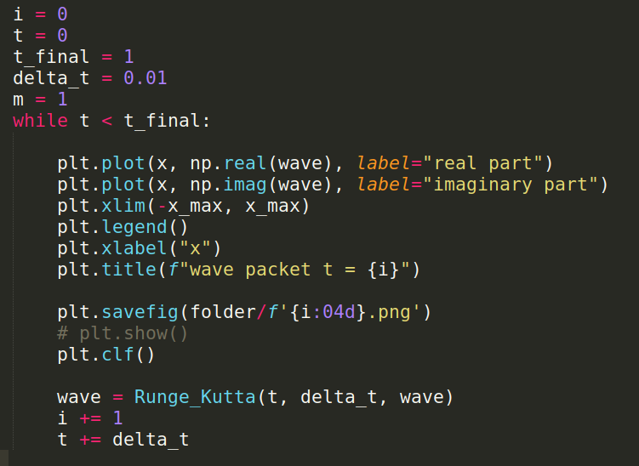

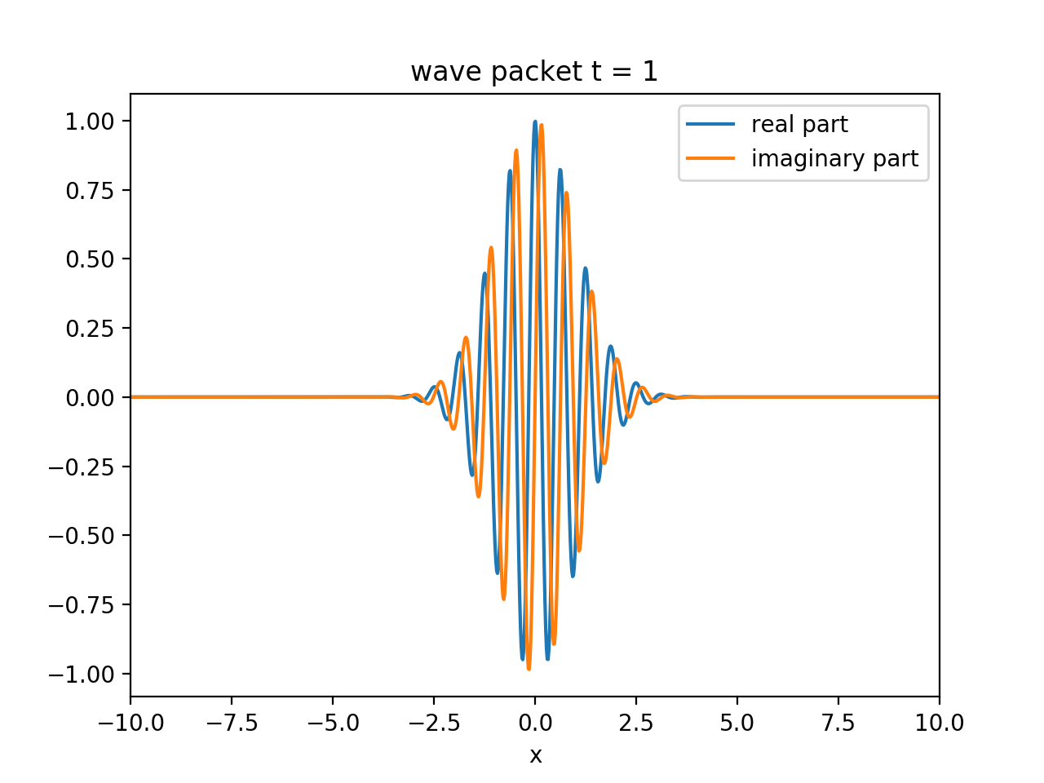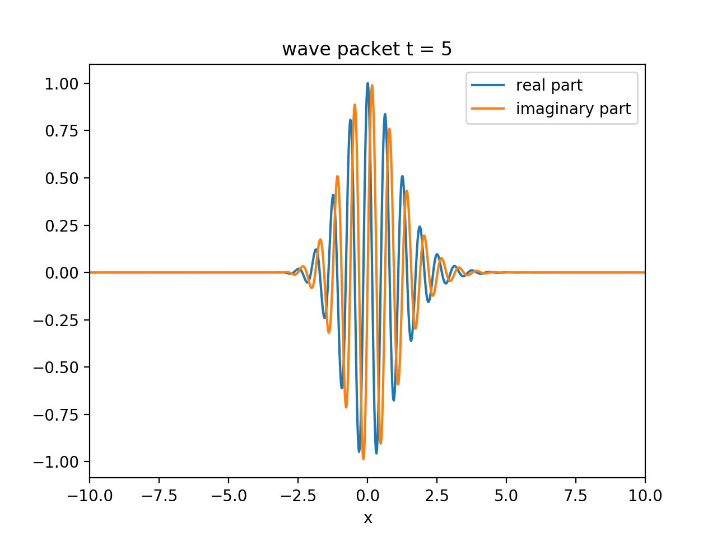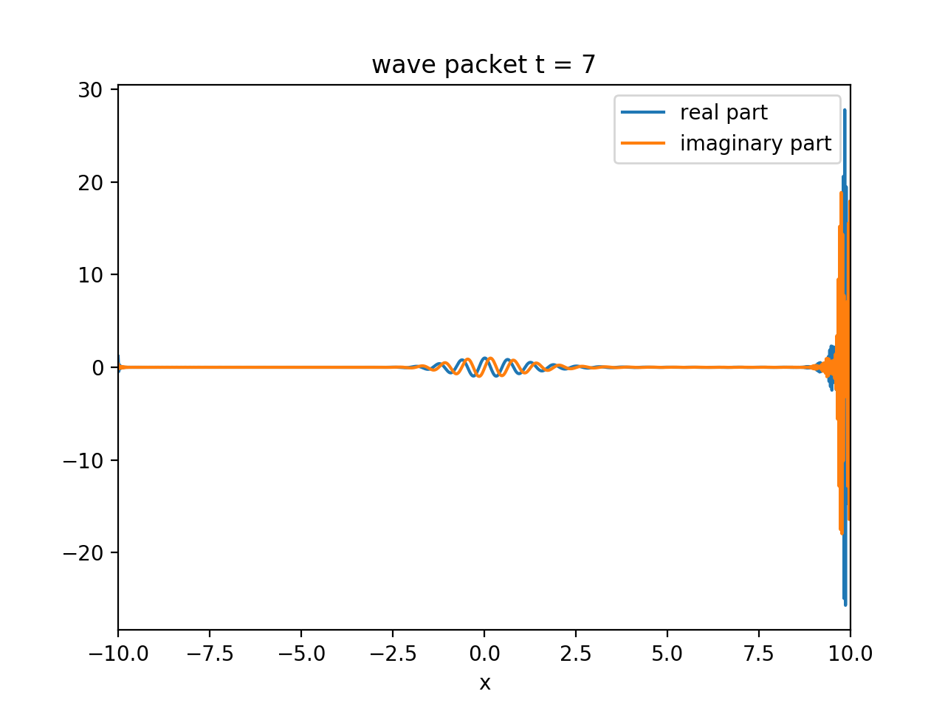

I get some movement of the wave packet to the right but it soon blows up at the boundary! Seems like it still doesn’t have enough space to go to zero at the edges and so we get undesirable interference soon after we start evolving in time.

Here is a small gif to demonstrate the blow up…



I use **convert gif_wavepacket/* moving_wave.gif** to make gif on the command line. I only show a few frames here but it can be seen that after frame 8 every other frame is blown up.

I also used **ffmpeg -i “wavepacket_time_evolution/%04d.png” moving_wave.mp4** in the command line to make a little movie with all the frames from the output (careful with those quote marks since we don’t want them to be “smart”) . Unfortunately I cannot share the movie in this log, since it is an unsupported format.

**Debugging the blow up!**

I found an error in the function Runge_Kutta specifically the variable k4. This is now corrected:  


There also was an error in the definition of my x_step, This is now corrected   
After fixing these bugs I still have blow ups on the whole wave packet from frame 5 onwards.

Maybe my delta_t is too large?   
While talking to Chris about my problem he brought up the Nyquist frequency. Which is a new term for me.  
Delta_t must be small enough to be able to resolve motion of the nyquist mode within the spatial step specified.

After this chat I changed delta_t = 0.001. But A blow up still occurs

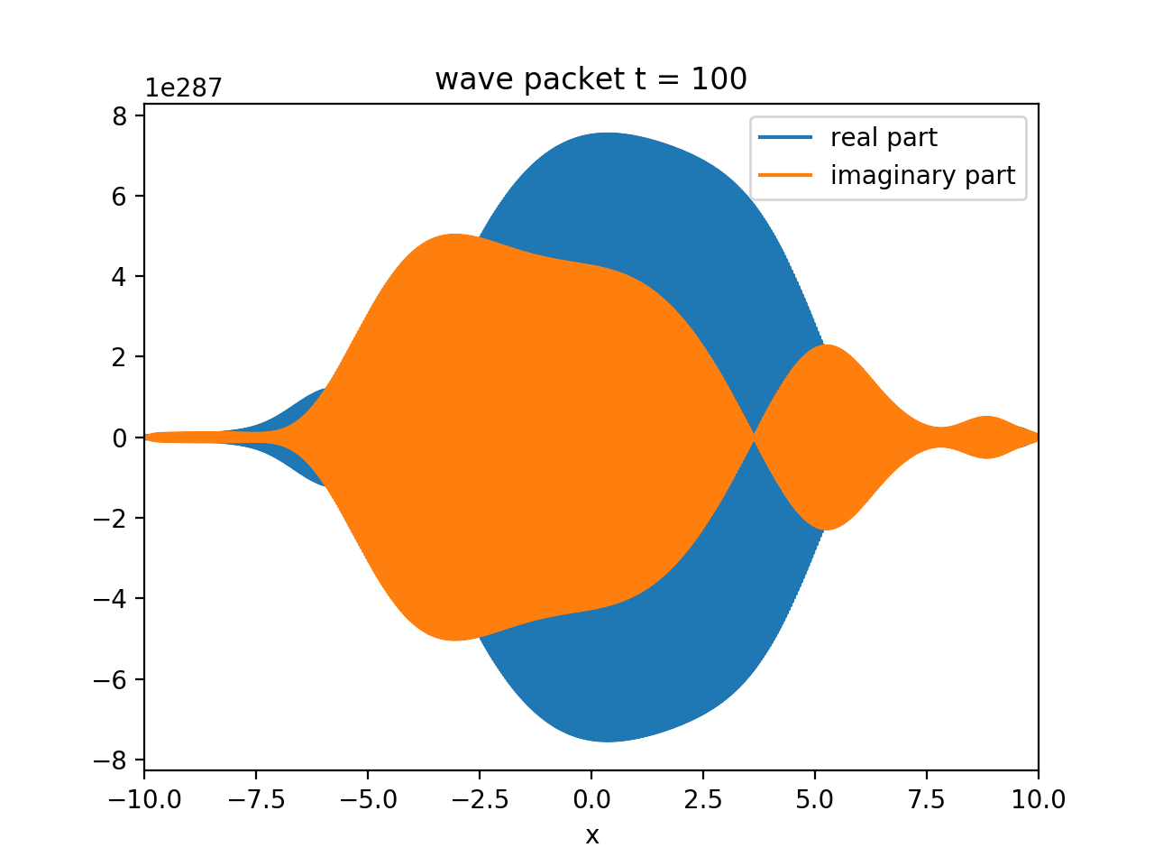

What about removing the phase factor from my wave? Ie. only using  


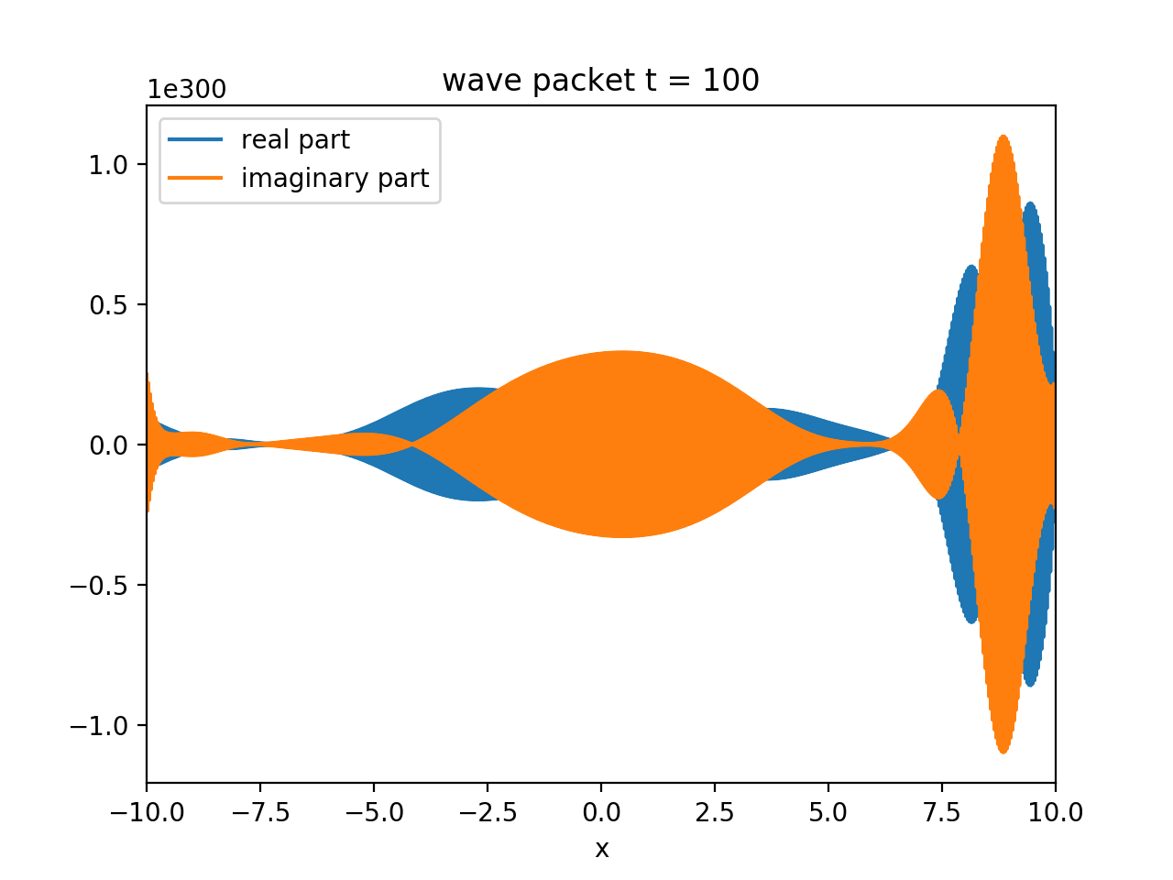

The blow up is different, but still this situation is not ideal.

Based on the possibility of having discontinuous boundaries based on not having an integer number of waves within the region I changed k0 to k0 = 2*pi /x_max * 5

I also decreased the time step, currently delta_t =0.0001

**What if my assumption of the potential is the problem?**  
Obviously this is the main goal of the exercise but I am actually not sure that this is the correct potential to use in my numerics… What happens if I delete the potential ix?



I got a propagating wave packet!  
**In conclusion**: The time step was too large. The **nyquist** mode must not move more than the spatial step otherwise the numerics won’t be able to resolve the motion in the simulation.

**The imaginary potential (RF-CAP) remains to be added to the Schrödinger equation.**

14/03/21  
Currently, I have continuous BCs, so I don’t see non-physical interference effects due to reflections off the edge. To fix this I need to impose a box potential on the edges of my frame.

**SQUARE WELL POTENTIAL**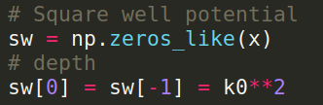  
Is an array that is zero everywhere except at the boundaries. Its height is calculated based on the kinetic energy of the wave packet. It appears that the barrier is not big enough to prevent tunnelling since nothing changed in the simulation so far using this depth! When I increase the barrier depth by 100 I still get tunnelling. Therefore I will increase the barrier depth by 1000. Ie. 1000*k0^2

  
 Yay! I have the desired **undesirable** reflection!

#### **Constructing the RF CAP**

I am reading chapter 5 of Moiseyev since apparently this is where the implementation of RF-CAP is discussed. Starting to read this chapter gives me the hibbie-jibbies since the first sentence states “...as discussed in the previous chapter…” and I have not attempted to read chapter 4.  
Still, I am going to see if I can get anything out of chapter 5 in order to finish my simulation.  
From (Moiseyev 130.131)

#### 5.4 The smooth exterior scaling Transformation

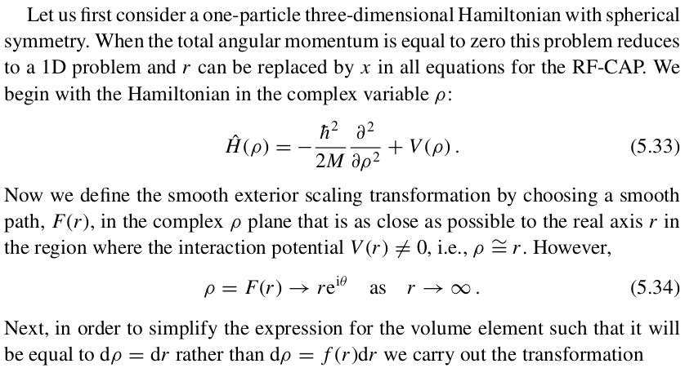

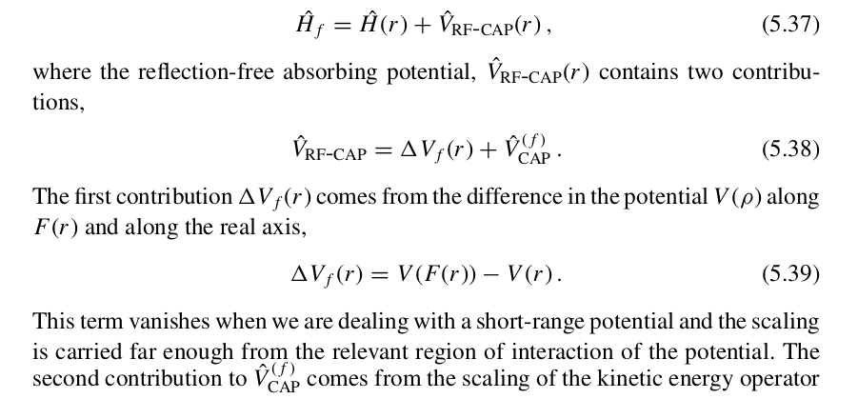

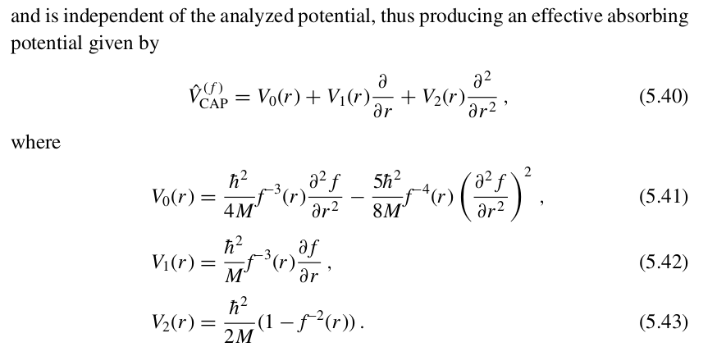

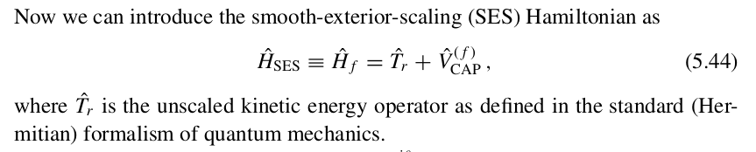

I do not understand many terms and concepts used in this method. I probably can’t finish this task without having a look at previous chapters.

#### Important points

* IF a Hamiltonian has unbroken $𝒫𝒯$- symmetry then it has real eigenvalues provided the parameter g has values smaller than a critical value. Above this value the spectrum of these Hamiltonians is comprised of real and complex conjugate pairs.(Moiseyev 11)
* Bender mentions the $ε$ parameter as a key to the number of real eigenvalues in the real part of the energy spectrum of a Hamiltonian.
* There is no experimental evidence that proves definitely that quantum systems defined by $𝒫𝒯$- symmetric NHH do exist in nature (Bender 953)
* I don’t have to read and answer every single question… progress is not linear (chill)

#### Important questions

* Do eigenfunctions of NH operators for a complete set in the series expansion of any wave packet?  
   Answer lies in CHAPTER 5 of Moiseyev
* Are different poles of the S-matrix orthogonal to each other?
* Are the expectation values of the physical quantities within the NHQM formalism real or complex?

## 

## Week 3 (15/03/21 – 21/03/21)

Aims:

1. Try to understand Gao et al.’s (2x2 Hamiltonian)  
    (Compare Gao et al. to Bender page 986 to see if comparison is useful)
2. Reproduce Fig 1 in Bender
3. **Simulate a RF-CAP**

Tasks:

1. ~~Meeting with J&M (Wednesday 14:30)  
    inform J&M about my~~ **~~RF-CAP~~** ~~situation.~~
2. ~~Attend group meeting~~

16/03/21

#### Observation of non Hermitian degeneracies in a chaotic exciton polariton billiard

Notes, direct quotes and screenshots from Gao et al. :

* Exciton-polaritons (E-P) are a non Hermitian system   
  (requires constant energy pumping and continuously decays releasing coherent radiation)
* non-Hermicity modifies the structure of **modes** and **spectral degeneracies of E-P**  
  (affecting quantum transport, localisation and dynamics)
* **Exceptional points (EP):** non hermitian spectral degeneracies of the modes  
  Consider reading :  [doi:10.1088/1751-8113/45/44/444016](http://dx.doi.org/10.1088/1751-8113/45/44/444016)
* Topological berry phase

(By going in a loop around the exceptional point in the parameter plane, you can never return to the same quantum state you started from. A second loop will then flip the state upside down. (ANU))

Metastable states (decay in time) ⇒ complex eigenenergies

2D Quantum billiard (modified Sinai billiard) results in strongly correlated energy levels and transition to quantum chaos. The billiard used has “soft” walls (this is generically adequate for observing mixed regular-chaotic behaviour) The observation of multiple degeneracies is expected in the “hard” wall setup.

The increase in the observed number of degeneracies implies the transition from regular to chaotic dynamics

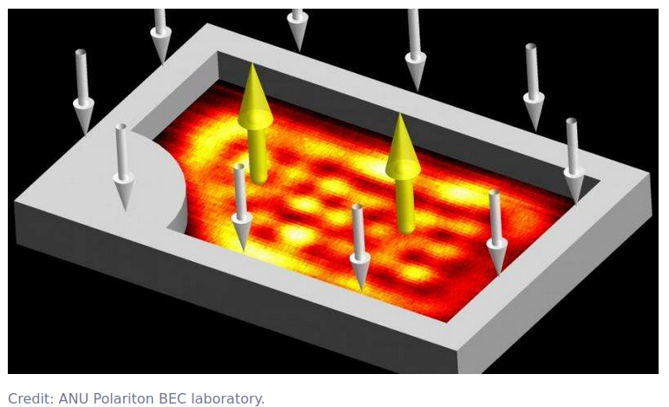

The observed energy levels crossing and anti-crossing in the vicinity of degeneracies (as expected from the non- Hermitian system) is because the energy eigenvalues are complex.

The REAL and IMAGINARY PARTS of the eigenvalues correspond to the real energies and **bandwidth of the modes** respectively

Important note: provided that the internal area remains unchanged the thickness of the walls (*d)* does not affect the geometry of the billiard and primarily controls the imaginary part of the non-Hermitian potential barrier (V’’).  
 Given the prior explanation I am unsure about FIg 2 showing one pair of modes near a degeneracy and why they can cross and anticross depending on the value of the parameter *d.* From(Gao et al. 556):

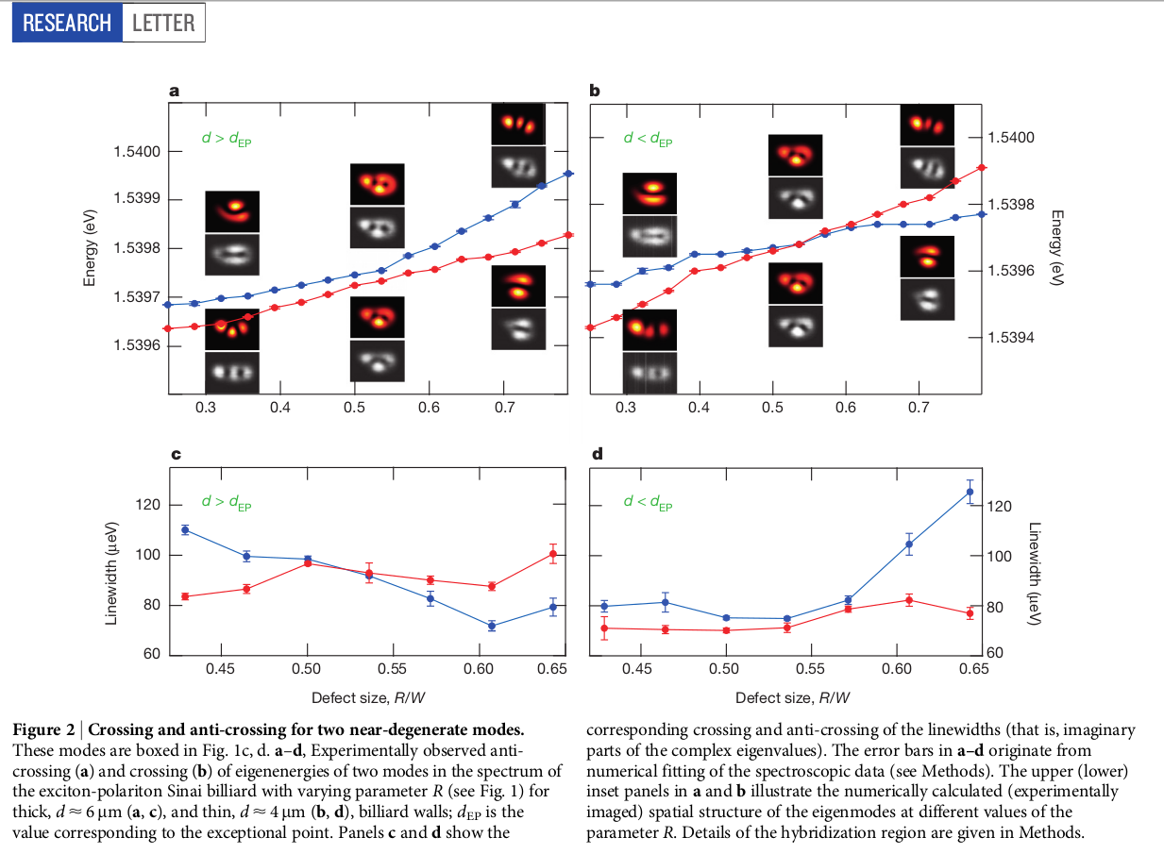

For two near degenerate modes:

if ${d<d}_{EP}:$  
 The Energy (real part) and Linewidth (imaginary part) anti-cross and cross respectively

elif ${d>d}_{EP}$:

The Energy (real part) and Linewidth (imaginary part) cross and anti-cross respectively

Does this mean that the exceptional point forms at $d_{EP}$? Yes.

17/03/21

MEETING Day!

The following text includes some direct quotes from (Gao et al. 554):

The main properties of the eigenstate of the E-P condensate can be described by a linear Schrödinger equation with a complex 2D potential $V(r) = V'(r)+iV''(r)$

Where the real part of the potential $V’(r)∝ P(r)$ is the potential barrier (Sinai billiard boundary with a gaussian envelope).The parameter R mostly affects the real part of the potential and hence the energy difference between the modes. The optical pump rate $P(r)$ is induced by the strong repulsive interaction between the excitonic reservoir populated by the pump and the polariton BEC.

The imaginary part of the potential $V''(r) ∝ P(r) - γ$ combines the gain profile introduced by the optical pump $P(r)$ with the spatially uniform loss $γ$ due to polariton decay.

Direct quotes and **screenshots** from (Gao et al. 555):

**Modifying the Radius defect of the potential R varies the geometry of the billiard** tuning the eigenmodes at different rates, Ie. some energy levels approach each other with varying values of R (hence they observe regular to chaos dynamics transitions)

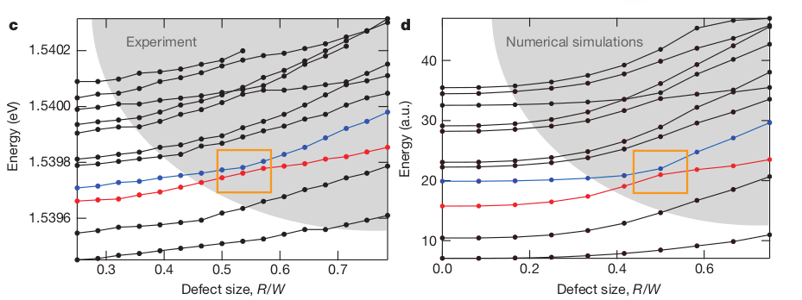

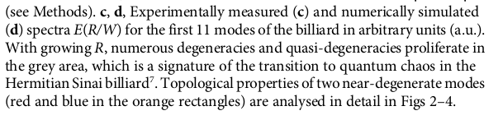

The grey area shows both behaviours crossing and anti-crossing of the energy levels near degeneracies

**So I think that I figured out the function of parameter *d:* The real and imaginary parts of the complex eigenenergies of the NHH may cross or anti-cross depending on control parameter *d* .   
Thicker walls imply less decay. Which implies more energy in the system.**

#### DEGENERACY REGION

The behaviour of two billiard modes in the vicinity of a degeneracy can be described by a two-level system with an effective coupling .The corresponding NHH is:

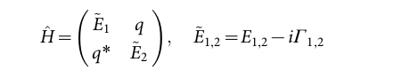

Where $Ẽ_{1,2}$ are the complex energies of two uncoupled modes. $Г_{1,2}$ are decay/gain rates. Coupling between the modes is $q$ with $q^{*}$ as the complex conjugate.

**Other important expressions**

1. The mean complex energy: $Ẽ_{}= {(Ẽ}_{1}+ Ẽ_{2}) / 2 ≡ E - i Г_{}$
2. The complex energy difference: $δẼ_{}={(Ẽ}_{1}- Ẽ_{2}) / 2 ≡ δE - i {δГ}_{}$
3. Eigenvalues: $λ_{1,2}=$ $Ẽ_{}±\sqrt{δ{Ẽ_{}}^{2}+ |q|^{2}}$

#### Exceptional points

**EP are non- Hermitian spectral degeneracies** (eigenvalues coalesce) , that can cause remarkable wave phenomena:

* unidirectional transport
* anomalous lasing /absorption
* chiral modes

Eigenstates also coalesce at the EPs (where $iδẼ_{}=±|q|$) and form a single **chiral** **mode**.   
**Gao et al. also assume $q$ is fixed EPs appear in the parameter plane as $($ $δẼ_{EP},δГ_{EP})=(0,±|q|)$ and $δГ_{}>0$ so that there is only one EP in the domain of interest.**

From (Gao et al. 556):

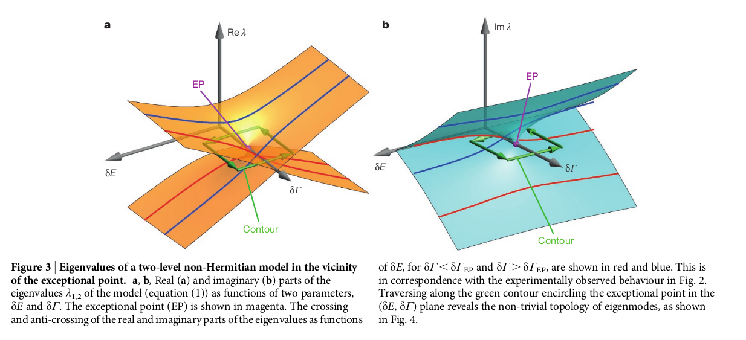

Correspondence of the parameters in the model $(δE,δГ_{})$ to the parameters in the E-P billiard $(R, d)$

* Increasing R (corresponds to a greater confinement ) $⇒$ increasing $δE$
* Thickness of billiard walls controls gain and loss profile $V''(r)$

MEETING notes:  
J&M asked me to **present this paper** to them in our next meeting.  
They also suggested that I slow down on my RF-CAP simulation and read as much as possible in order to figure out how to implement the absorbing potential in my equation. Let’s see how far I get!

J&M found this paper <https://arxiv.org/abs/2006.01837> which might be of use in my understanding of NHQM.

18/03/21

Today I re-read the first couple of pages of Gao et al.’s paper and started to work on some slides for my presentation on the next meeting. This is not the final form of the slides but I guess this process has helped me to try to map my ideas a little more concisely.

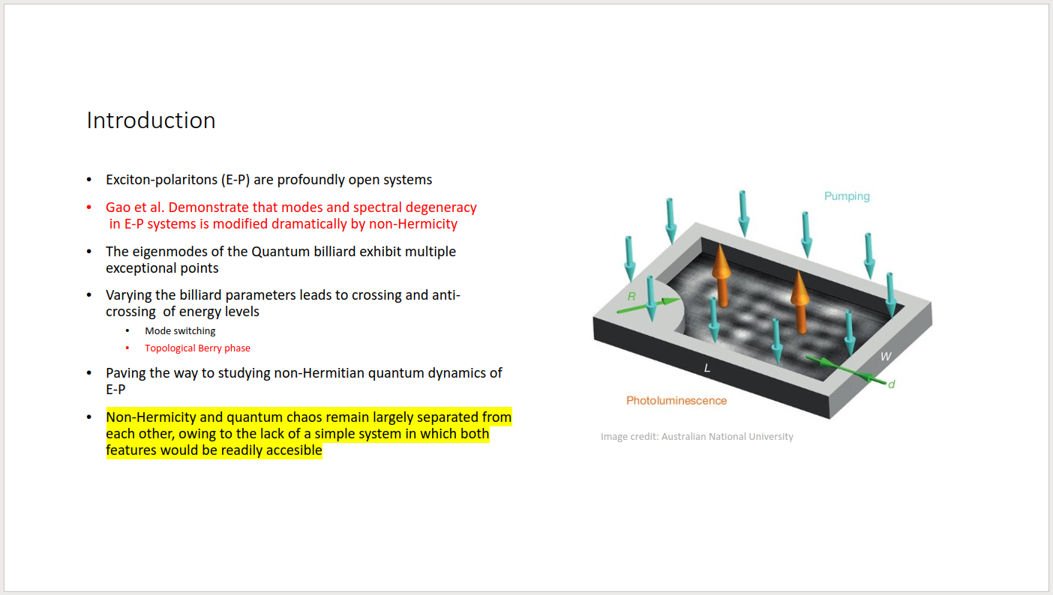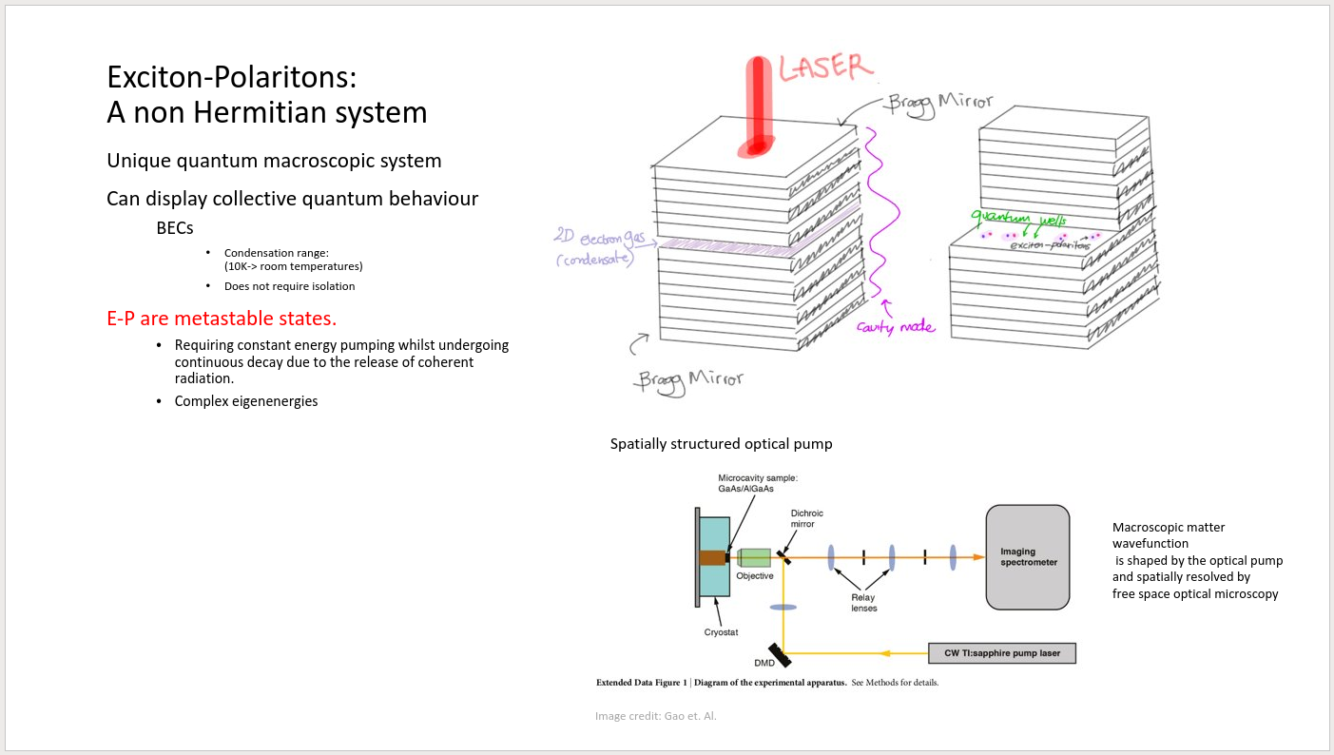

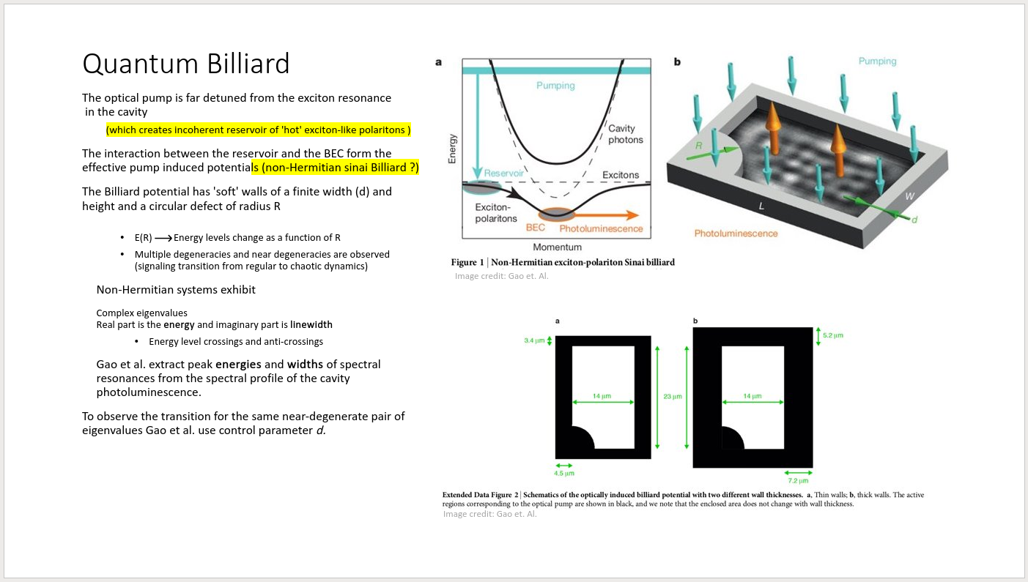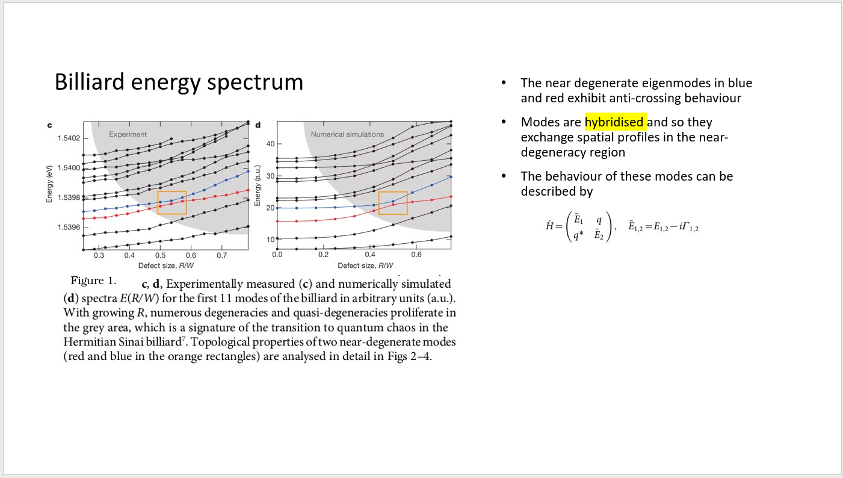

I currently don’t understand the following terms:

1. **Hybridization**   
   Applied to the cavity and the modes
2. **Lobes**  
   The modes can have lobes (horizontal and vertical)
3. $iδẼ_{EP}=±|q|$ (coalesced eigenstates condition)

#### Important points:

* I think that the paper aims to provide a link between a non-Hermitian system and quantum chaos
* An exceptional point happens when two different modes of a non hermitian system coalesce into one. (ANU)
* Topological Berry phase: By going in a loop around the exceptional point in the parameter plane, you can never return to the same quantum state you started from. A second loop will then flip the state upside down. (ANU)

#### Important questions:

* What are the **modes** of the exciton-polariton systems?  
   The eigenmodes are the **wavefunctions** (Gao et al. 555)   
   So, the eigenmodes = eigenstates ie. mode = state
* Why are the energy levels in a quantum billiard strongly correlated?
* Is the linewidth (imaginary part of eigenvalues) the same as the spatial structure of the eigenmodes?

## Week 4 (22/03/21 – 28/03/21)

Aims:

1. **Compare Gao et al.’s (2x2 Hamiltonian) to Bender page 986 (is the comparison useful?)**
2. Reproduce Fig 1 in Bender
3. Simulate a RF-CAP

Tasks:

1. ~~Finish up slides for billiard talk~~
2. ~~Meeting with J&M (Wednesday 14:15)  
    give the billiard talk!~~
3. ~~START PROGRESS REPORT~~

~~What to write about?~~

22/03/21

#### Topological Berry phase

Gao et al. observe a non- trivial topological defect known as an exceptional point (EP).They trace the topological structure of two modes in the vicinity of the EP and compare the eigenmodes along a contour. They loop around the parameter space (by modifying the biliard parameters (*R, d*)). In the following image (from Gao et al.) I can see that the eigenstates change with the parameters. The paper explains that varying *R* mostly affects the real part of the potential which corresponds to an increase in the energy ($δE$) when they increase *R*.

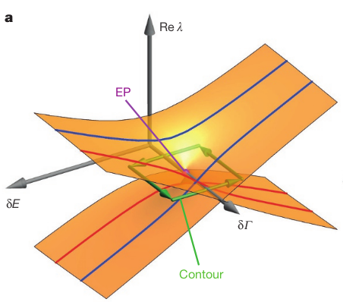

Modifying the wall thickness *d* controls the gain/loss (dissipation parameter) profile of the potential $δГ_{}.$

Increasing *d* corresponds to decreasing $δГ_{}$  
  
Different modes have different spatial overlaps characterised by different integral (spatially averaged) dissipation parameters $Г_{1,2}$. The effective coupling *q* is determined by the spatial overlap between two modes away from the hybridization region

In the figure above (part of fig 3. Gao et al ) it can be seen that the structure of the complex eigenvalues reveals a branching point in the vicinity of the EP. Following the green contour around the EP I can see that it is necessary to do the loop twice in order to return to the starting point in the space since a single loop takes us through the branch. Most significantly once we return to the starting point we have a topological phase shift of $π.$  
  
The topological Berry phase is this phase shift. It occurs because of the encircling of a non-Hermitian degeneracy in a 2D parameter space

Gao et al. do not consider adiabatic evolution of modes due to the variation of parameters (R, d) in time. They explain that such evolution would be accompanied by non-avoidable adiabatic transitions in the non-Hermitian case. They instead examine the topological structure and geometrical connection of stationary modes depending on the parameter values. (?)  
  
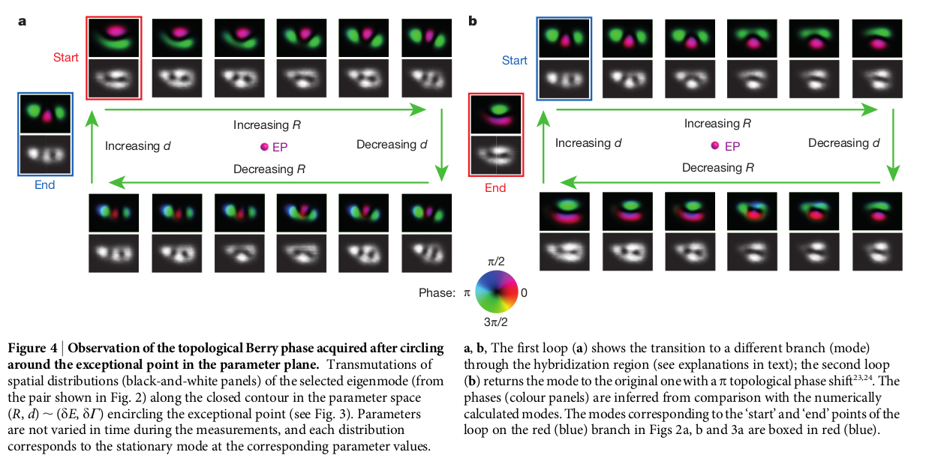

23/03/21

I have been correcting my slides and reading the methods section of the paper. I am still not done with the work but I think I understand a lot more than a week ago.

|  |  |
| --- | --- |
| **Hybridization** | **Lobes** |

But I am still confused about the meaning of this expression

$iδẼ_{EP}=±|q|$ (coalesced eigenstates condition)

24/03/21

MEETING Day! This is the final form of the slides:

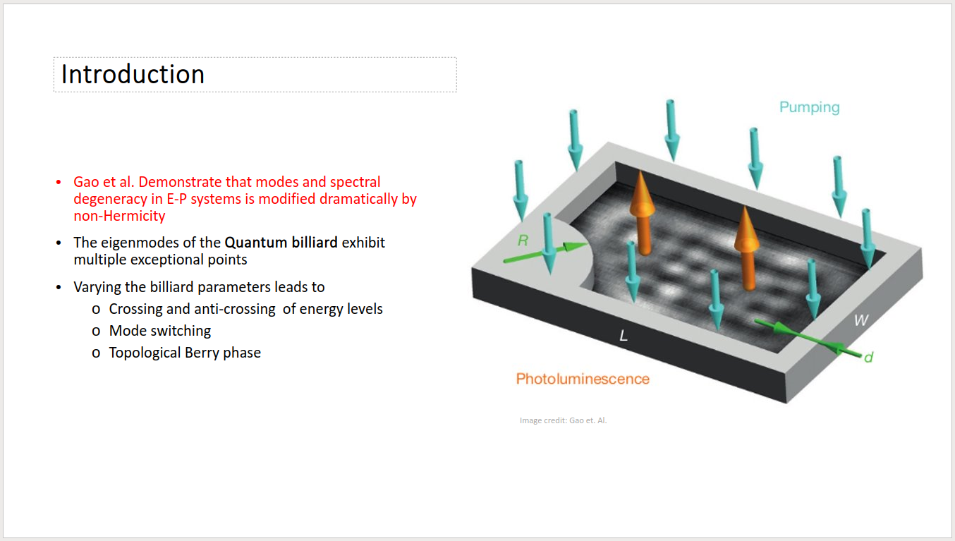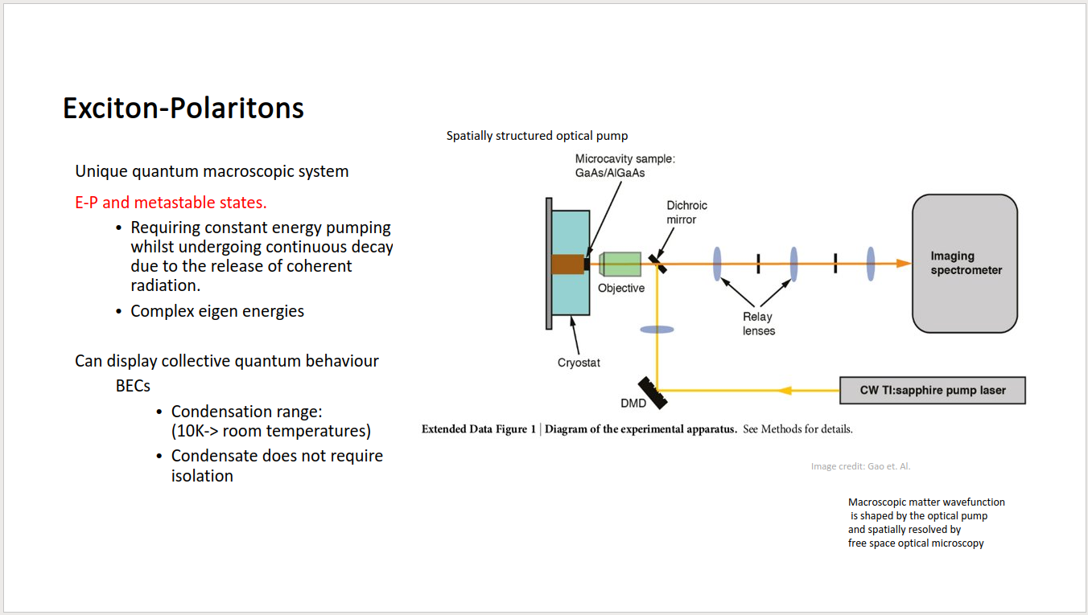

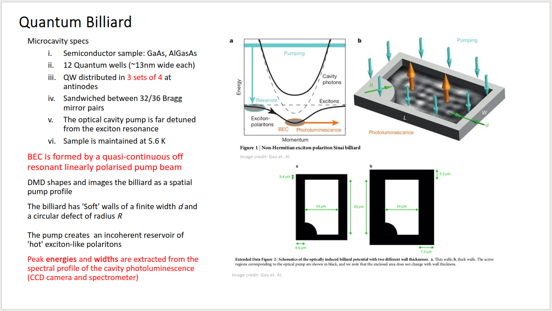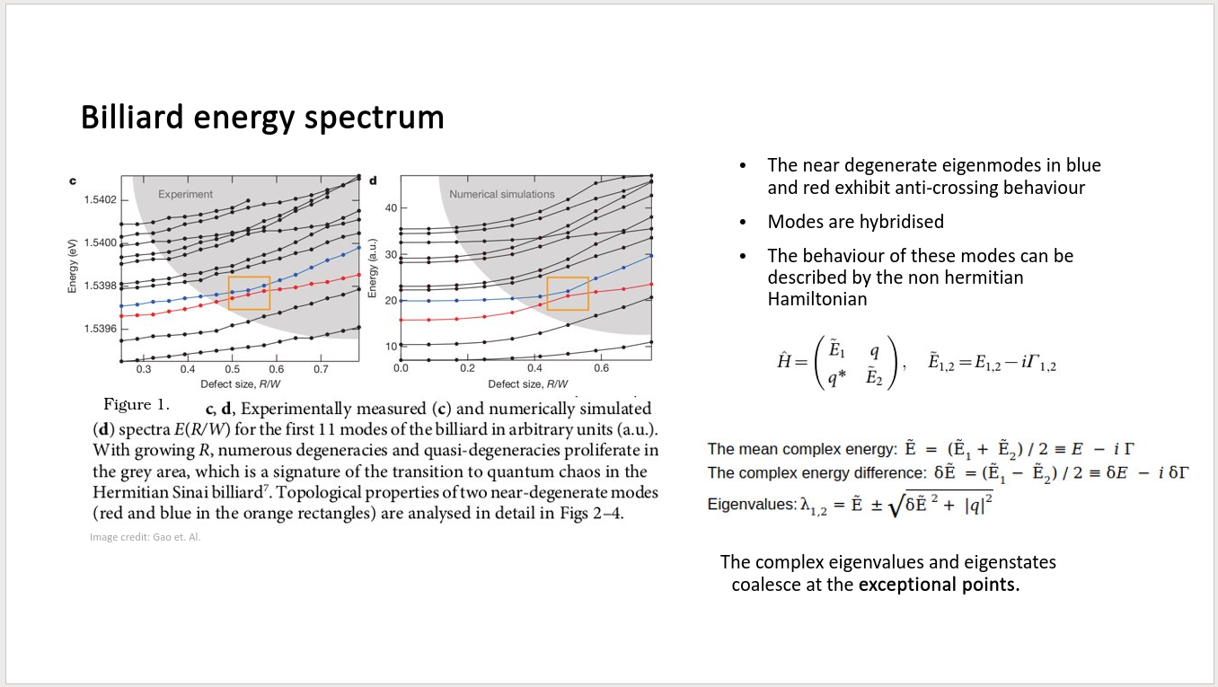

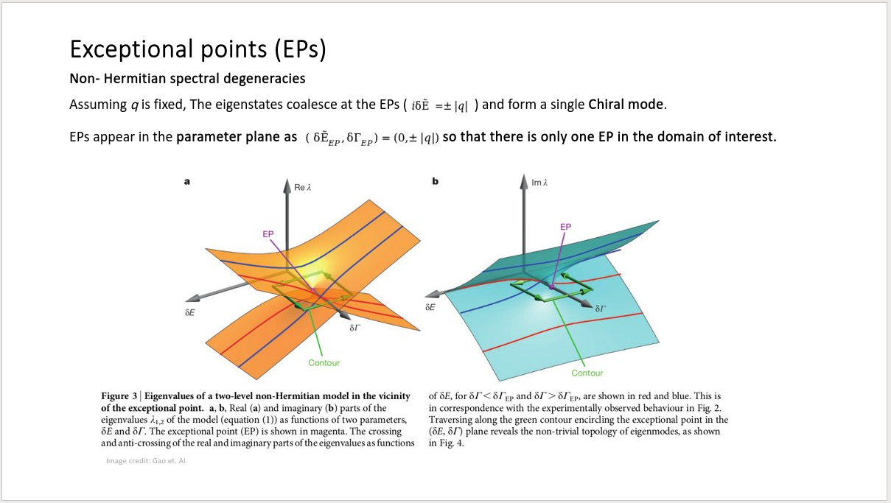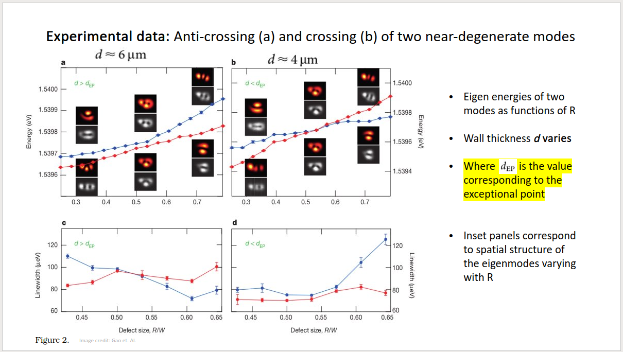

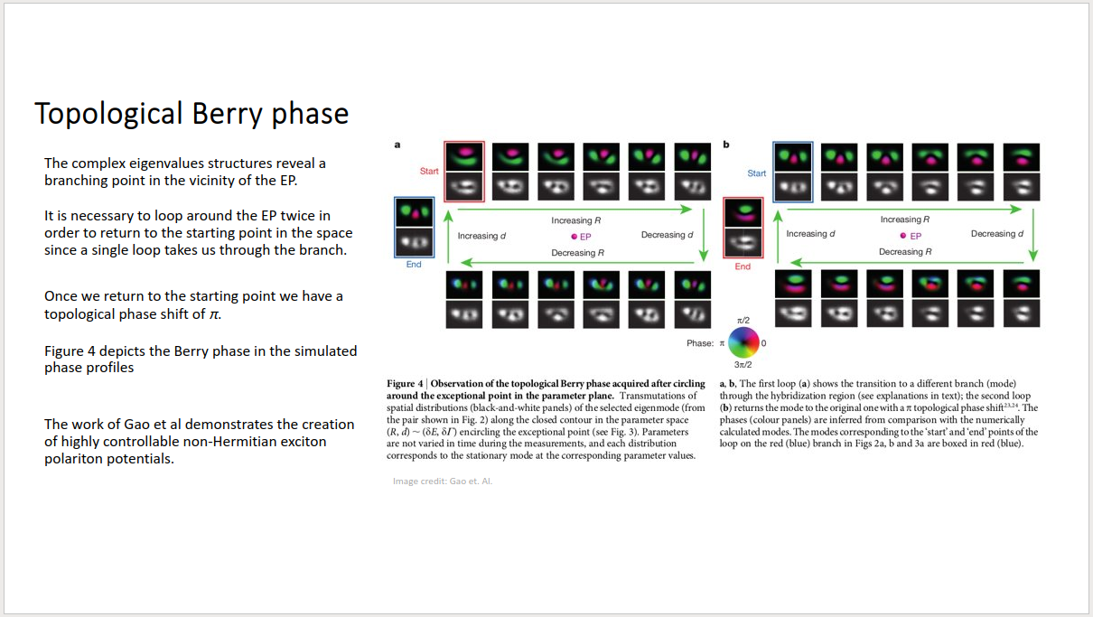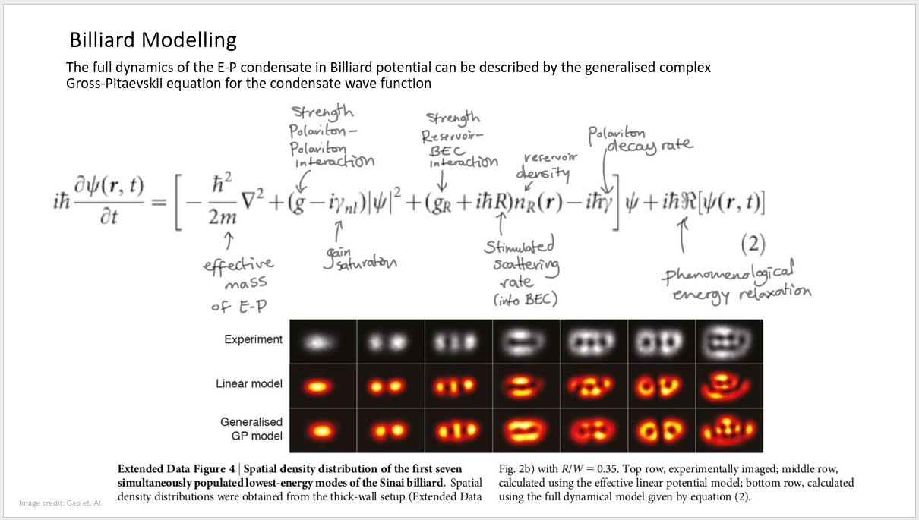

Meeting notes:  
I think that the main aim now is to understand equation (1).  
This is the 2 level linear model used in the paper. It looks considerably easier than the G-P model and somehow it appears very useful.

Aim 1 in my weekly list seems more important than ever!  
Compare Gao et al.’s (2x2 Hamiltonian) to Bender page 986 (is the comparison useful?)

#### What do I write in my progress report?

1. What is my topic?
2. What have I done so far?  
    -READING  
    -What do I currently understand?
3. What Ideas do I have?
4. What is the goal of my project?

Why are NHHs useful and for what kind of systems they can be used

27/03/21

#### **Investigation**: Linear coupled-mode model in Gao et al.

Gao et al. explain in the **methods** section of their paper that in the degeneracy region, the behaviour of any two modes (*n, n’*) of the billiard potential can be described by a standard (dimensionless) **coupled-mode model**:

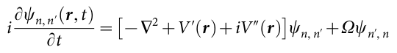

Where  characterises the coupling strength between the modes.  
Gao et al. define an arbitrary state as separable ie. . Where $φ_{n}$ are the basis vectors of the real part of the Hamiltonian $H_{0}$ (with real eigenvalues away from the degeneracy)

The imaginary parts of the eigenenergies are given by the overlap between the billiard modes and the exciton reservoir.   
The decay and gain rates from the reservoir BEC interaction are 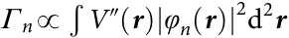

I write the vector equation as:

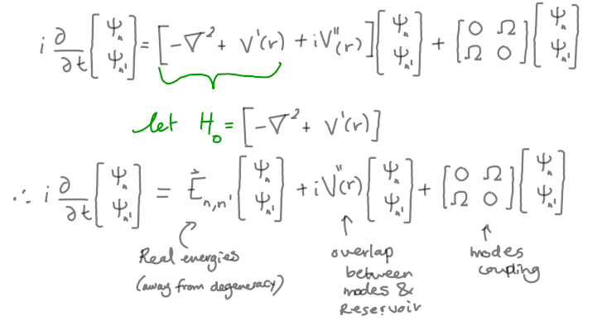

My derivation of equation 1 in the main text:

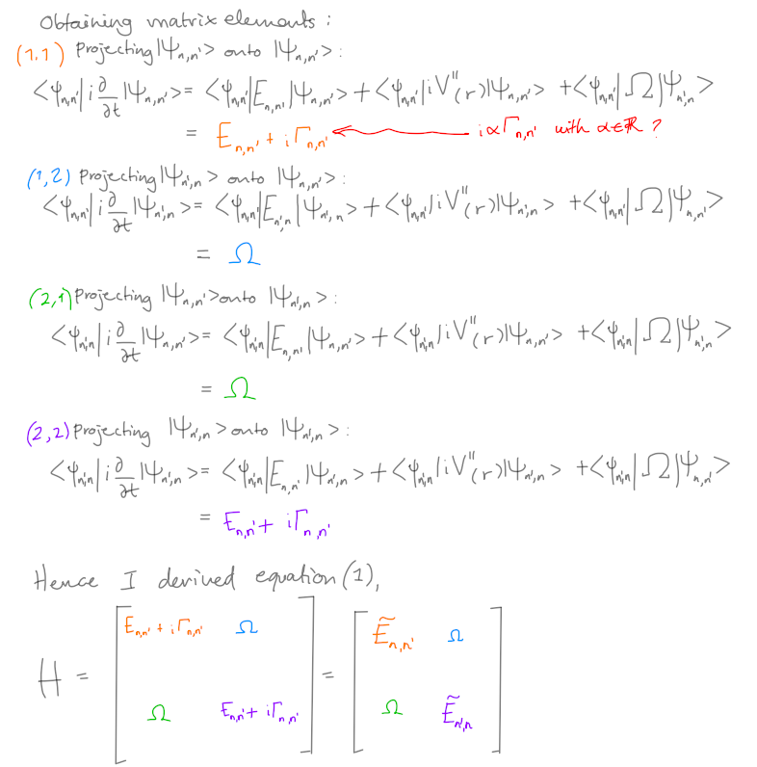



Where $Ẽ_{n,n'}$ are the complex energies of two uncoupled modes. $Г_{n,n'}$ are decay/gain rates.   
Nevertheless, coupling between the modes should be $q$ with $q^{*}$ as the complex conjugate. And I still have coupling strength $Ω$

Notes on equation (1) derivation:

* What is the proportionality constant of the imaginary terms in the main diagonal?
* I am unsure about the sign of the gain/decay rates in the main diagonal, since the value reported in the paper is:
${Ẽ_{}}_{n,n'}= E_{n,n'} - i {Г_{n,n'}}_{}$

* I also don’t understand the relation between $Ω$ and *q*
  + *q* characterizes the coupling between the states n and n’.
  + $Ω$ characterizes the coupling strength between these two modes.
* The methods section explains that the off-diagonal matrix elements in equation (1)

are determined by the degree of spatial overlap between the two modes,



I don’t understand this proportionality relation.  
Is this a typo? I suspect it because n and n’ are supposed to be orthogonal

$⇔$ $〈φ_{n}|φ_{n'}〉=0$

28/03/21

#### Gao et al.’s (2x2 Hamiltonian) vs Bender (page 986) “Illustrative 2 × 2 matrix example of a PT-symmetric Hamiltonian”

We consider the 2x2 Hamiltonian matrix H in Gao et al.

where the three parameters $E_{1,2},Γ_{1,2},q$ are real

STEPS:

1. FIND if H is PT symmetric

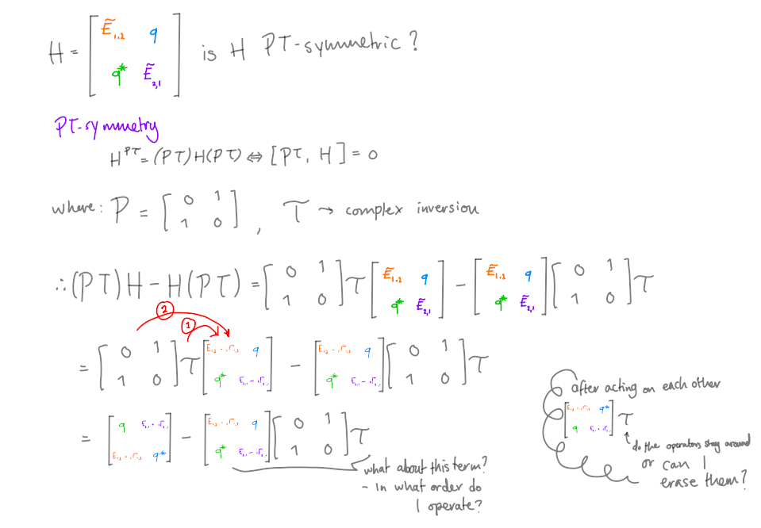

Normally the operators do disappear - as long as it acted on everything to the right of it.   
But since the 𝒯 operator is an antilinear, I am less sure.

## Week 5 (29/03/21 – 04/04/21)

Aims:

1. Compare Gao et al.’s (2x2 Hamiltonian) to Bender page 986 (is the comparison useful?)
2. Reproduce Fig 1 in Bender
3. Simulate a RF-CAP

Tasks:

1. Meeting with J&M (Wednesday 3:00pm?)

~~Ask J&M for feedback on my progress report~~

~~Ask them about my issues understanding 2x2 model in Gao et al.~~

1. ~~SUBMIT PROGRESS REPORT~~
2. investigating the further papers on the E-P quantum billiard, or EPs done by Ostrovskaya’s group

29/03/21

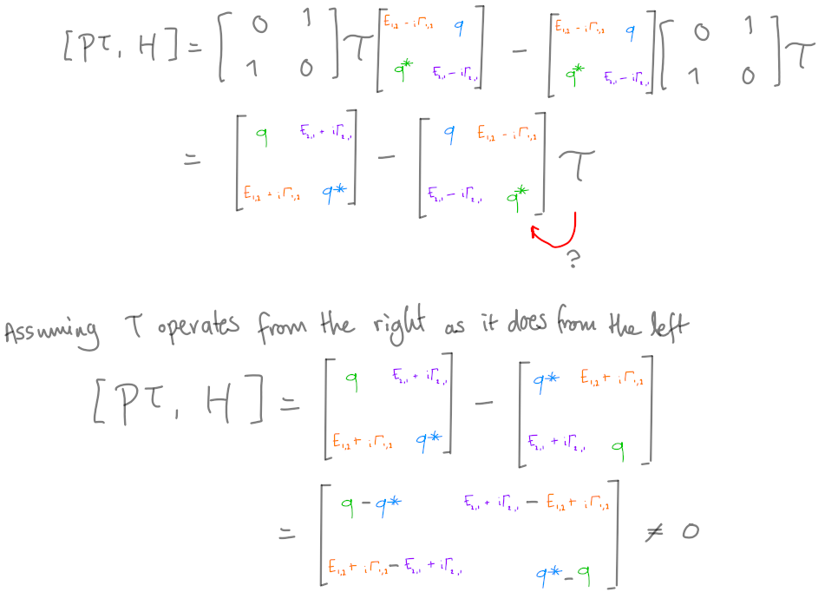

Note: there are edge cases when the commutator could be zero.

I know that if $q$ is real, but i will also need ${Ẽ_{}}_{1,2}={Ẽ_{}}_{2,1}$ and $Γ_{1,2}$ = - $Γ_{2,1}$

I suspect that this is not applicable in general.

I can try a different definition: A Hamiltonian H is 𝒫𝒯-symmetric if $H^{𝒫𝒯}=(𝒫𝒯)H(𝒫𝒯) = H$

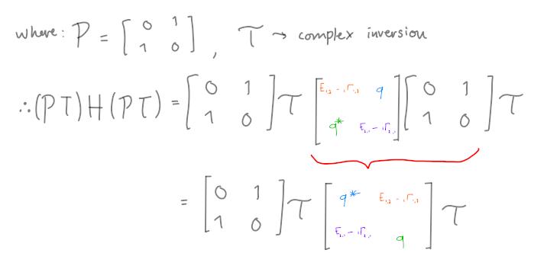

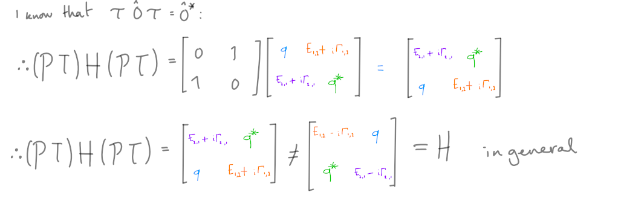

H does not appear to be PT-symmetric in general. (?)

30/03/21

A colleague (Olivier) from my group found an error in my work. He explained that:  
 I forgot to conjugate q→ q* and q*→q when taking the complex conjugation (between the 2nd and 3rd lines).

He also mentioned that denoting the complex diagonal elements of the original matrix as **A11 and A22**, then the Hamiltonian is 𝒫𝒯-symmetric  
 **iff A22*=A11**. Hence, A11 and A22 should have the same real parts, and exactly opposite imaginary parts. Essentially, the same conditions as I suspected earlier apply.

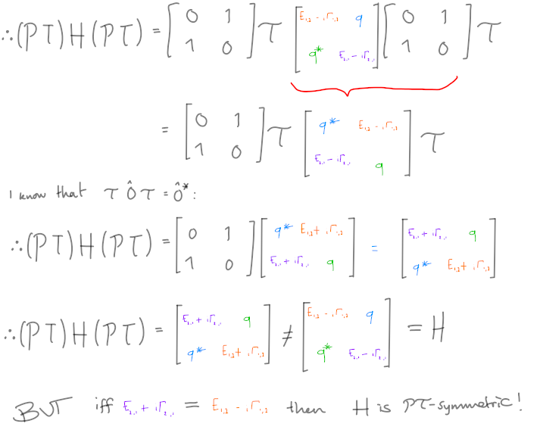

This is basically the same result obtained from the commutator analysis I did earlier.   
I really need to understand the relations between the coupling strengths: $Ω↔q$

31/03/21

MEETING Day!

1. Find eigenvalues of H

I am Diagonalizing H using mathematica, first I write $E=λ$ (since E symbol representing the base of the natural logarithm)

Then I find the eigenvectors of the matrix, and diagonalize it!

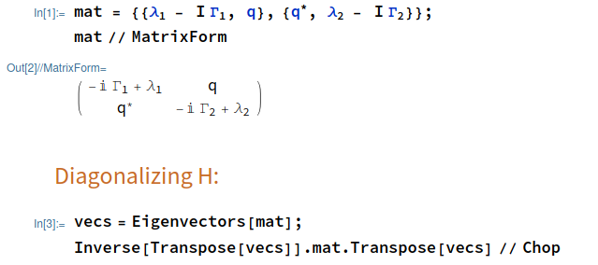

But the output is… not very pretty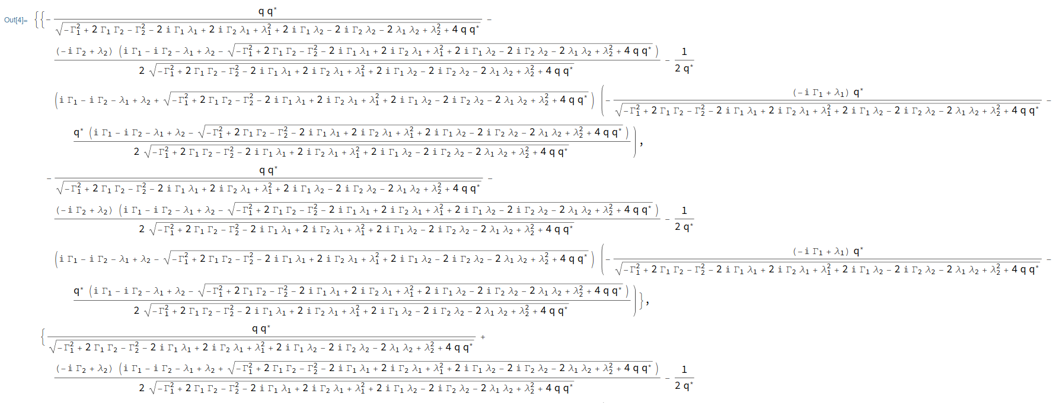

Bender proceeds to analyse the parametric regions of the space from the eigenvalues in his example… But mine looks a bit too tricky...  
**I am a bit stuck on this part now...!**

During our meeting I explained to J&M what I have understood so far and what I have not.   
They both agree on my interpretation of the gain/decay rates in the main diagonal. Seems like ${Г_{n,n'}}_{}$ should be equal in magnitude but opposite in sign between the two coupled modes. But we were not able to find a reason on why I have a different sign for the imaginary part to the model equation (1) :

${Ẽ_{}}_{n,n'}= E_{n,n'} - i {Г_{n,n'}}_{}$

Neither of us yet understand the relation between $Ω$ and *q* properly.   
In fact all three of us feel a bit confused by the definition in the paper for q (supposedly determined by the degree of spatial overlap between the two modes,)



This definition is confusing because as I already stated earlier the basis vectors $|φ_{n'}〉,|φ_{n}〉$ are supposed to be orthogonal, which applies to their conjugates also. Meera suggested I find more information on this result by investigating the following papers on this subject done by Ostrovskaya’s group. Maybe they will have further information that I can find useful to figure out this issue.

Jesper was wondering if the 𝒯 operator ever yields any non-trivial results. As defined it seems like a very simple operator. I told Jesper that from what I have read I think it doesn’t have any sort of particularly interesting behaviour. But I am unsure.

Unfortunately we weren’t able to get to the eigenvalues part of my work, so I could not show them how unaesthetic they appear.  
  
*~Now, to something else entirely...~*

#### Reproducing Figure 1 in Bender

The general parametric family of $𝒫𝒯$-symmetric Hamiltonians $H = {p̂}^{2} + {x̂}^{2} (i x̂)^{ϵ}$ as a function of the real parameter $ϵ$.

When $ϵ≥0$, the $𝒫𝒯$-symmetry is unbroken, but when $ϵ<0$ the $𝒫𝒯$-symmetry is broken.

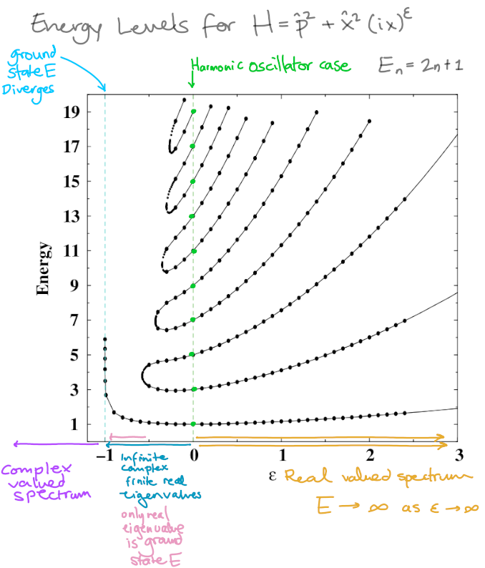

The three regions:

1. $ϵ≥0$, the spectrum is real and positive and the energy levels rise with increasing $ϵ$.
2. $-1≤ϵ≤$ 0, there is a finite number of real positive eigenvalues and an infinite number of complex-conjugate pairs of eigenvalues (as $ϵ$ decreases from 0 to −1, the number of real eigenvalues decreases).
3. For $ϵ≤$ −1 there are no real eigenvalues.

Note:

$ϵ= 0$, corresponds to the harmonic oscillator,

$ϵ≤−0.57793$ The only real eigenvalue is the ground-state energy.

As $ε→-1^{+}$, the ground-state energy diverges.

The principle behind this image is that we can think of the family of non-Hermitian Hamiltonians $H = {p̂}^{2} + {x̂}^{2} (i x̂)^{ϵ}$ as complex extensions of the 1D harmonic oscillator (which is Hermitian and $𝒫𝒯$-symmetric) by introducing a real parameter $ϵ$ in such a way that as $ϵ$ increases from 0 the Hamiltonian is no longer Hermitian but its $𝒫𝒯$-symmetry is maintained. This can be done with any of the Hermitian Hamiltonians $H = {p̂}^{2} + {x̂}^{2N}$ where $N∊ℕ$ (Bender 953).

**Bender claims that boundary conditions imposed on the eigenfunctions are the key enforcers of $𝒫𝒯$-symmetry and hence are responsible for the “reality” of the energy spectrum of a Hamiltonian (Bender 959).**

It is impossible to solve $-ψ''+x^{2}(ix)^{ϵ}ψ=Eψ$ analytically and in closed form in the cases $ϵ=0$, $ϵ→∞$

Thus it is necessary to use approximate analytic or numerical methods

02/04/21

#### WKB integral techniques to calculate eigenvalues

* WKB is a great approximation to the eigenvalues when $ϵ>0$.
* WKB must be performed on the complex plane.

The turning points $x_{±}$ are those roots of $E=x^{2}(ix)^{ϵ}$ that analytically continue off the real axis as $ϵ$ increases from 0.

These turning points

$x_{-}= E^{\frac{1}{ϵ+2}}e^{iπ(\frac{3}{2}-\frac{1}{ϵ+2})}$ $x_{+}= E^{\frac{1}{ϵ+2}}e^{-iπ(\frac{1}{2}-\frac{1}{ϵ+2})}$

Lie in the lower-half (upper-half) x-plane when $ϵ>0$ ($ϵ<0$) of fig 2. In Bender

#### 

I don’t actually understand these regions well enough though, why are there turning points?

Bender references the following paper in his work so I think I should read this paper to get a more detailed methodology on the WKB method and the Stokes wedges regions in the complex x-plane.

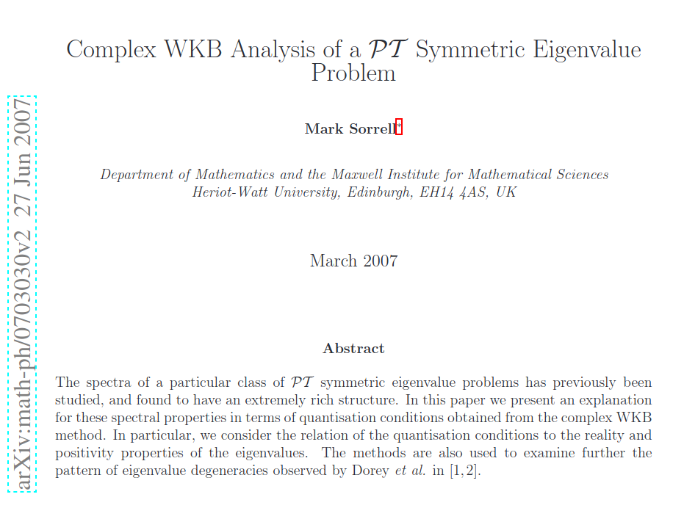

#### Complex WKB (?)

The complex WKB method involves treating x as a complex variable, and calculating how the asymptotic form of the solutions change as they are traced around the complex plane (Sorrell 4).

For a 1D TISE:

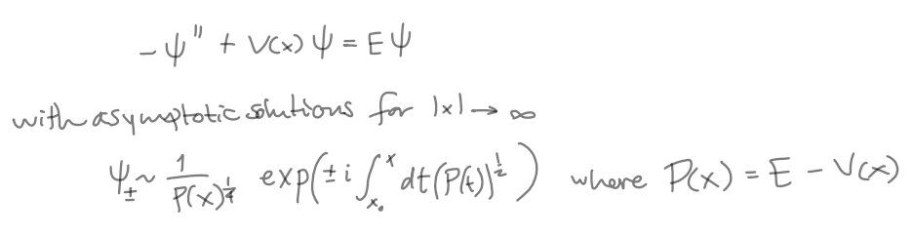

The solutions are valid in some region of the complex plane around $x_{0}$ ($P(x) = 0$ ie. a turning point)

The integral in the exponent is in general complex valued. The real exponential parts of the solutions will either be growing (dominant) or decaying (subdominant). IF the integral is purely real then the solutions will be purely oscillatory (no domination)(Sorrell 4).

###### Stokes and Anti-stokes lines

The curves where $ℑm(\int_{x_{0}}^{x}{}P(t)^{\frac{1}{2}}dt) = 0)$ are known as anti-Stokes lines. Anti-Stokes lines mark the borders between sectors of dominant/subdominant behaviour; in a given sector one solution will be dominant, but on crossing an **anti-Stokes** **line** to the next sector the dominance behaviour reverses and the solution will be subdominant in the new sector. We can also find the regions where $ℜe(\int_{x_{0}}^{x}{}P(t)^{\frac{1}{2}}dt) = 0.$ These are known as Stokes lines, and are the regions where the solutions are most dominant/subdominant. Upon crossing a **Stokes line**, the coefficient of the subdominant solution changes by an amount proportional to the coefficient of the dominant term. Knowing the position of Stokes and anti-Stokes lines is crucial in applying **complex WKB methods**(Sorrell 4).

Crossing a Stokes line: new_subdominant_coeff = old_subdominant_coeff + T $×$ old_dominant_coeff

T is the Stokes multiplier and it depends on the nature of the turning point where the Stokes line originates from.

**If: the Stokes line is emanating from a simple turning point $T = i$,**

**Else: the Stokes line is emanating from a double zero $T=\sqrt{2i }$ (to first-order)**

*Note: new_dominant_coeff = old_dominant_coeff

To connect solutions defined in terms of different turning points, $x_{1}$ and $x_{2}$, use:



Note: it is chosen to introduce the discontinuous change in the subdominant coefficient at the Stokes line, so that this discontinuity is small compared to the error in the WKB approximation(Sorrell 5).

###### WKB Quantization conditions for eigenvalue problems

By starting with a WKB solution that is purely subdominant (decaying) in the Stokes sector $S_{-1}$

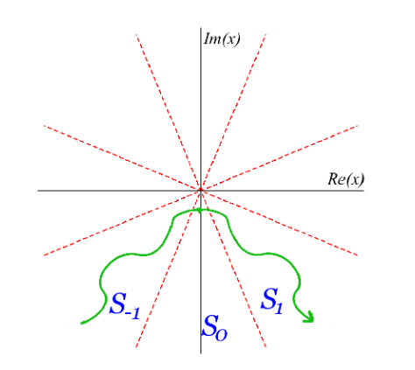

Tracing the solution around the complex plane, in an anti-clockwise direction.

As Stokes lines are crossed new subdominant exponentials appear. The new subdominant contributions will have a coefficient of $i$ (from Stokes line from a simple turning point) or $√2i$ (Stokes line from a second order zero) multiplied by the coefficient of the dominant exponential at that Stokes line leads to a wave function in the Stokes sector $S_{1}$ that has both a subdominant and dominant components(Sorrell 5).

Different Stokes’ structures are obtained depending on whether the double zeros occur within, outside of, or directly in line with the other turning points.

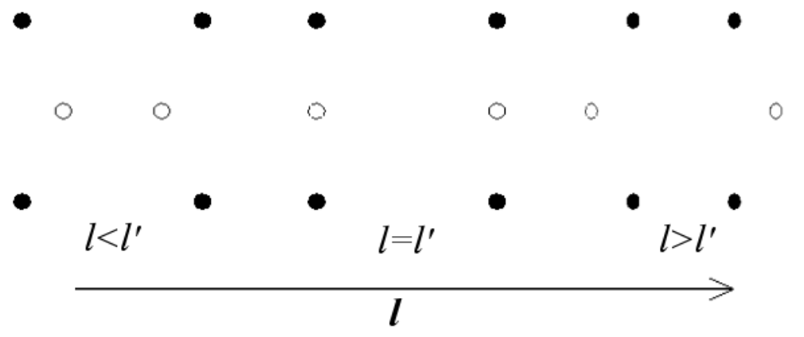  
Fig 5. In Sorrell: Relative positions of turning points.   
The double zeros (white dots) with respect to single zeros (black dots).

For a given value of the parameter $α$, the value of $l$ required for the zeros that coalesce to lineup with the others, (denoted $l'$), is given by

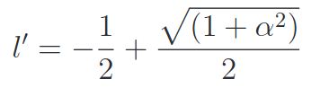

The organisation of the different possible structures of the stokes lines in the plane due to the **sequence of turning point configurations** depends on the value of $l$ relative to $l'$ for a given $α$ (Sorrell 10).

The $(α, l)$ plane can be divided up into sectors according to which sequence of turning point arrangements is valid there.  
**Note: A sequence is obtained because the pattern of zeros obtained also depends on energy** (Sorrell 10).

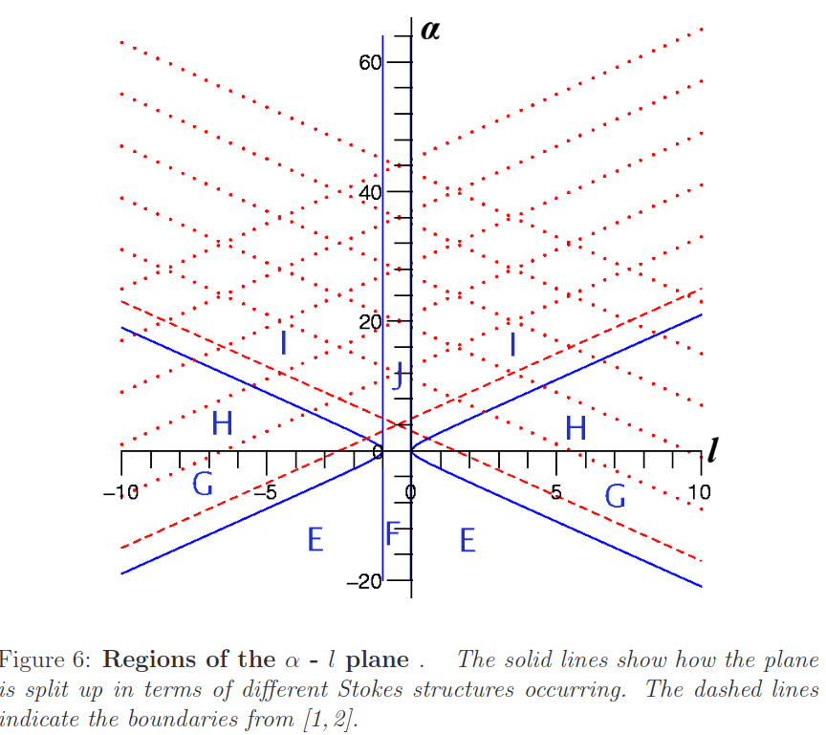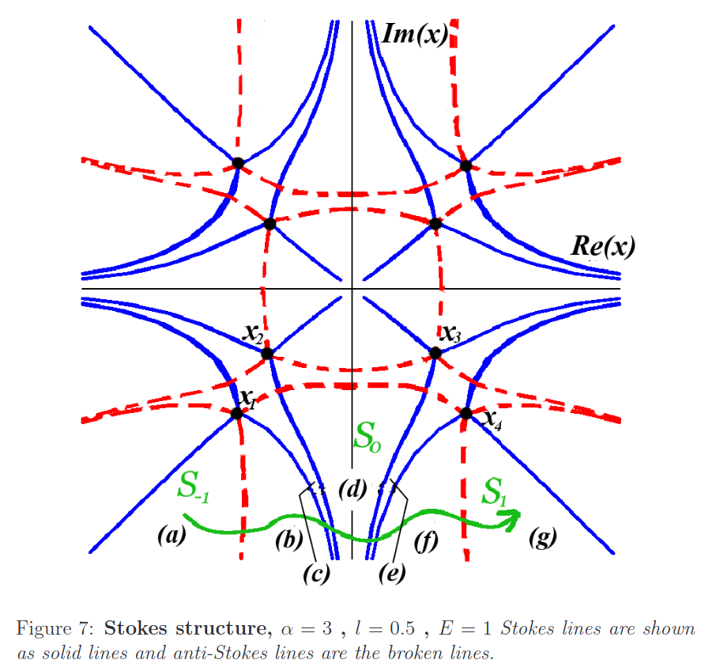

I feel like I don’t actually understand the concept of the Stokes structures in the complex plane and I don’t actually have a proper plan to replicate Fig 1 in Bender yet.

04/04/2021

###### Boundary conditions for the Schrödinger eigenvalue problem (Bender 956)

To solve the Schrödinger eigenvalue problem we write the Schrödinger equation in coordinate space. The question is, what are the BCs??  
In coordinate space the operators $x →x$ and $p→-i\frac{d}{dx}$, we want to treat the variable x as complex.

As we know the Schrödinger eigenvalue problem for $H = {p̂}^{2} + {x̂}^{2} (i x̂)^{ϵ}$ takes the form $-ψ''+x^{2}(ix)^{ϵ}ψ=Eψ$.

We cannot solve this equation for an arbitrary $ε$ (it is impossible to solve the differential equation eigenvalue problem analytically and in closed form except in two special cases, namely, for $ε$ = 0 (the harmonic oscillator) and for $ε$ → ∞).

Therefore we use the WKB approximation to find asymptotic solutions:

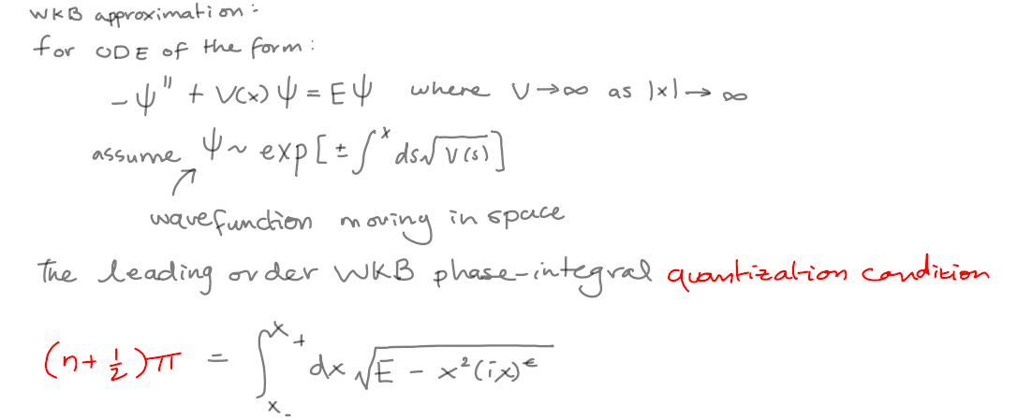

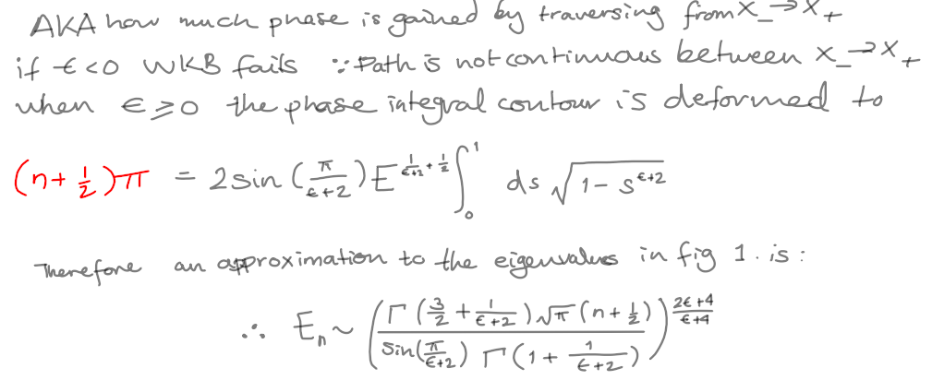

When $ε$ > 0 this path lies entirely in the lower-half x plane, and when $ε$ = 0 (the case of the harmonic oscillator) the path lies on the real axis. However, when $ε$ < 0 the path lies in the upper-half x plane and crosses the cut on the positive imaginary-x axis. In this case there is no continuous path joining the turning points. Hence, **WKB fails when $ε$ < 0.**

According to Bender, the WKB formula gives a very accurate approximation to the eigenvalues plotted in figure 1. and it shows, at least in the WKB approximation, that the energy eigenvalues of $H = {p̂}^{2} + {x̂}^{2} (i x̂)^{ϵ}$ are real and positive (Bender 960).

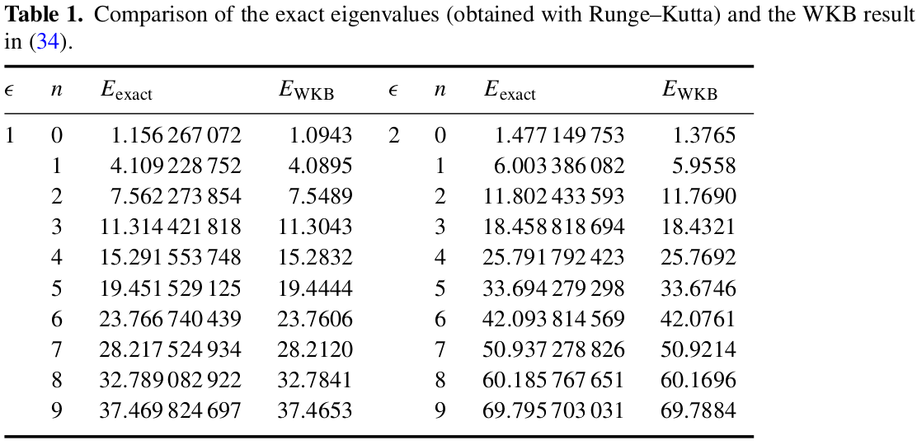

I don’t really follow the method further outlined involving complex integration of contours within the stokes regions.   
I will therefore go to the next section, explaining the numerical calculation.

#### **Numerical calculation of eigenvalues**

I require

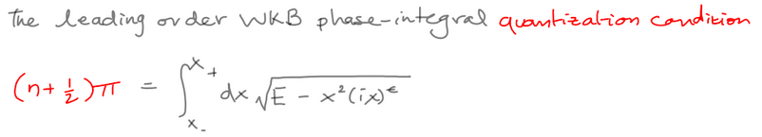

Where the **turning points**

$x_{-}= E^{\frac{1}{ϵ+2}}e^{iπ(\frac{3}{2}-\frac{1}{ϵ+2})}$ $x_{+}= E^{\frac{1}{ϵ+2}}e^{-iπ(\frac{1}{2}-\frac{1}{ϵ+2})}$

Here I have written the basic set up of what I think will give me the values of the eigen energies based on the WKB methodology

Where the LHS is the quantization condition I’ve written in red above and the RHS is the WKB integral that defines the energy  
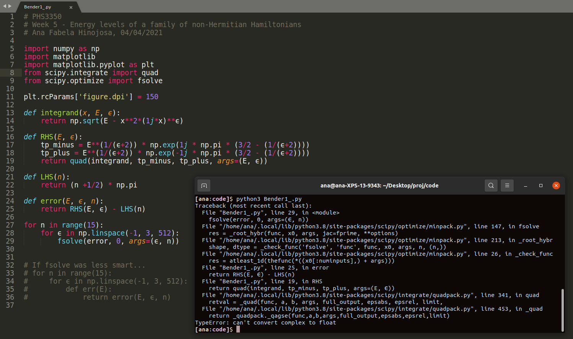

I think that I am getting an error because I am using the complex turning points as the limits in the integral. I am performing a complex integral.  
Maybe I need a change of variables so I can translate those points into the real line.

#### Important questions:

* is a definition that makes sense?

## MID-SEM break (05/04/21 – 11/04/21)

Aims:

1. Reproduce Fig 1 in Bender
2. Compare Gao et al.’s (2x2 Hamiltonian) to Bender page 986 (is the comparison useful?)
3. Simulate a RF-CAP

Tasks:

1. F~~ix complex integral by change of variables~~
2. investigating the further papers on the E-P quantum billiard, or EPs done by Ostrovskaya’s group (?)

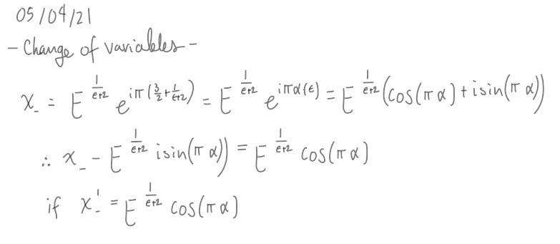

After this kind change of variables for both my integration limits I still obtain the same TypeError: can't convert complex to float

Possible approach

* Complex integral?
  + Solving real and imaginary part separately

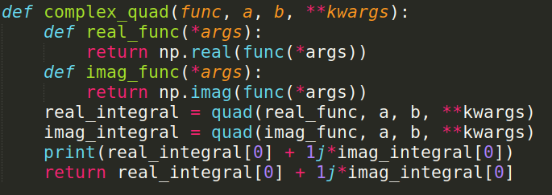

* Calling fsolve twice?
  + real and imaginary part respectively (also)

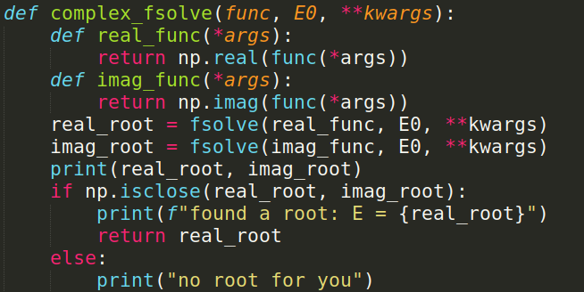

Test call:  
 complex_fsolve(error, E0=47, args=(3, 200))

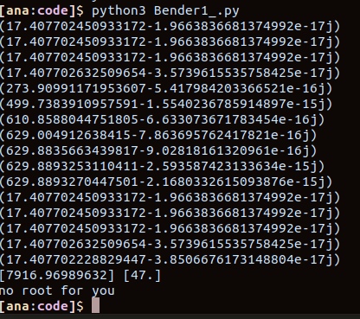

It works (?)… Also the calculated output for the imaginary part of the RHS is very small! Therefore the code assumes it is negligible.

Chris noticed that I haven’t finished my change of variables completely OH NO!  
I haven’t changed my integrand!!

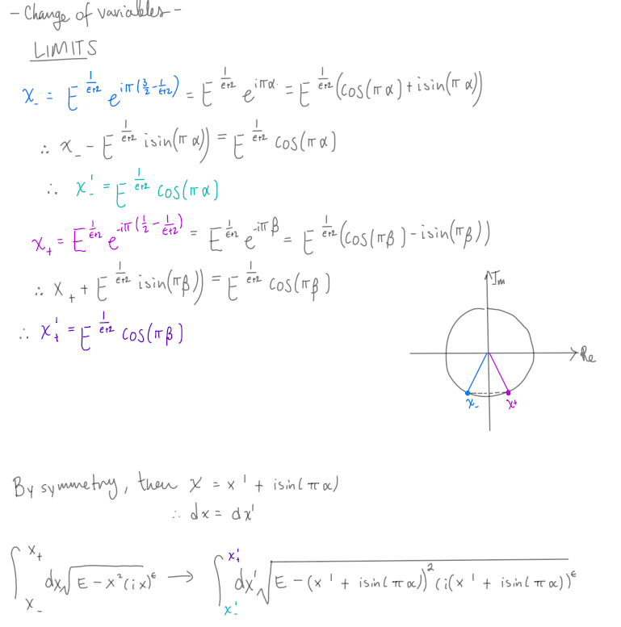

Corrected INTEGRAND  
 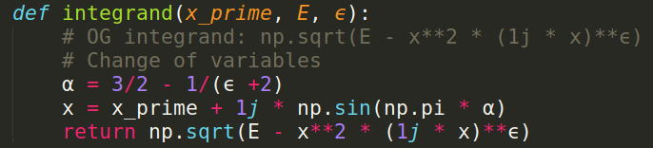

OUTPUT:

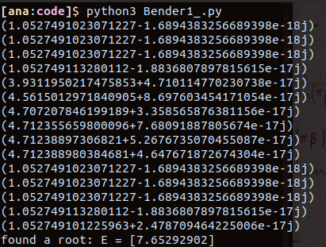

Imaginary part resulting from the complex integration remains negligible.

Which it’s probably correct.

06/04/21

##### TESTS

I want to compare the obtain values for a few cases displayed in table 1 in Bender



* IF $(n,ϵ)=(0,1)$

THEN my code output is:

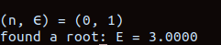

Which is not correct according to the table.

1. I have checked my integrand function and it seems like I have done my change of variables correctly.
2. I have checked my RHS function and the limits I defined for the integral seem to be correct also.

I want to plot the real part of my integrand function as a function of E.   
Maybe I can see where it crosses zero. Since square roots have 2 possible solutions, maybe the plot of the integrand will show if there are any discontinuities in the function from random choosings by numpy between the 2 possible solutions that it displays to me.

For this test I created a linspace of Es and used this to evaluate RHS(E, $ϵ$ =1)

I stored the result of each integration done by RHS in a list and then plotted this vs the E linspace. Since the LHS(0) = π/2

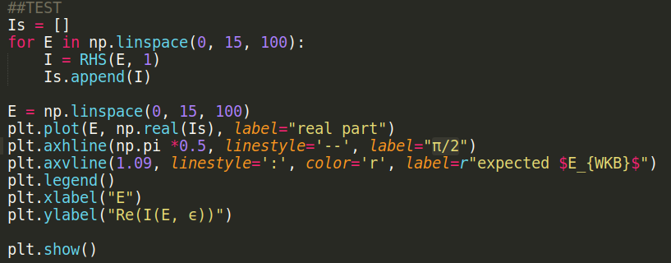

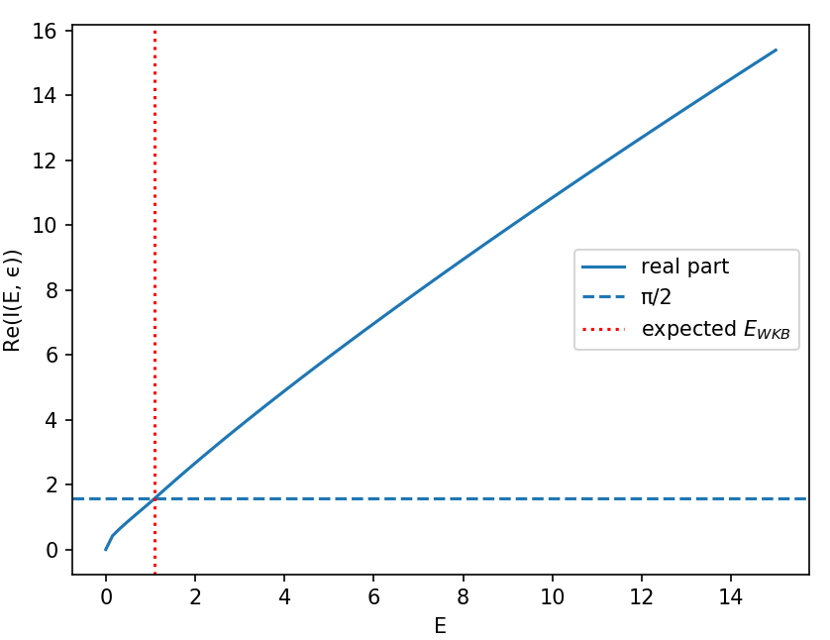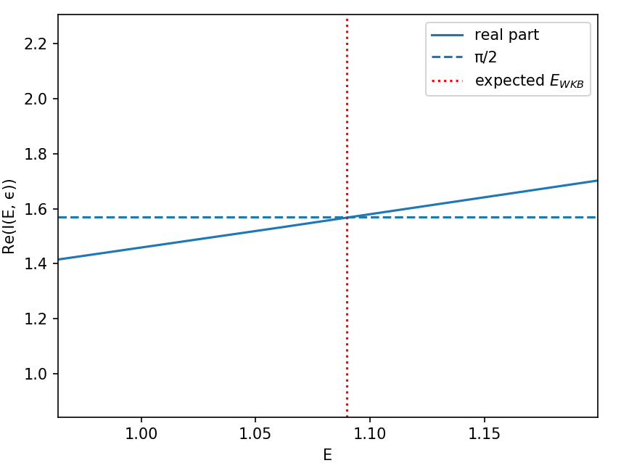

I found the correct approximation to the energy value given the n and $ϵ$ parameters.

So, both my change of variables and integration function work correctly.

Then why do I obtain the wrong root when I use fsolve on error?

**BUG SOLVED:** I was feeding the parameters n, $ϵ$ in the wrong order to fsolve!

This is the correct output:

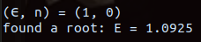

It is less accurate than the WKB approximation by 0.1% :

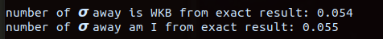

I am going to proceed with an iterative approach to see if I can find close values for all $ϵ=1$ and all n in table table 1 in Bender.

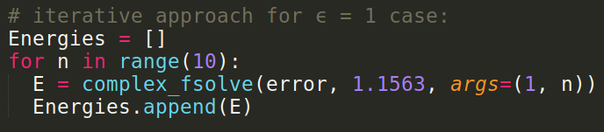

|  |  |
| --- | --- |
|  |  |

I obtain smaller values nearly each time. The **error grows** as the energy increases.

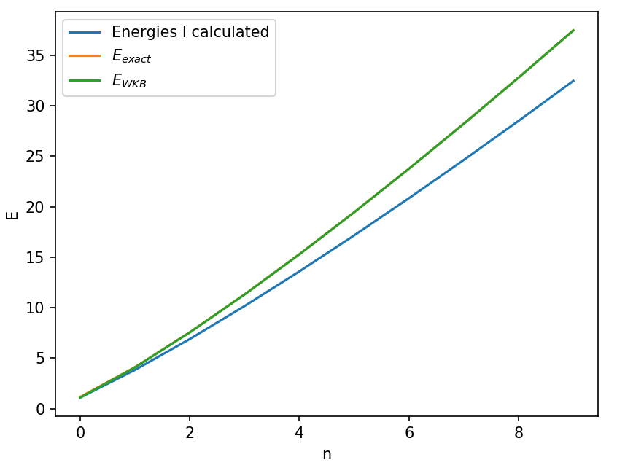

The exact energies reported in Bender are so close to the WKB energies

that at this scale the error between them is invisible, unlike with my result.

I have tried increasing the accuracy of my integration function by decreasing the allowed error tolerance as the documentation describes but that has no impact on my outputs.

The eigenvalues of the harmonic oscillator case ie $ϵ=0$:

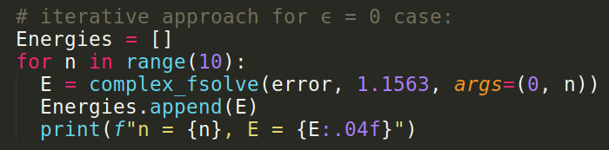

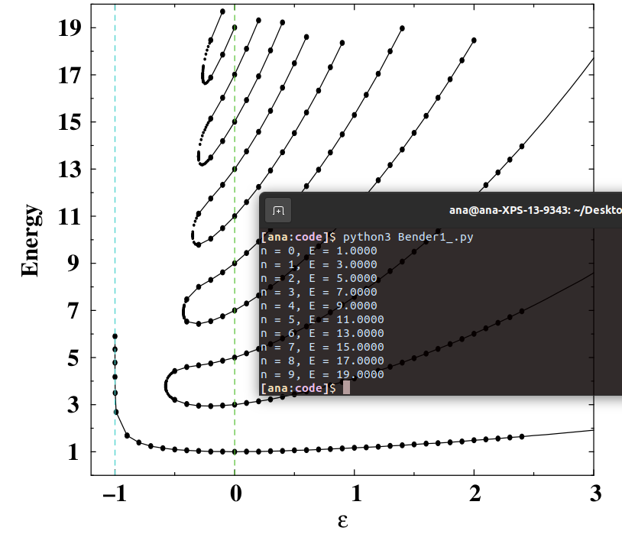  
I obtain the Harmonic oscillator eigenvalues exactly as the reported values in Bender.

I could do 2 more checks.

1. **FIRST TEST:** I want to try comparing Bender's analytic expression to my numerical results and see if I differ from his.

|  |  |
| --- | --- |
|  |  |

1. **IF FIRST TEST FAILS**: I would want to write a brute force integral to try and bypass any possible issues I might be having with scipy’s quad()

I could do this by simply summing over all integrand $×$ dx’

Currently my code can plot the Hermitian region of the Hamiltonian family

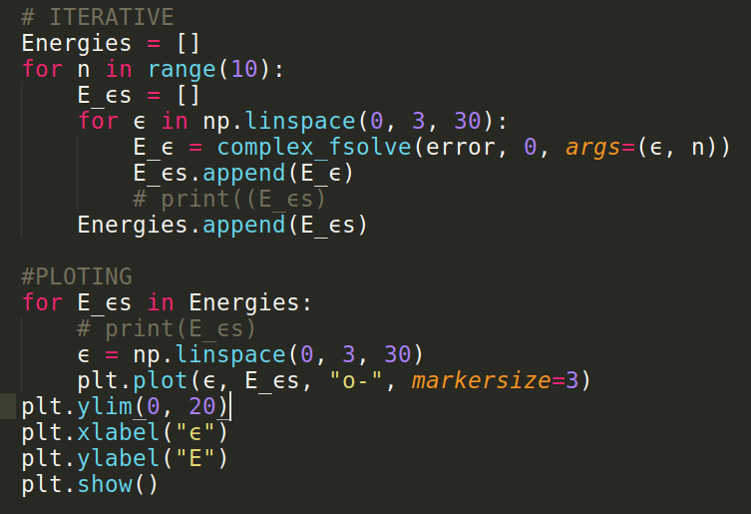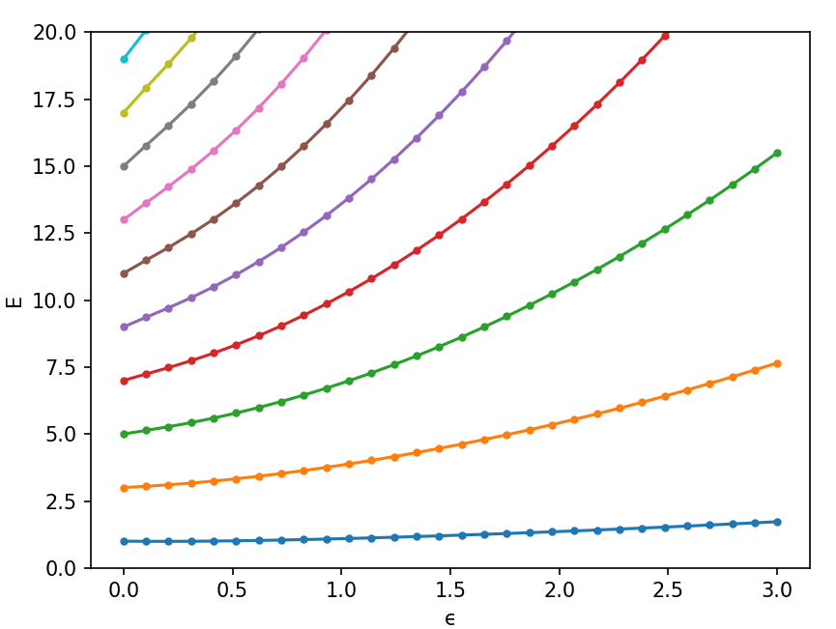

It is looking pretty good but again, i am not entirely sure of how precise it is. Given the comparative results vs WKB and RK.

I need to figure out how to do the broken symmetry sector of the spectrum ie. if $ϵ<0$

08/04/21

###### Test 1: comparison to the analytical solution in Bender

Here I am testing my method vs Bender’s analytical result for many $ϵ$ but with n=0:

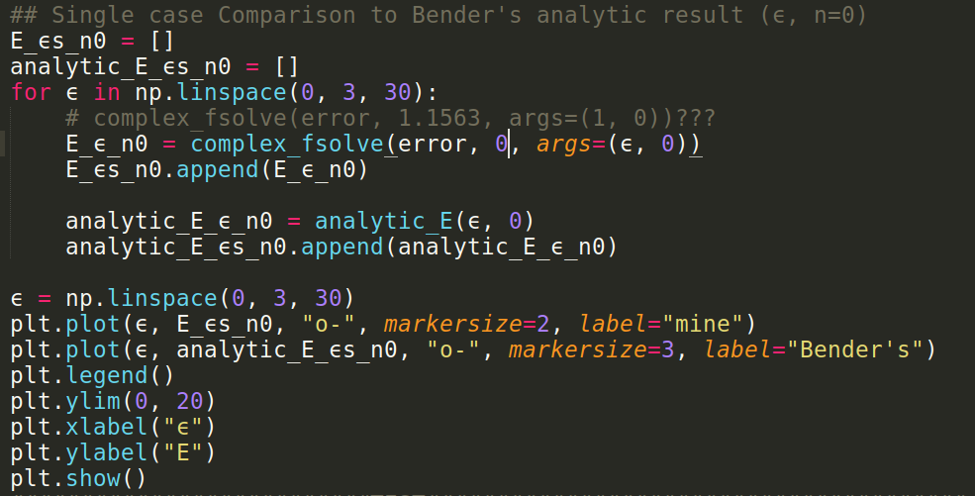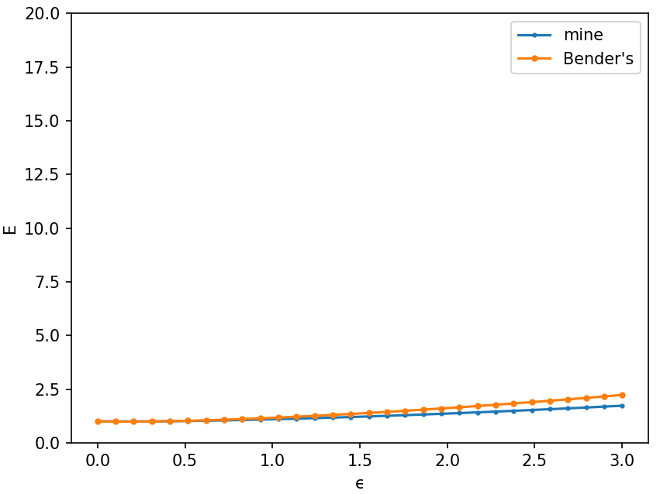

The plot looks the same if I make my initial guess for E in complex_fsolve E0 = 1.1563.  
  
My current hypothesis: The issue might be in the precision of quad().

|  |  |
| --- | --- |
|  | To obtain the figure on the left I simply made n=1.  It can be seen that the error is much larger than in the n=0 case.  The situation becomes weirder if I increase the n value to n=2 (as in the figure below). The solution reported by bender is simply not visible anymore.  This issue continues as n increases. Bender is off the charts! WHY? |

**Found a TYPO!** After re reading Benders analytic solution I discovered an error in the power :D

|  |  |
| --- | --- |
|  |  |

09/04/21

|  |  |
| --- | --- |
| To obtain this figure I set n = 2 once again and it can be seen that I obtain a better match with my result. But there is still divergence from the solution for large $ϵ$. So I should try adjusting the accuracy of fsolve() and see if that makes a difference...Aaand it doesn’t.  Below I have the numerical results compared to the Bender results. |  |
|  |  |

I will proceed with **test 2**

Using my obtained numerical results.

###### Test 2: The brute force integral.

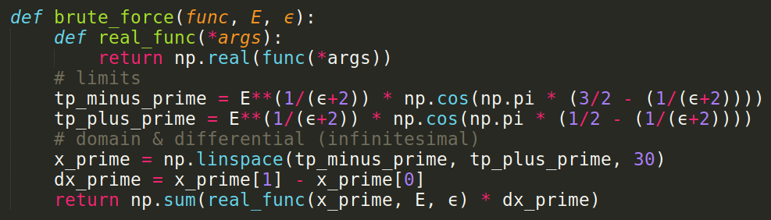

Since I have obtained a list of energies from my method. I can use one of these E in this integral and see if it solves the quantization condition accurately

I am going to use the (arbitrarily chosen) energy value : ϵ = 1, n = 6, E = 20.84313934174705

Does the brute force integral solve the quantization condition?

|  |  |
| --- | --- |
|  |  |

The accuracy of the brute force integral increases as the infinitesimal differential decreases… this size is adjusted by changing the number of points in the linspace… I went for it and slowly increased the number from 30 →3000

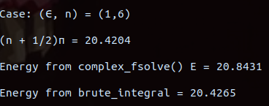

Since I am using an energy I calculated using my complex_fsolve() function and passing it into the brute_ integral() it appears that my method does in fact satisfy the quantization condition when I have many very small integration steps!  
This means that my functions: complex_quad() and complex_fsolve() are doing a good job!

The trend continues as I increase the number of integration steps in the region.

This tells me nothing about the discrepancy between my results and the reported results in Bender though. SAD reacc

#### Important questions:

* How can I figure out if the eigenvalues of Gao et al’s 2x2 Hamiltonian are correct?

What is next?

* What other test can I do in order to check my code vs Bender?  
   Can Bender’s results be wrong?
* When $ε$ < 0 the path lies in the upper-half x plane and crosses the cut on the positive imaginary-x axis. In this case there is no continuous path joining the turning points. Hence, **WKB fails when $ε$ < 0.**

**How do I obtain the Energy values on the broken symmetry sector of the spectrum?**

## Week 6 (12/04/21 – 18/04/21)

Aims:

1. Reproduce Fig 1 in Bender
2. Compare Gao et al.’s (2x2 Hamiltonian) to Bender page 986 (is the comparison useful?)
3. Simulate a RF-CAP

Tasks:

1. ~~Ask for advice on discrepancy between mine and Bender results~~

~~-Reproducing fig 1 in Bender (TESTS)~~

1. ~~Show J&M my results for Gao et al.’s 2x2 Hamiltonian eigenvalues~~

~~-Mathematica code~~

1. ~~Email Dr. T Gao and Prof E Ostrovskaya and ask about the definition of~~ ***~~q~~***
2. **Understand how is it that complex eigenstates of NH systems are not orthogonal**
3. **FIND OUT HOW TO PLOT THE BROKEN SYMMETRY SECTOR OF THE SPECTRUM IN FIG 1.**

14/04/21

MEETING Day!

Prof Elena Ostrovskaya replied to my email and clarified that my assumption of the orthogonality of the eigenstates is not true.

**I should find out more about these kinds of basis states.**

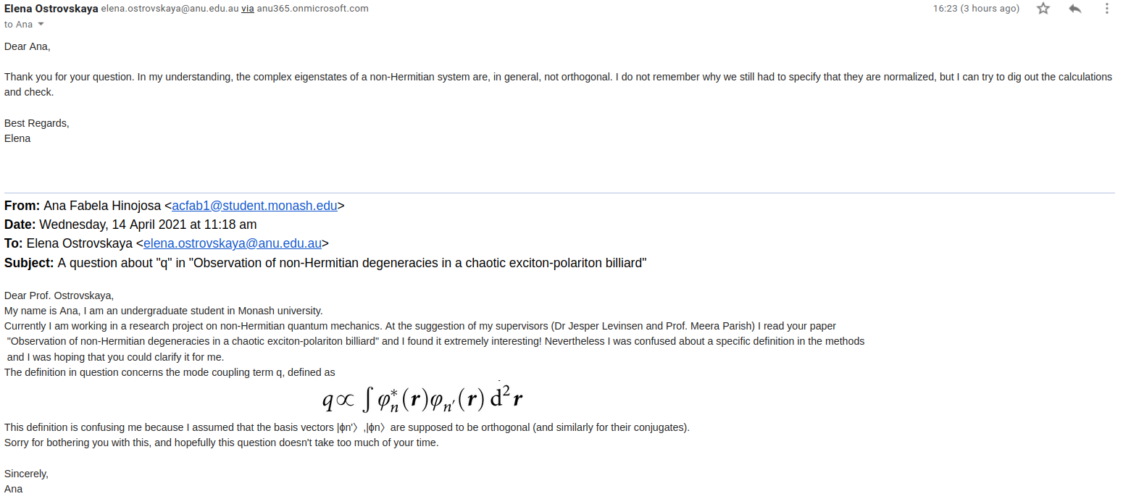

In my meeting with J&M I showed them diagonalisation of the 2x2 Hamiltonian (H) in Gao et al.  
 Since I am not super savvy using Mathematica, Jesper was able to show me how to obtain a simpler looking result for the eigenvalues of H, by setting the assumption for all our parameters to be real valued.

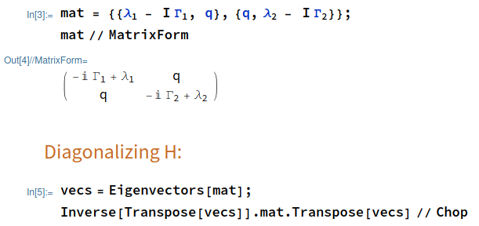



**This output is now manageable so I can continue reading the methodology that Bender outlines.**

Another suggestion made by Jesper was that I could re-scale the matrix by setting q = Ei $φ$ or simply q = 1.

I also showed J&M my work of Bender’s figure 1. Since my results are so similar and yet quite different to Bender’s several points were Raised by J&M:

1. I should aim to understand the contour of integration mentioned in the text since we are dealing with integration in the complex plane and the integrand involves a square root it is likely that python is spitting out one of multiple results at random … ie. It could be the case that I am seeing selections of different Riemann sheets or something of that sort given that the square root function has a branch cut.
2. I should consider replicating the Runge Kutta results from Bender.

But I reckon this option should not be a priority since I am unsure on how to implement RK using complex numbers.

14/04/21

#### Square root analysis

What exactly is going on in the integration of the square root of a complex number? Here I am plotting the behaviour of the RHS of the WKB approximation as stated in Bender. First I want to check what is going on with my integrand without the square root for any x and some fixed $ϵ$, (note: $ϵ$ =1, E0 = 1.1563):

|  |  |
| --- | --- |
|  |  |

|  |  |
| --- | --- |
| In the next plot ! am simply increasing $ϵ$ by 1 in order to see if there are any strange behaviours (ie. discontinuities).   It looks like the real and imaginary parts swap from action/inaction (one of them is zero everywhere and the other one isn’t) depending on the power $ϵ$ (even or odd behaviour, This only occurs if the power is an integer).  I observe no discontinuous behaviour so far. | $ϵ$ =2 |
| As is visible here, if the power is not an integer both parts of the integrand’s argument are “active” even though they do not share oddness or evenness.  What happens if I take the square root? And observe the actual integrand in Bender? **Will I have jumpy behaviour in my plots?** | $ϵ$ =⅔ |

No, even after implementing the square root function, the plots **do not show discontinuities** as far as I can see.

|  |  |  |
| --- | --- | --- |
| $ϵ$ =1 | $ϵ$ =2 | $ϵ$ =⅔ |

I am pretty certain that this demonstrates that:  
 **Python would not be giving me an answer to the square root chosen at random IF I was using Bender’s integrand**.

16/04/21

Given that I am using a change or variables in my integral I should do the same sort of test but for **the integrand that I am actually using in my code.**

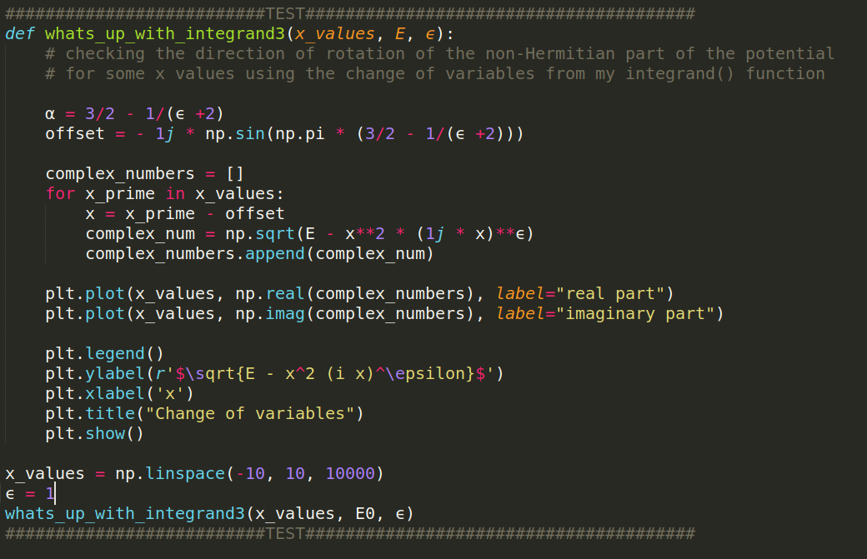

No, the plots **do not show discontinuities** as far as I can see.

|  |  |  |
| --- | --- | --- |
| $ϵ$ =1 | $ϵ$ =2 | $ϵ$ =⅔ |

|  |  |
| --- | --- |
|  | Zoomed version of the plot for the case when $ϵ$ =1 above.  The plots are continuous and smooth everywhere in sight. |

Even though my plots look slightly different from the ones yielded by Bender’s expression (complex valued) I am pretty certain that this demonstrates that **Python is not giving me an answer to the square root that is chosen at random (from distinct Riemann sheets)**.

18/04/21

Below I show that as x increases the resulting values in the integrand form a symmetric continuous function in the positive real quadrants of the argand plane, First I do the analysis for the WKB expression in Bender, and immediately below I modify the code for my change of variables below

It can be seen that the trajectory begins in the positive imaginary, and positive real axes (first quadrant) crosses at the origin and continues to the negative imaginary, and positive real axes (fourth quadrant).

|  |  |
| --- | --- |
|  |  |
| The function is still continuous and smooth but it shows even more multivalue behaviour than Bender’s expression.  **This path is the integration path that Bender describes in the methodology describing the BCs that define the Schrödinger equation.**  NEXT:  PLOT a different E for a corresponding $ϵ$ |  |

**For the case**

$ϵ$ = 2, n =1, E = 6.003386082

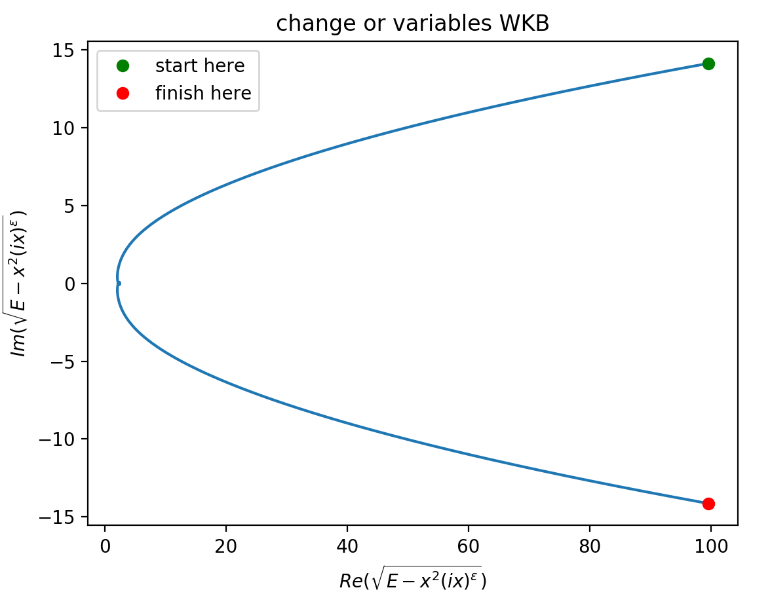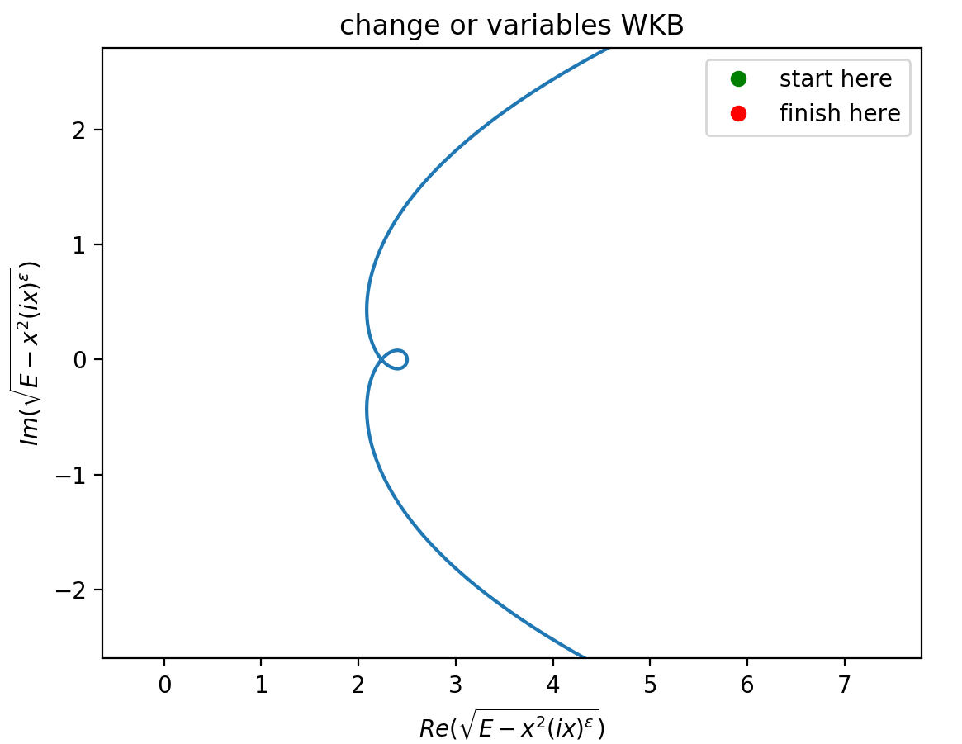

#### Important questions:

* Is the path I see the one Bender describes as the integration contour lying inside the Stokes wedges in the complex plane?
* Why is my change of variables showing this strange loop behaviour near the origin?

## Week 7 (19/04/21 – 25/04/21)

Aims:

1. Reproduce Fig 1 in Bender
2. Compare Gao et al.’s (2x2 Hamiltonian) to Bender page 986 (is the comparison useful?)
3. Simulate a RF-CAP

Tasks:

1. ~~Continue TESTS fig 1 in Bender (unbroken symmetry sector)~~
2. **FIND OUT HOW TO PLOT THE BROKEN SYMMETRY SECTOR OF THE SPECTRUM IN FIG 1.**
3. Continue Gao’s Hamiltonian analysis (using Benders methodology)
4. **Understand how is it that complex eigenstates of NH systems are not orthogonal**
   1. Maybe something to do with Bi-orthogonality?

20/04/21

#### Square root analysis (continued)

I’ve noticed that my change of variables offset was still missing a factor of: $E^{(1/(ε +2))}$ (I had noticed this error before but failed to make this correction)

I have made this correction and this is the resulting plot (zoomed) for the cases (as reported in Table 1. In Bender)

$ϵ$ = 2, n =1, E = 6.003386082

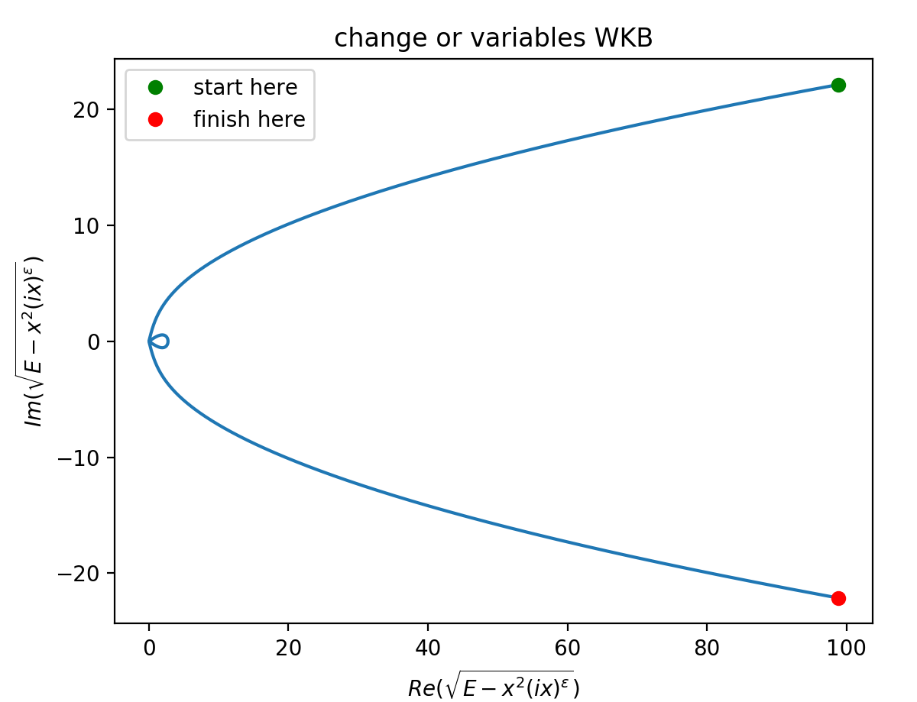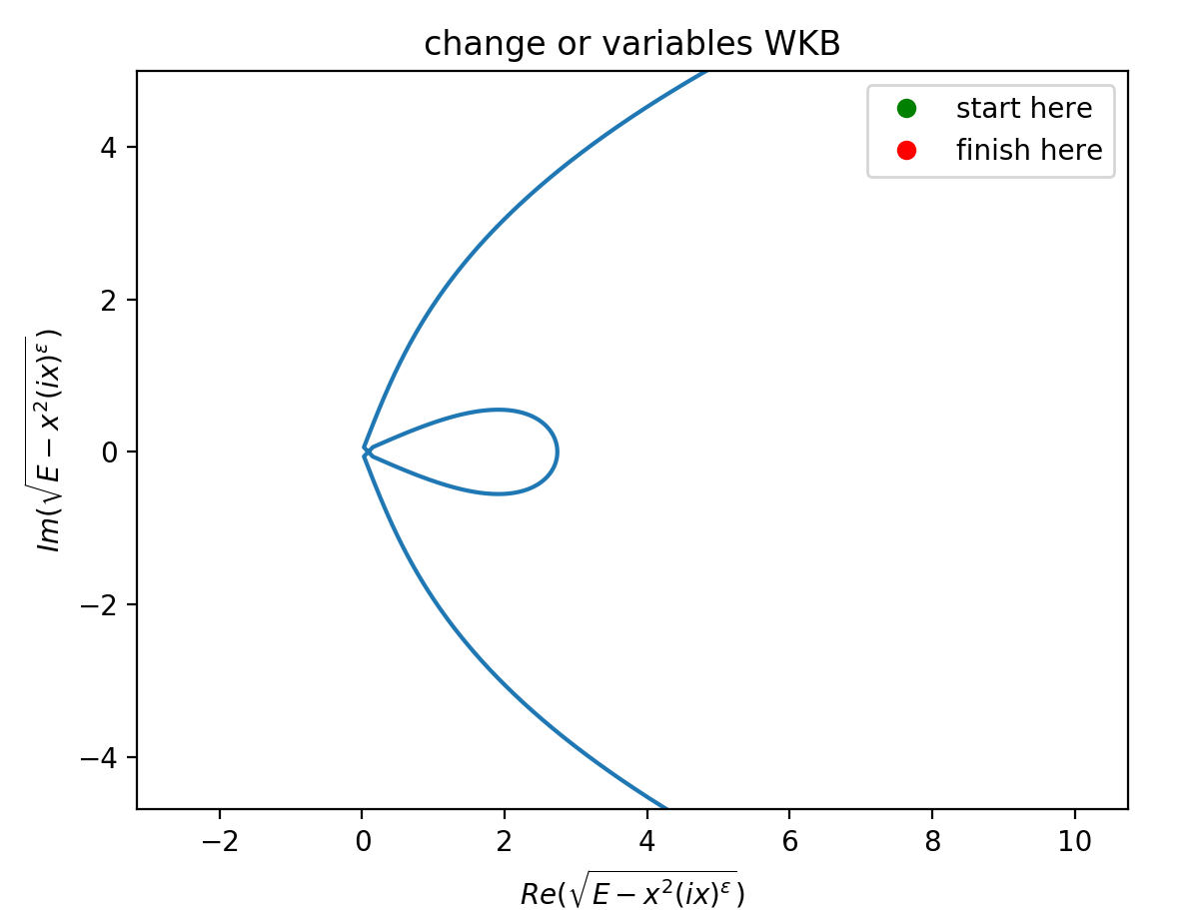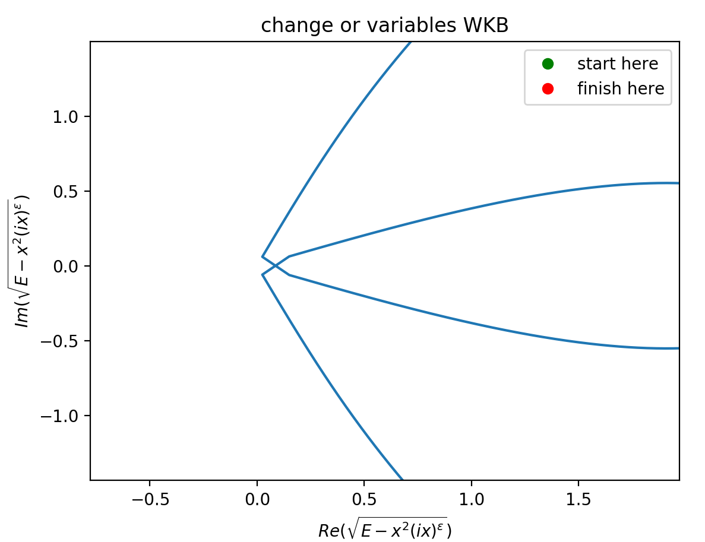

ε = 2, n = 8, E = 60.185767651

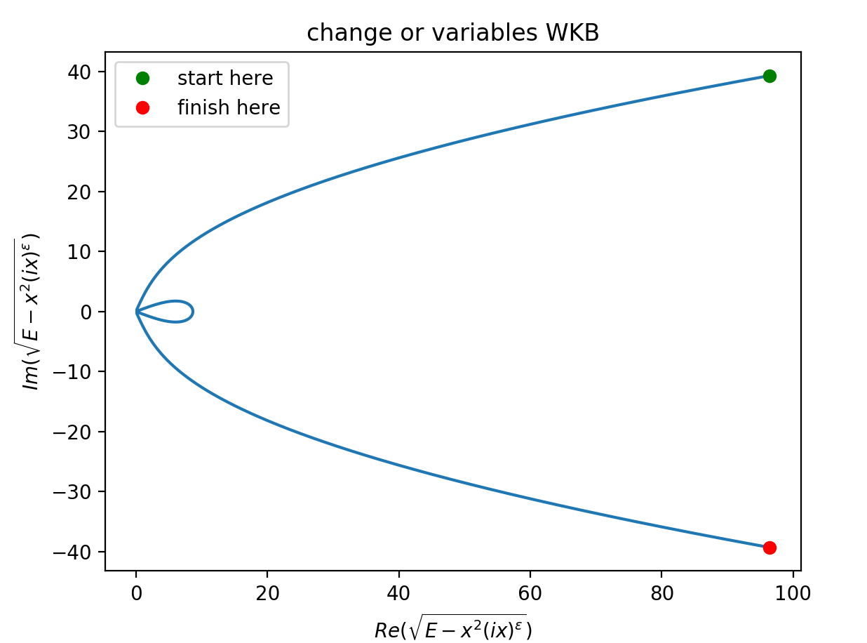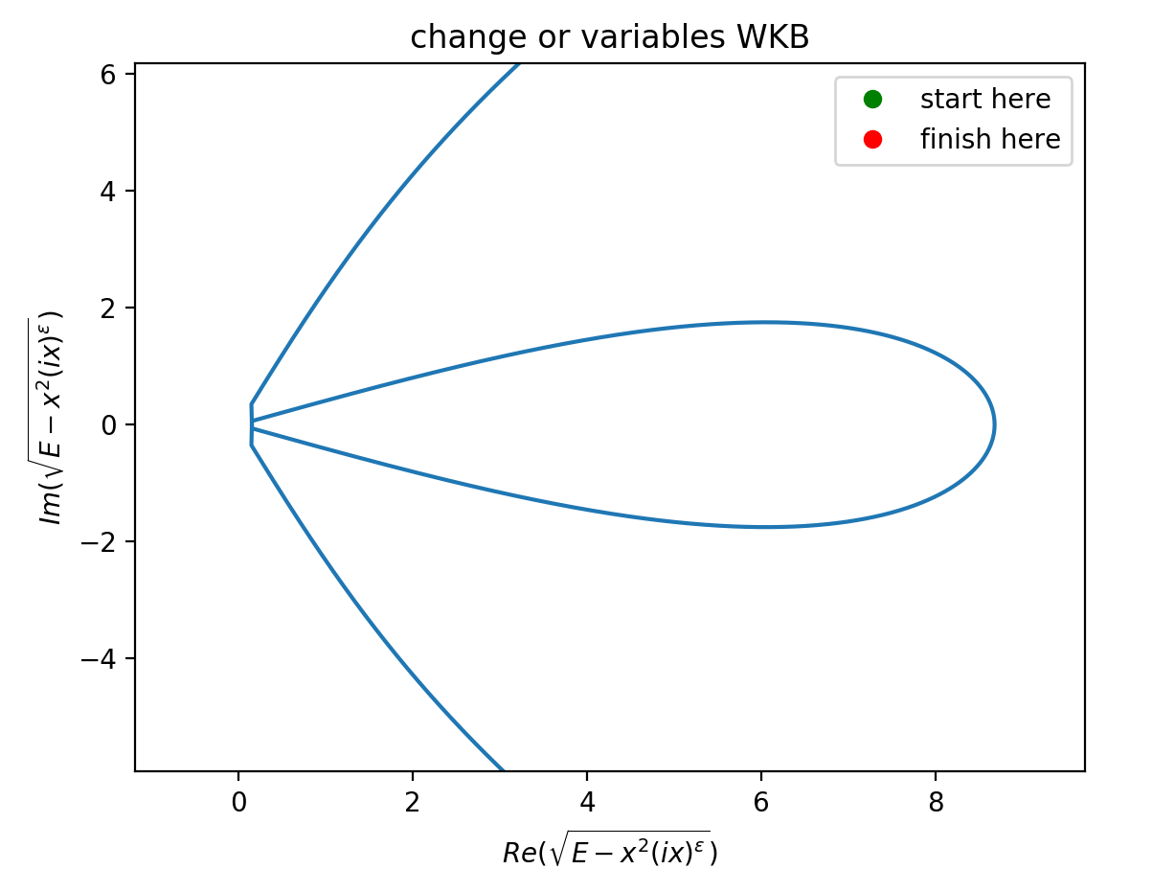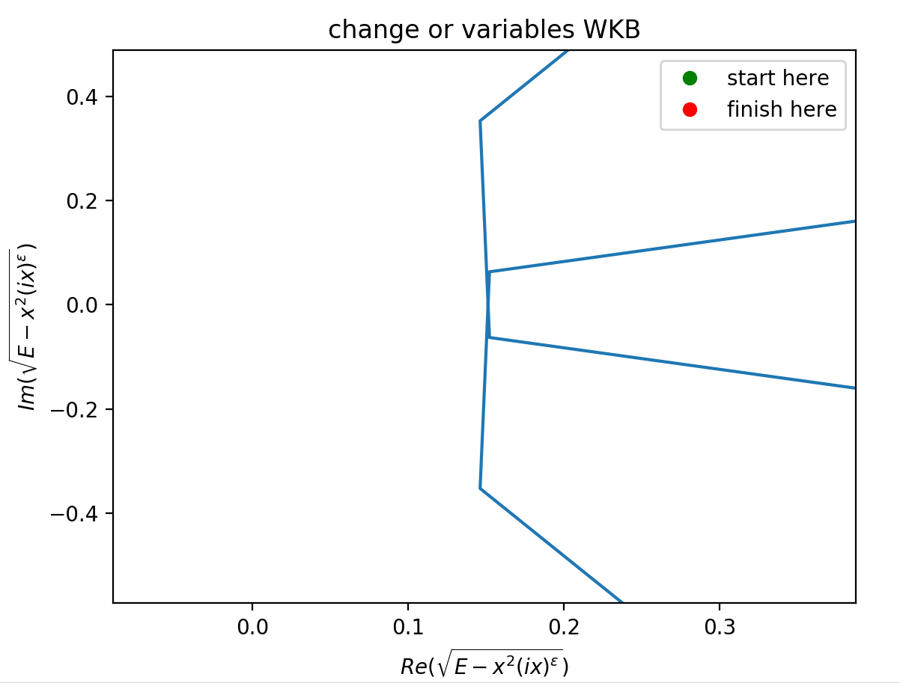

What happens if I change the sign of my offset in the change of variables?

Currently I am using



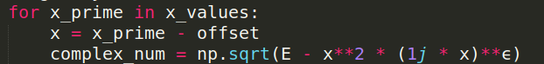

So I’ll change the offset to a positive number

$ϵ$ = 1, n = 0, E0 = 1.1563

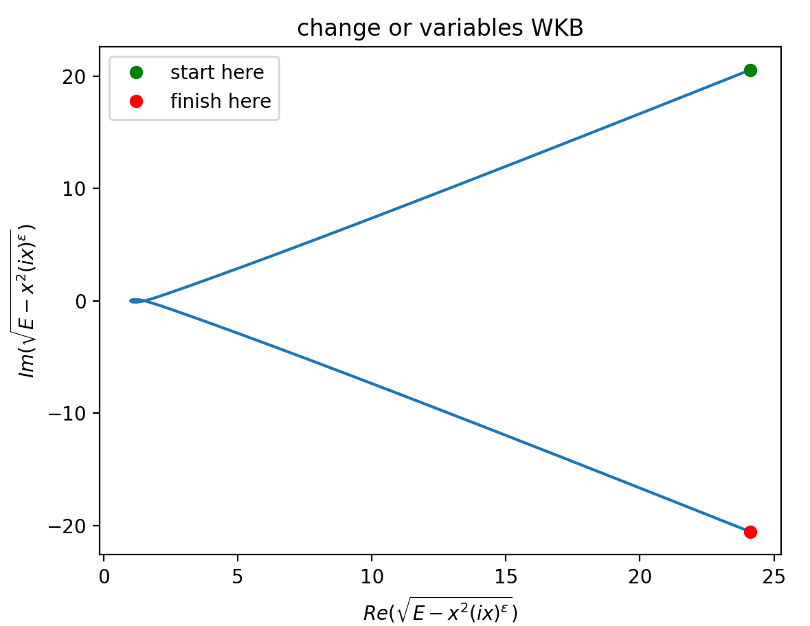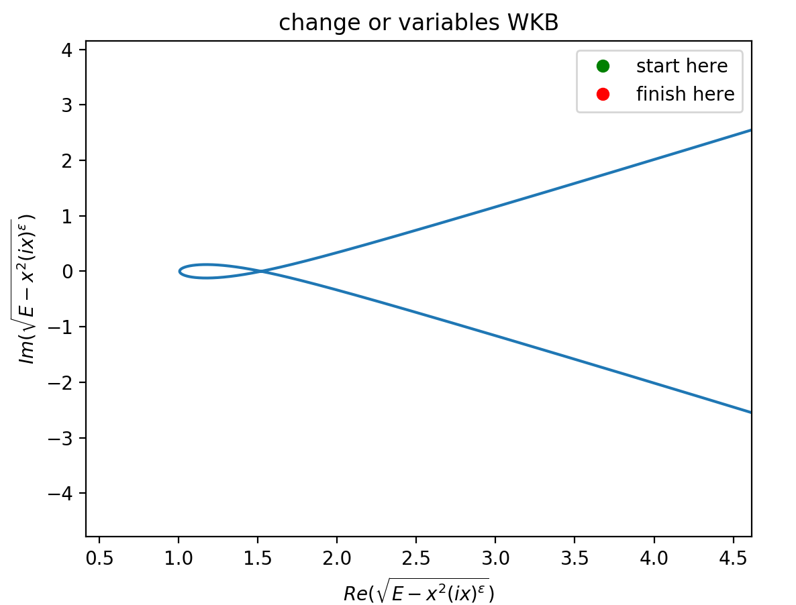

The loop still appears… just by the looks of the plot I suspect that the negative sign offset was closer to the desired result.

I changed the offset once again but this time I used the argument from the $x_{+}$ limit ie:

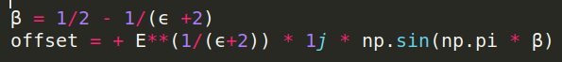

As expected, given the symmetry of the setup, the result from using this argument is very similar to the previous one

$ϵ$ = 1, n = 0, E0 = 1.1563

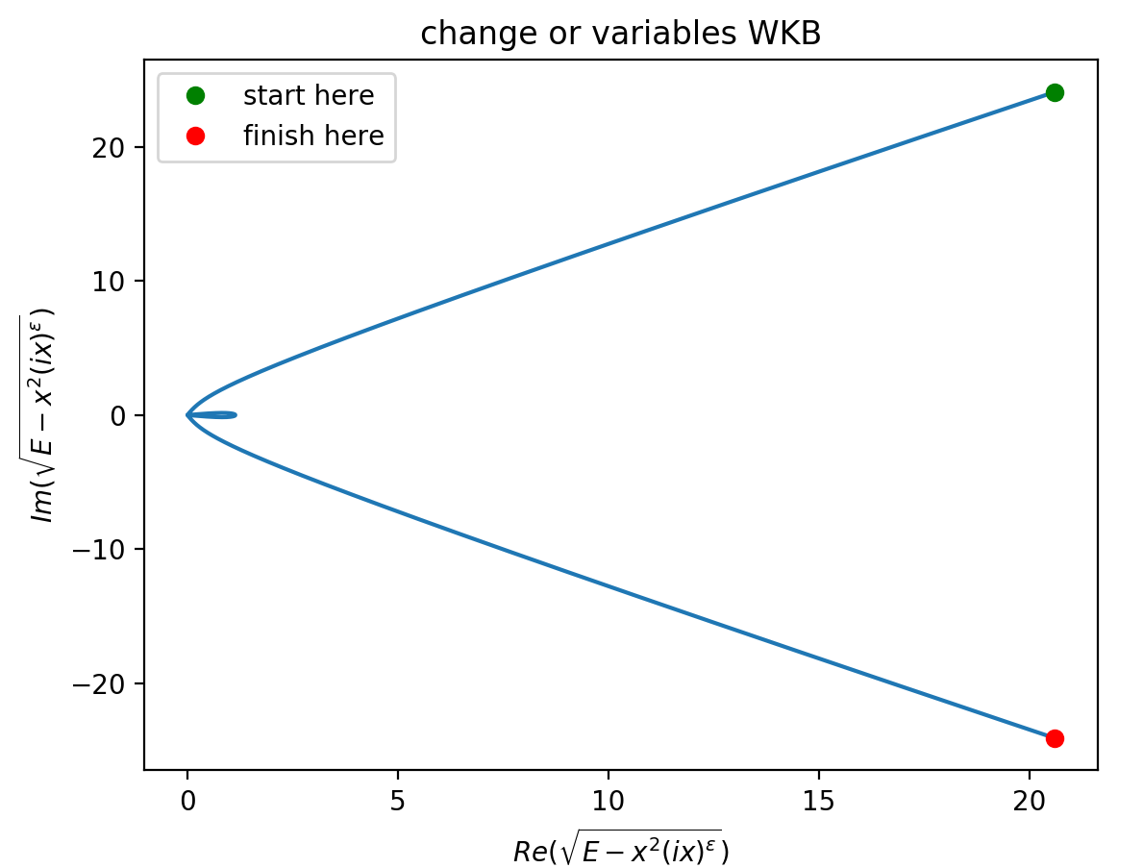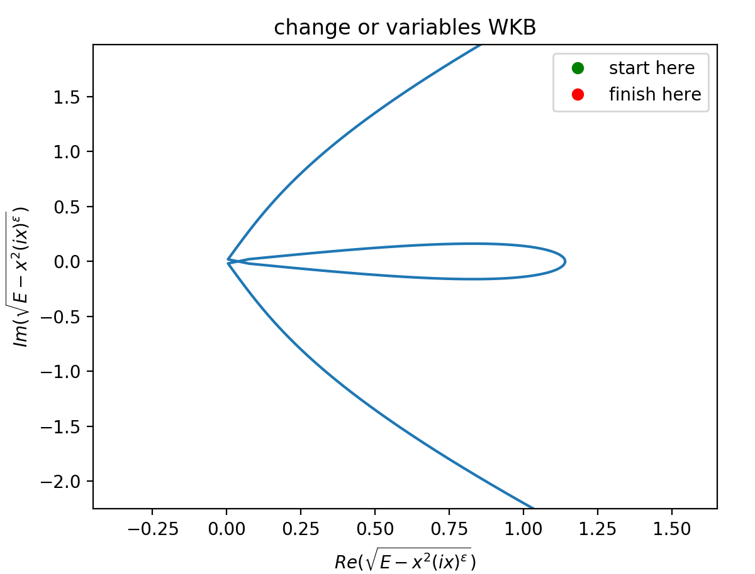

ε = 2, n = 8, E = 60.185767651

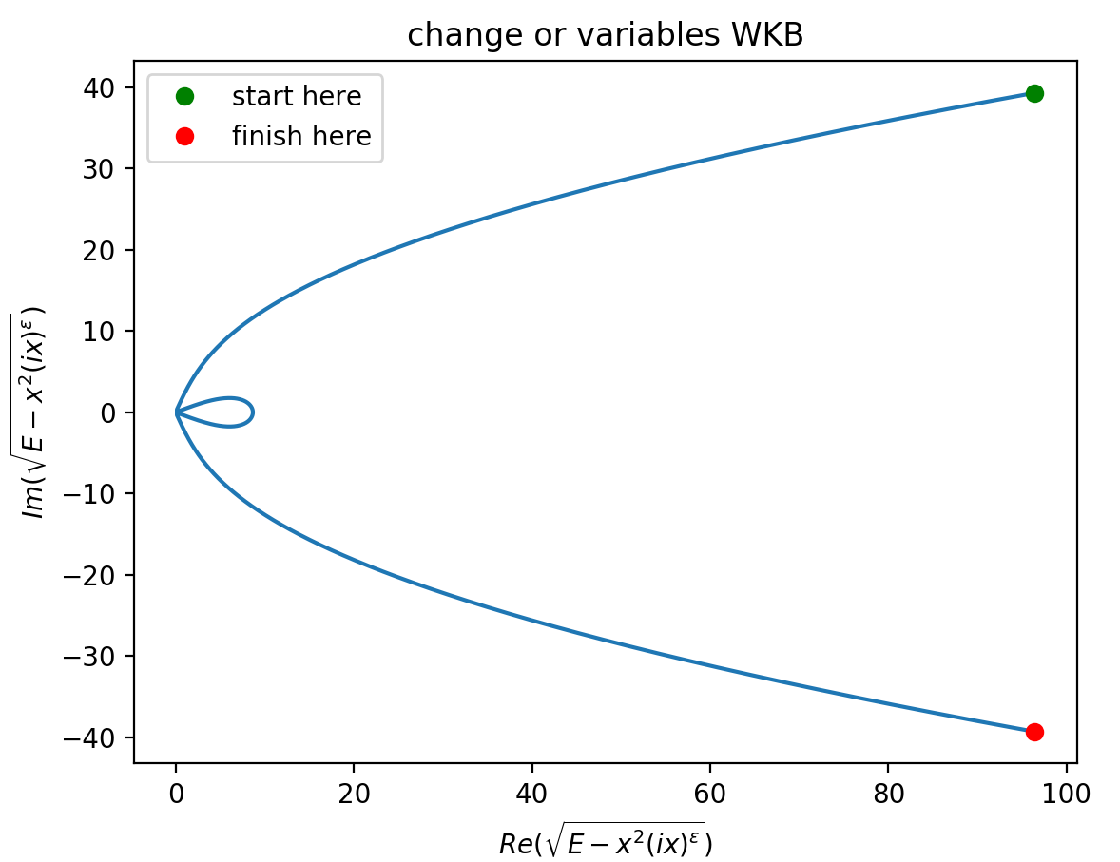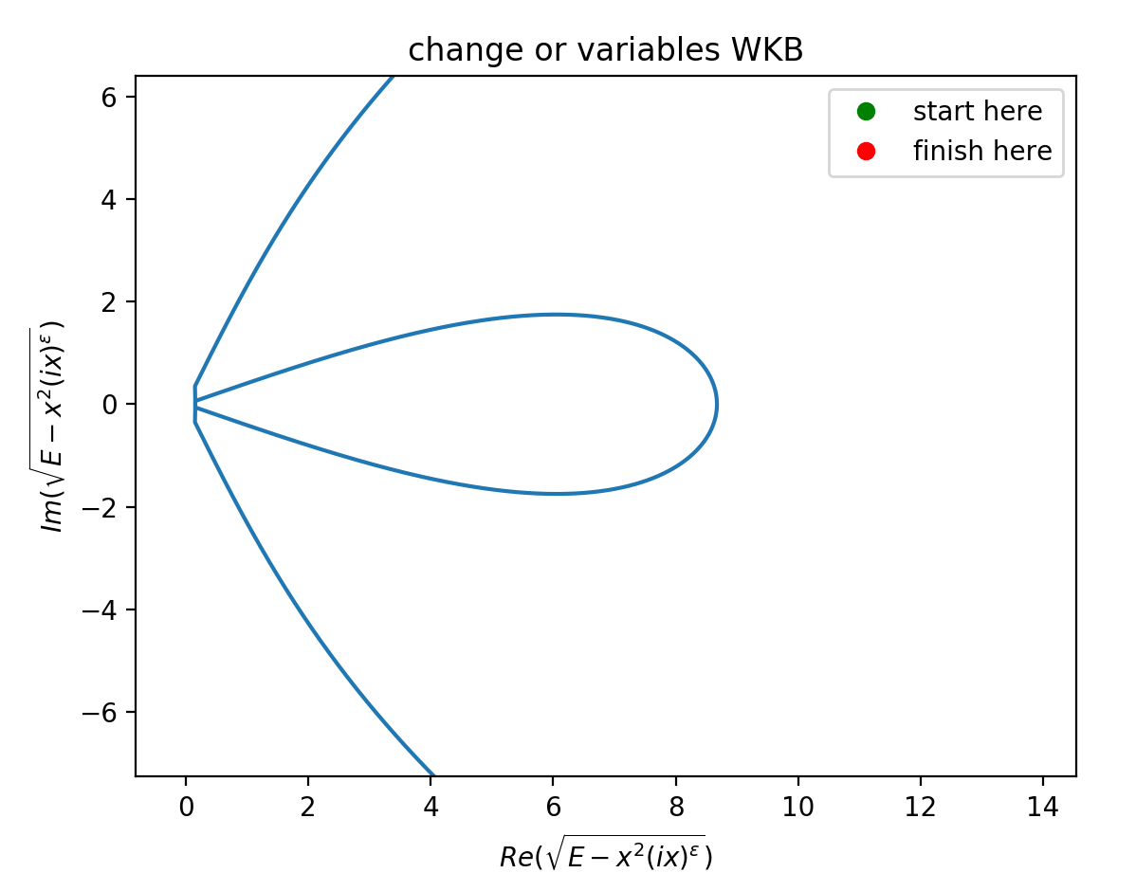

Why is the contour of integration looping near the origin when I do a change of variables? Clearly something subtle is wrong because I cannot find the issue .

Presently, I cannot think of other possible tests to apply to my methodology.   
I must continue onwards and try to understand what is going on in the broken symmetry part of the spectrum.

When I continued reading Bender I found this…

There are several highly accurate numerical techniques for computing the energy spectrum that

is displayed in figure 1. The simplest and most direct method is to integrate the Schrödinger

differential equation (24) using a Runge–Kutta approach. To do so, we convert this complex

differential equation to a system of coupled, real, second-order equations (Bender 962)...

The convergence is most rapid when we integrate along paths located at the centers of the Stokes wedges and

follow these paths out to ∞. We then patch the two solutions in each Stokes wedge together at

the origin.(Bender 963).

Maybe I should follow Meera’s advice and try using Runge-Kutta instead of a change of variables WKB

**I could solve the real and imaginary parts of the equation separately and use the shooting method**

Turns out that I was feeding the wrong linspace object to my function and to Bender’s expression when I was checking the integration contour… in addition I was missing a bunch of i’s in my change of variables(in the integrand and the limits). I assume that this happened because I was writing the analytic expressions that I worked out in paper rather than using the functions provided in python to add and subtract the imaginary offset of my change of variables.

I was also plotting the expression from Bender’s paper wrong because I had shifted my x-values from the complex plane to the real line when that expression

didn't require the transformation of the x-values at all.

I now know that Python doesn't spit out random results from taking the square root! But instead has a sensical method that returns a continuous set of roots.

**Eg.**

**tp_minus = E**(1/(ϵ+2)) * np.exp(np.pi * (3/2 - (1/(ϵ+2)))) vs tp_minus = E**(1/(ϵ+2)) * np.exp(1j * np.pi * (3/2 - (1/(ϵ+2))))**

**I have the corrected code and below the code snippet I show the plot that results from Bender’s expression and from my change of variables**

#### 

|  |  |
| --- | --- |
| Bender’s expression  ϵ = 1, E0 = 1.1563 | Change of variables expression  ϵ = 1, E0 = 1.1563 |

WOOHOO! Victory! The plots are identical and I don’t see any sort of branching behaviour in the contour.

I should check if my bug fixes help with my integration issues.

I wrote the following globals, and corrected the integrand function (which was missing a factor of i on the offset) for the following test

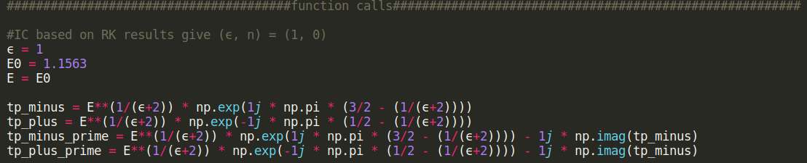

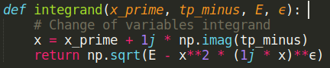

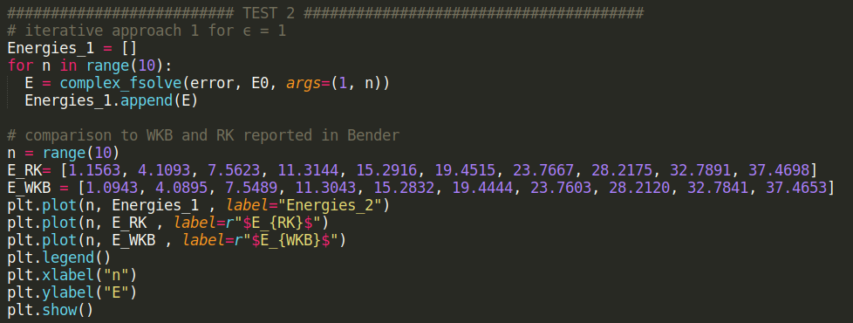

Output:

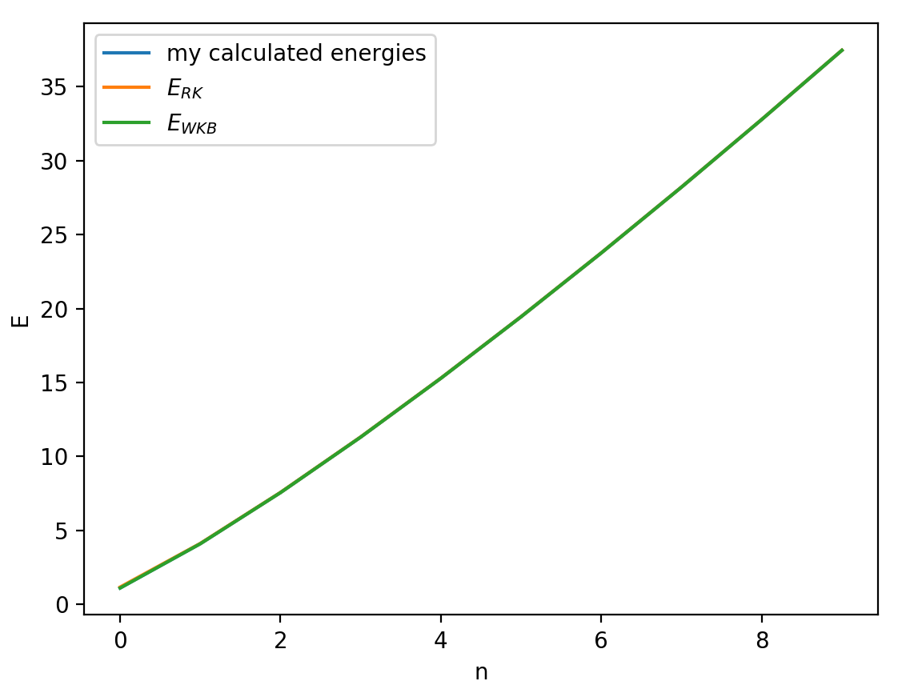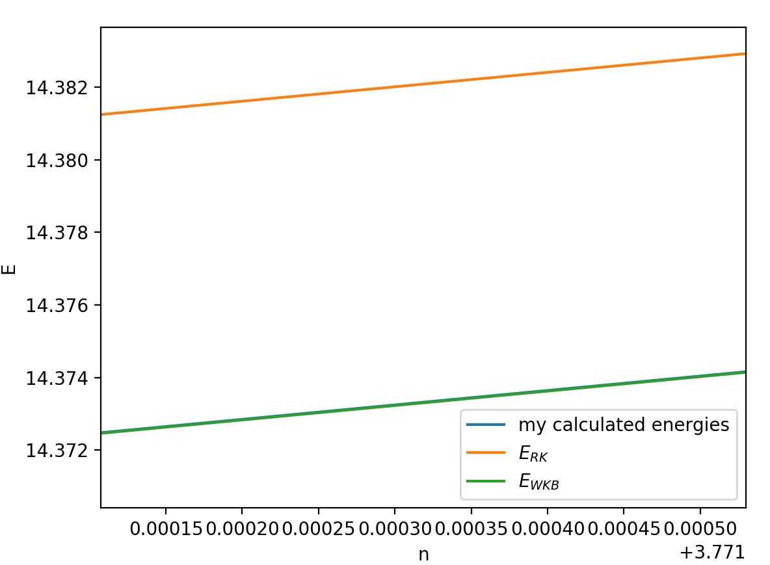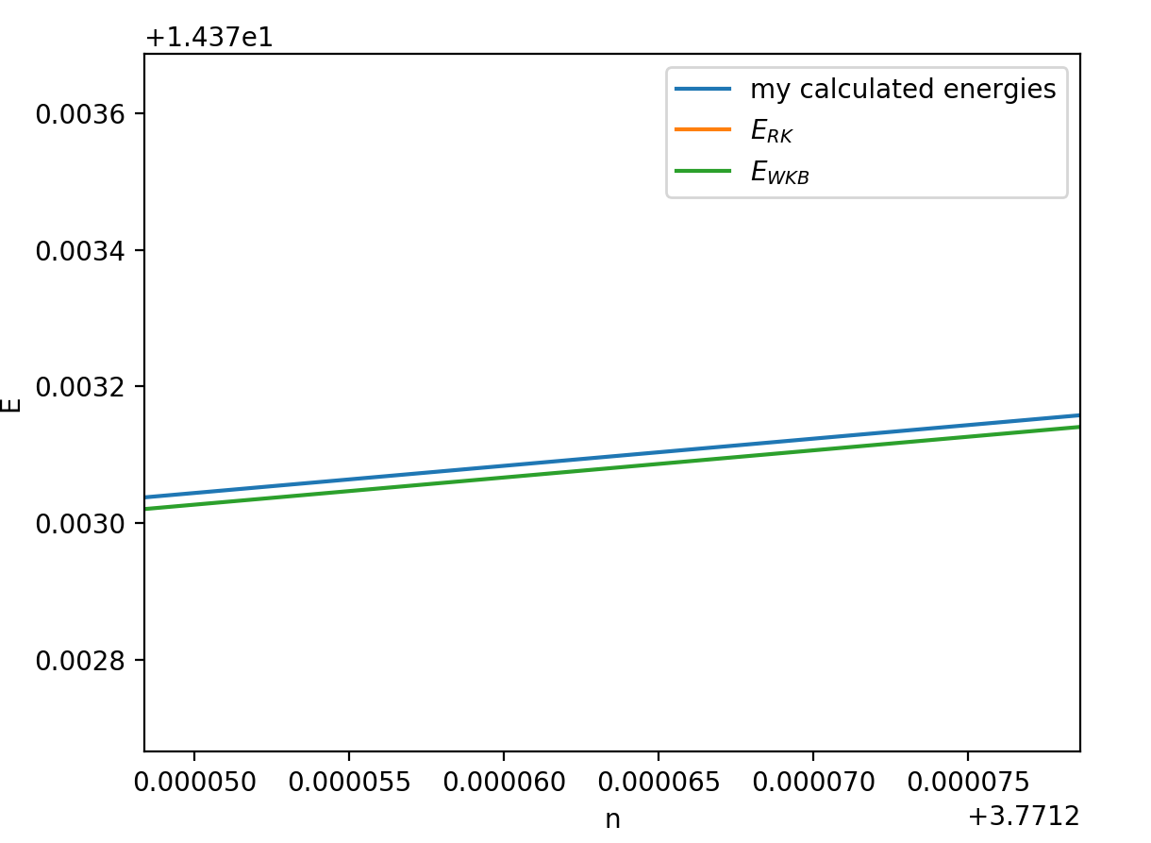

I have near perfect agreement with the values reported in Bender for ($ϵ=1$).  
 This means that my WKB method works! And also that the unbroken symmetry part of the spectrum is now correct!

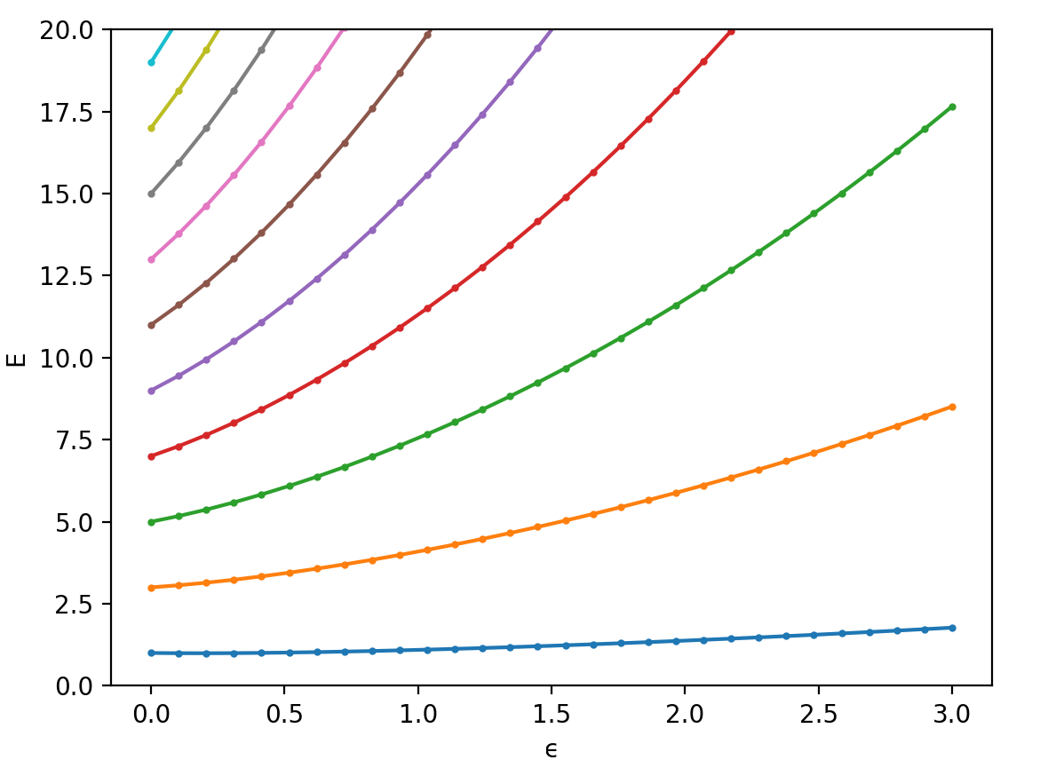

21/04/21

I suspect that the way to go with trying to plot the broken symmetry part of the spectrum is going to be using Runge-Kutta. I haven’t found any other mention of the methodology used by Bender for this sector of the spectrum.

23/04/21

#### Plotting Figure 1 with Runge-Kutta

To integrate the complex Schrödinger equation

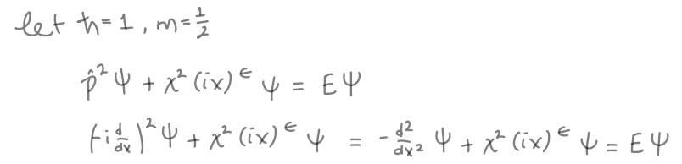

using a Runge–Kutta approach. I must convert the complex equation to a system of coupled, real, second-order equations. I don’t know when I exactly this needs to occur because to solve the equation in the first place I need ICs and BCs and I am unsure on how to obtain these.  
First, I need to find my ICs to feed into the RK method, to find these I need to use an asymptotic solution, But I don’t know that this will work.

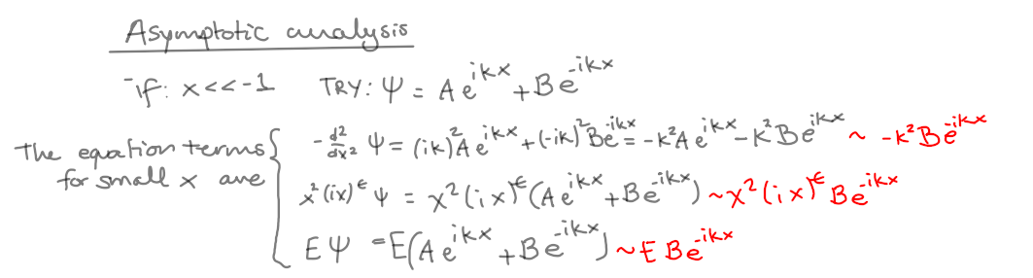

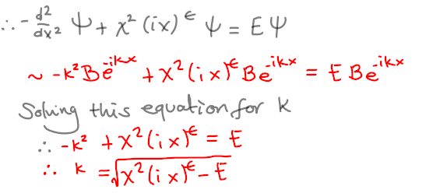

I would have to choose the correct k so that I obtain a IC wavefunction

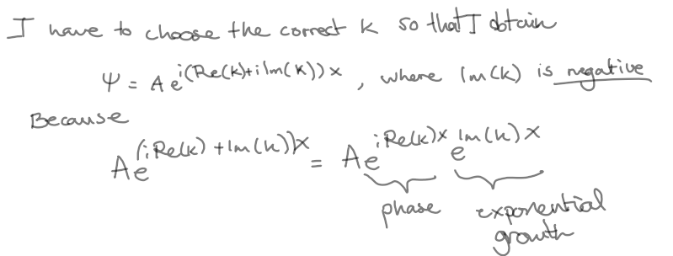

#### 

**This is a lucky first result… (find_k gave me the answer I wanted randomly yay)**

Solving theSchrödinger equation requires that I recasut the 2nd order ODE into a first order vector system. The thing is that the system is still complex here so I am not sure when I need to split it into 2 real coupled equations.

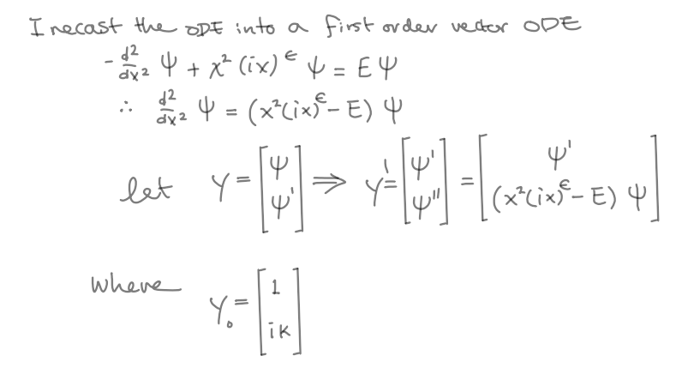

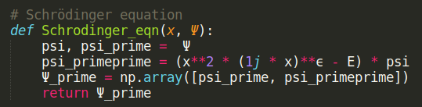

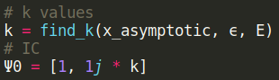

24/04/21  
I am having a hard time conceptualising the use of Runge Kutta and eventually solving the Schrödinger equation. I am finding it tricky because my equation is complex valued, so I am unsure of the order and process by which I should separate real and imaginary parts to solve the equation.

## Week 8 (26/04/21 – 02/05/21)

Aims:

1. Reproduce Fig 1 in Bender
2. **Understand how is it that complex eigenstates of NH systems are not orthogonal**
   1. Maybe something to do with Bi-orthogonality?
3. Simulate a RF-CAP

Tasks:

1. ~~Continue TESTS fig 1 in Bender (unbroken symmetry sector)~~
2. **~~FIND OUT HOW TO PLOT THE BROKEN SYMMETRY SECTOR OF THE SPECTRUM IN FIG 1.~~**

**HOW TO SEPARATE MY EQUATION INTO TWO COUPLED EQUATIONS?**

1. Continue Gao’s Hamiltonian analysis (using Benders methodology)
2. ~~START progress report Due: Friday 7th May (week 9)~~

26/04/21

#### Plotting Figure 1 with Runge-Kutta (continued)

So, I’ve been thinking about it quite a bit and I am currently building a shooting method that uses Runge Kutta to find the solution to the Schrödinger equation. The issue with the complex Hamiltonian remains though, I am unsure if this method will work at all.  
 This is a photo of my whiteboard:

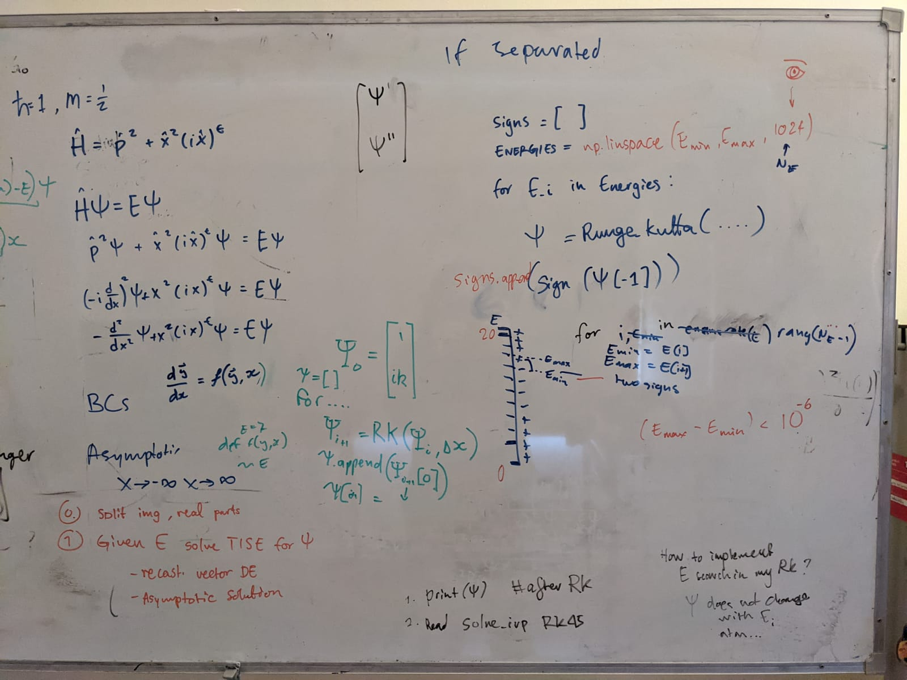

Another aspect of this problem that I am unsure about is which BCs I will use to fully solve the Schrödinger equation.  
Currently this is my Schrödinger equation and Runge_Kutta, after I implemented a changing E value as input (for the shooting method):

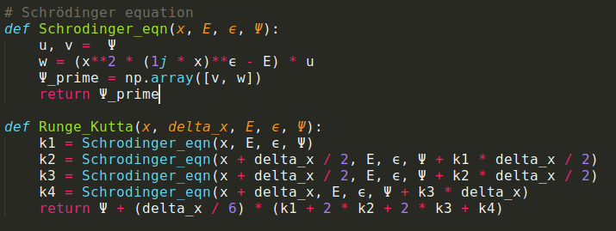

27/04/21

#### Shooting method

**The shooting method solves the TISE using Runge_Kutta and tries different values of E until we find one that causes the wavefunction to not blow up at large x. Hence finding a viable solution to the TISE (Bound state).**

**The ODE setup:**

Since our equation is second order, we recast the ODE into a first order vector equation.   
 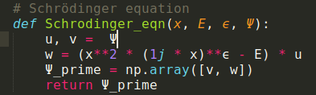  
**The ODE solver:**

The cool thing about the shooting method is that once we have integrated over all x for a specific E_i value in the range we tell the computer to only "care" about the behaviour of the solution at our upper integration limit for x: **x_max**.

Since the bound states remain small (zero) at x_max, then by the **intermediate value theorem (IVT)** the binding energies will be found between the energies of "solutions" that "blow-up" at x_max (blow-up positively and negatively).

The algorithm requires that we keep track of:

-the sign of each solution: psi(x_max)

-the energy of psi(x_max)

We can store these in 2 separate lists of the same size. (A signs list and an Energies list).

We are trying to find the eigenenergy of a solution to the ODE given a (currently complex) potential

The **steps** are as follows:

1. Using the whole energy range of the potential (this is a first guess of the range where a bound state is to be found).
   1. The bounds I used for this step are E_lower = 0 and E_upper = 20 ( both boundaries are set to be dimensionless from the TISE)
   2. I discretise the range E from E_lower to E_upper in n evenly spaced steps.
2. Using this first E range I solve the ODE (iteratively: for each E value in the range) by integrating for all x.
3. After the first run at solving the ODE I tell the computer to read the list of signs and notice the index where there is a change in sign (from positive to negative or vice versa).
4. I make the computer extract the corresponding (indexed) pairs of values from the Energies list and make them into a couple of upper and lower bounds to be checked:  
   [E_lower, E_uppper], since we know by the **IVT** that there is a bound statw between each of these pairs of energy values.
5. Since I have found all the subsets of energy bounds for the bound states we have to iteratively scan each subset.
   1. What we do here is unpack each of these lists **[E_lower, E_upper]**
   2. Define a midpoint between them: **E_mid = E_mid = (E_lower + E_upper) / 2**
   3. use **E_mid** to solve the ODE (once again for all x)
6. Just like before, we will have to keep track of the sign of the solutions at x_max.
7. This time we will compare these signs to the sign of the solution corresponding to E_lower and E_upper.
   1. IF the signs of these new solutions matches either of the signs corresponding to the solutions we had recorded
   2. THEN we set E_mid to either a new E_lower OR E_upper

This allows me to resume the search in a smaller range of energies.

In my code:

w[-1] is the solution to the ODE at x_max and sign_lower is the sign of the solution with energy E_lower (from our previous solver step).

THE CONDITIONAL STATEMENT for redefining our bounds and iteratively do the search is:

if np.sign(w[-1]) == sign_lower:

E_lower = E_mid

else:

E_upper = E_mid

In order to end the loop we define an arbitrary condition for the distance between E_upper and E_lower(ie. abs(E_upper - E_lower) > 1e-12 * meV)

Once this condition is not satisfied the Iterative search will end and we will have obtained a pretty accurate value for the **binding energy.**

**My problems with the complex valued function occur from step 3.   
How do I decide which is the sign?**

**Let’s try something  
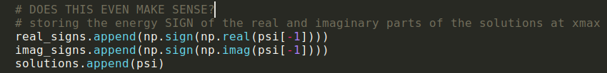  
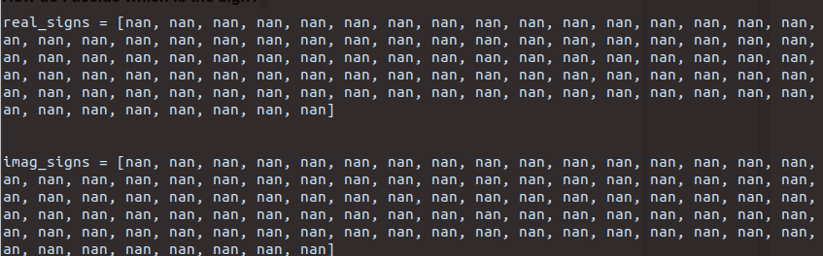**

Clearly the concept of the sign of a complex number is not actually meaningful.

I think I need to re imagine the shooting method…

28/04/21

MEETING DAY!

#### Modifying the shooting method

I talked to Chris about my issues (it always impresses me how many ideas he comes up with :) ) and he suggested a cool idea  
If I understood correctly… This is the strategy:

Starting with the whole energy range, I could use the mod squared (always positive) of 3 adjacent states (adjacent energy values).

1. I would still use Runge_Kutta to “evolve” the state in space as I am already doing.
2. I then store the value of the mod squared state at **x_max** in a list.
3. Then I would compare these values between any 3 adjacent states and aim to find a state such that:  
   IF the the mod squared of the state between the 2 other states is less than both the mod squared values of the 2 other states  
   THEN I would have found a bound state!

I should probably find a good optimization algorithm to find minima because i am finding minima

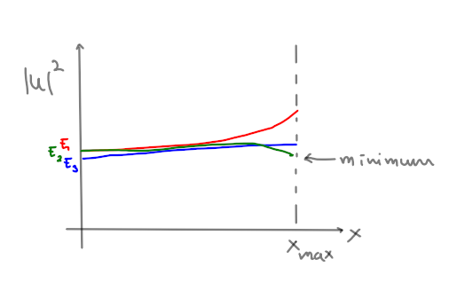

This is a plot of 3 of the mod square states I’ve calculated so far… they all blow up!

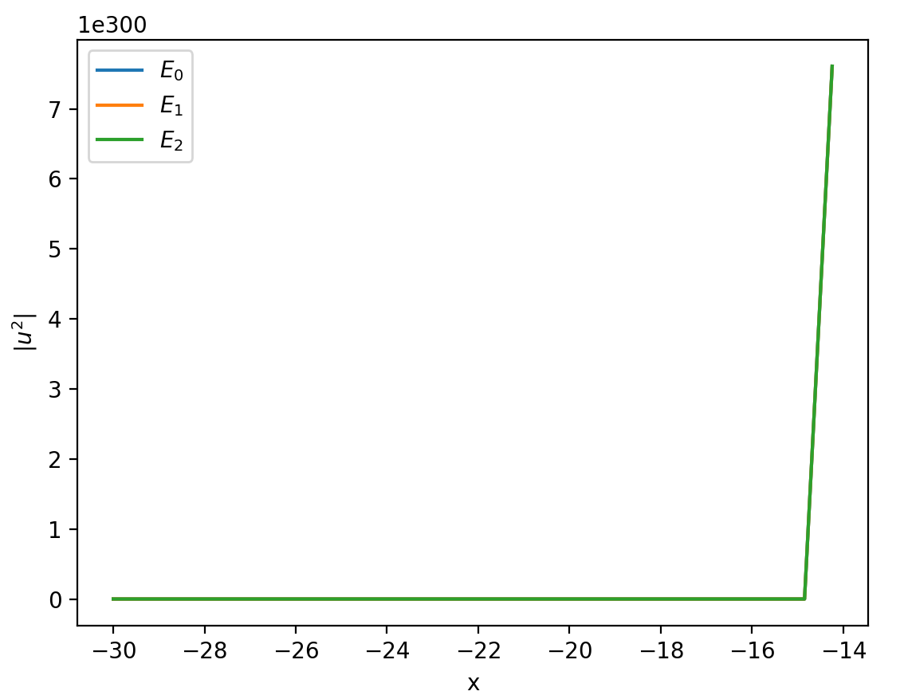

When I try to store the value of each of the mod square states at x_max I get nan values.   
because the numbers are too large to be dealt with by the computer.

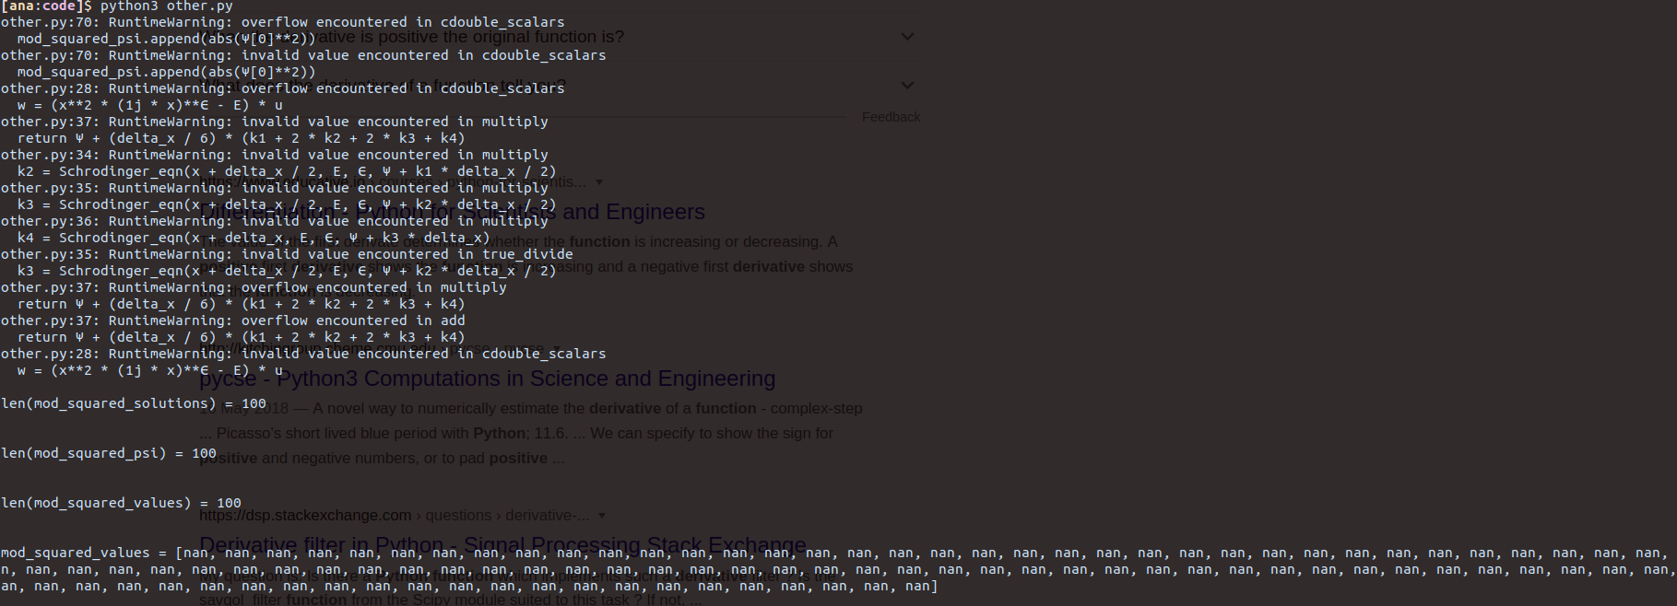  
I need to find a way to “clip” the states after they reach a certain arbitrarily large value, but at the same time I want to be able to preserve the ordering of the states

I am trying this:   
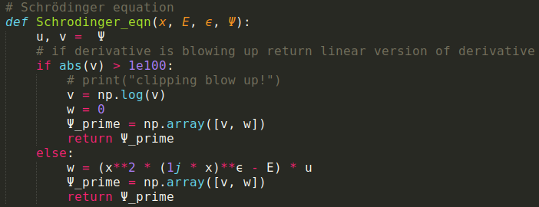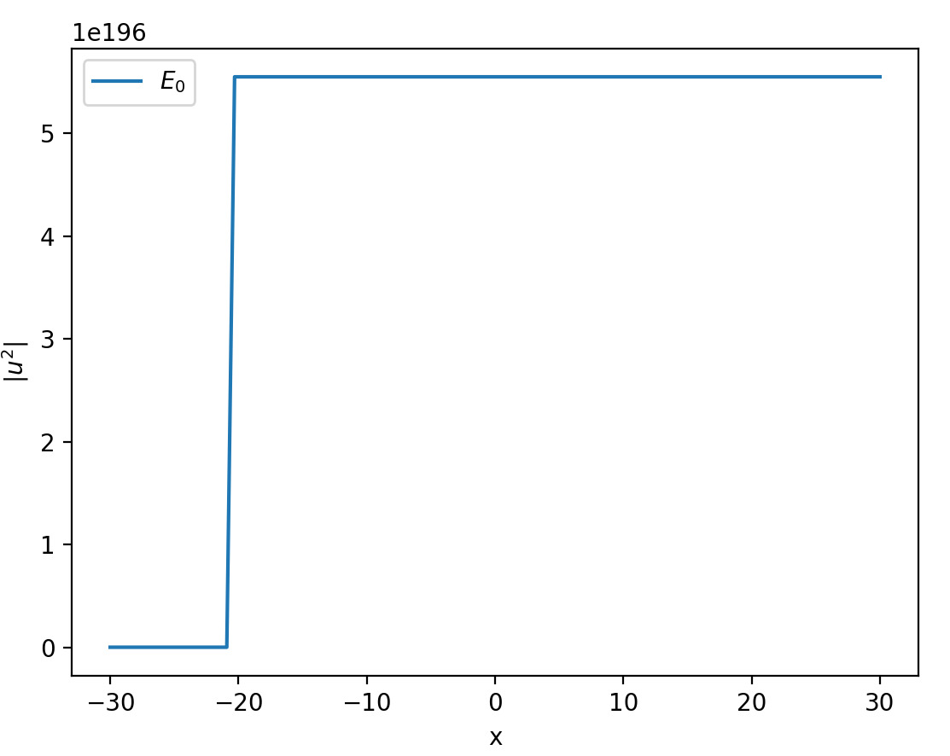

Which decreases the blow up but doesn’t work in the way I expected. I guess the log function could also give me trouble later.  
Chris gave me this code snippet:

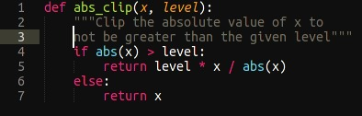

I think that it makes sense to simply scale down the states rather than change their shape and possibly create discontinuities.

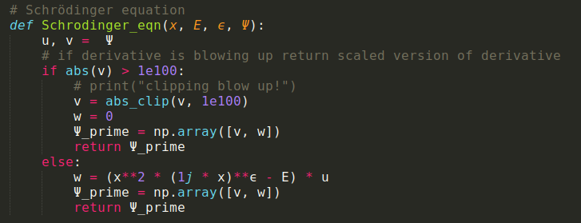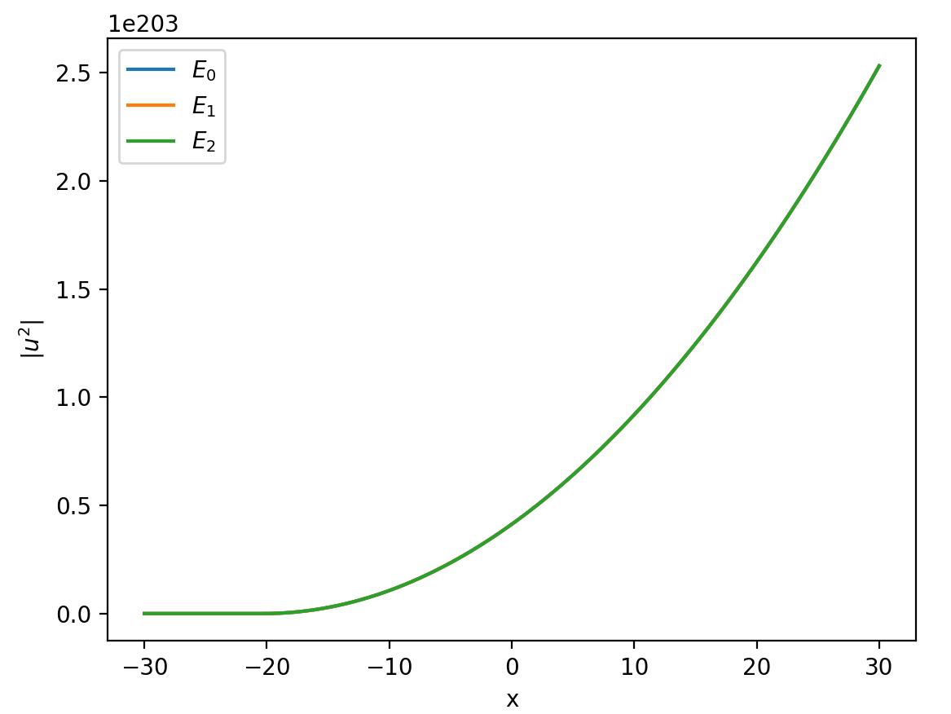

When I change a little of the redundancy conditions in the Schrödinger equation, I obtain this result:

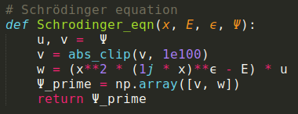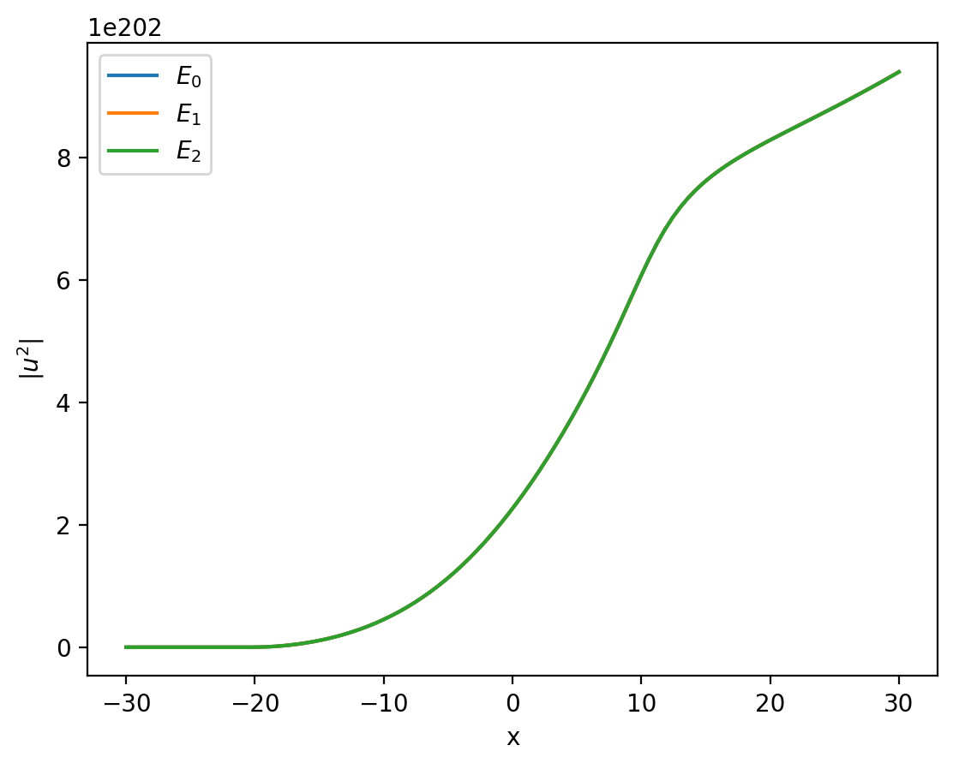

I am confused about implementing the clipping of the states. I can see that the functions blow up before even getting to x = 0  
This is tricky... because if I scale the whole wavefunction down that will mess up my comparison of wavefunctions at x_max, since they will have been scaled possibly a different number of times each!

UGH! This method is probably not going to work out..

#### post-meeting notes:

Chatting to J&M today was great!  
They suggested a method to split my Schrödinger equation into two coupled equations.  
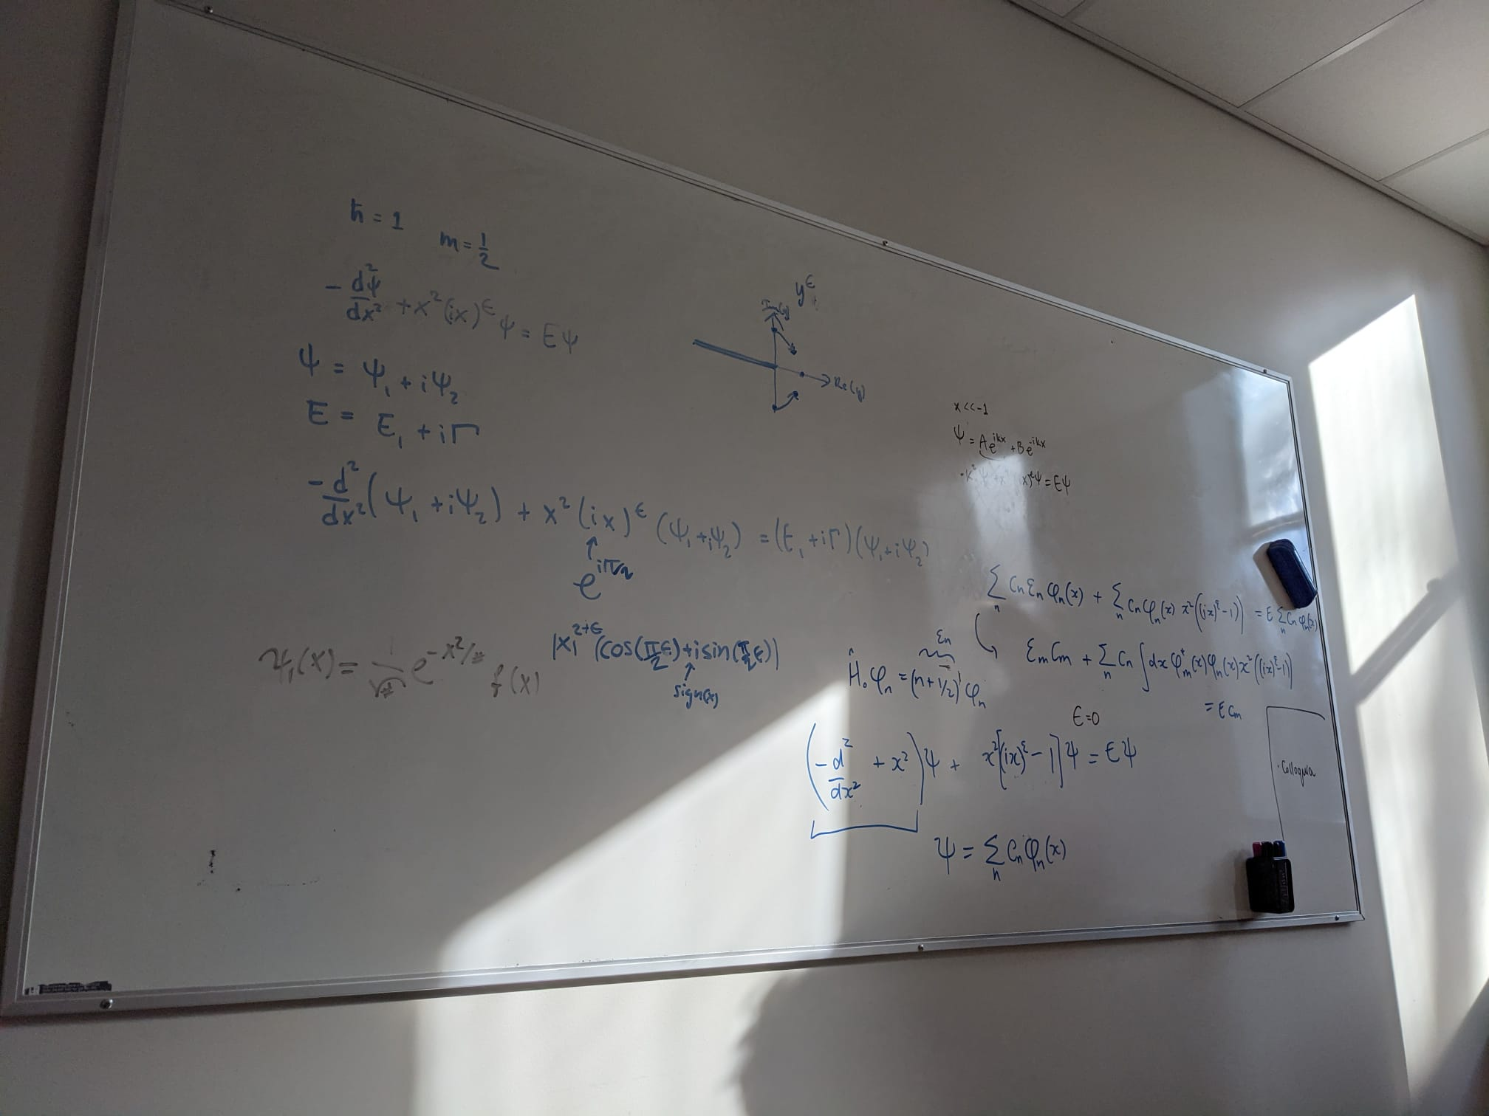

They said that I should write i as $e^{iΠ/2}$ and to pay special attention to the value of x and its sign.  
Another thing they said was to reconsider my asymptotic solution. They suggested to use the Harmonic oscillator case as the ICS  
I tried separating the equations into Real and Imaginary parts but I was not able to decouple the energy terms (real and imaginary)  
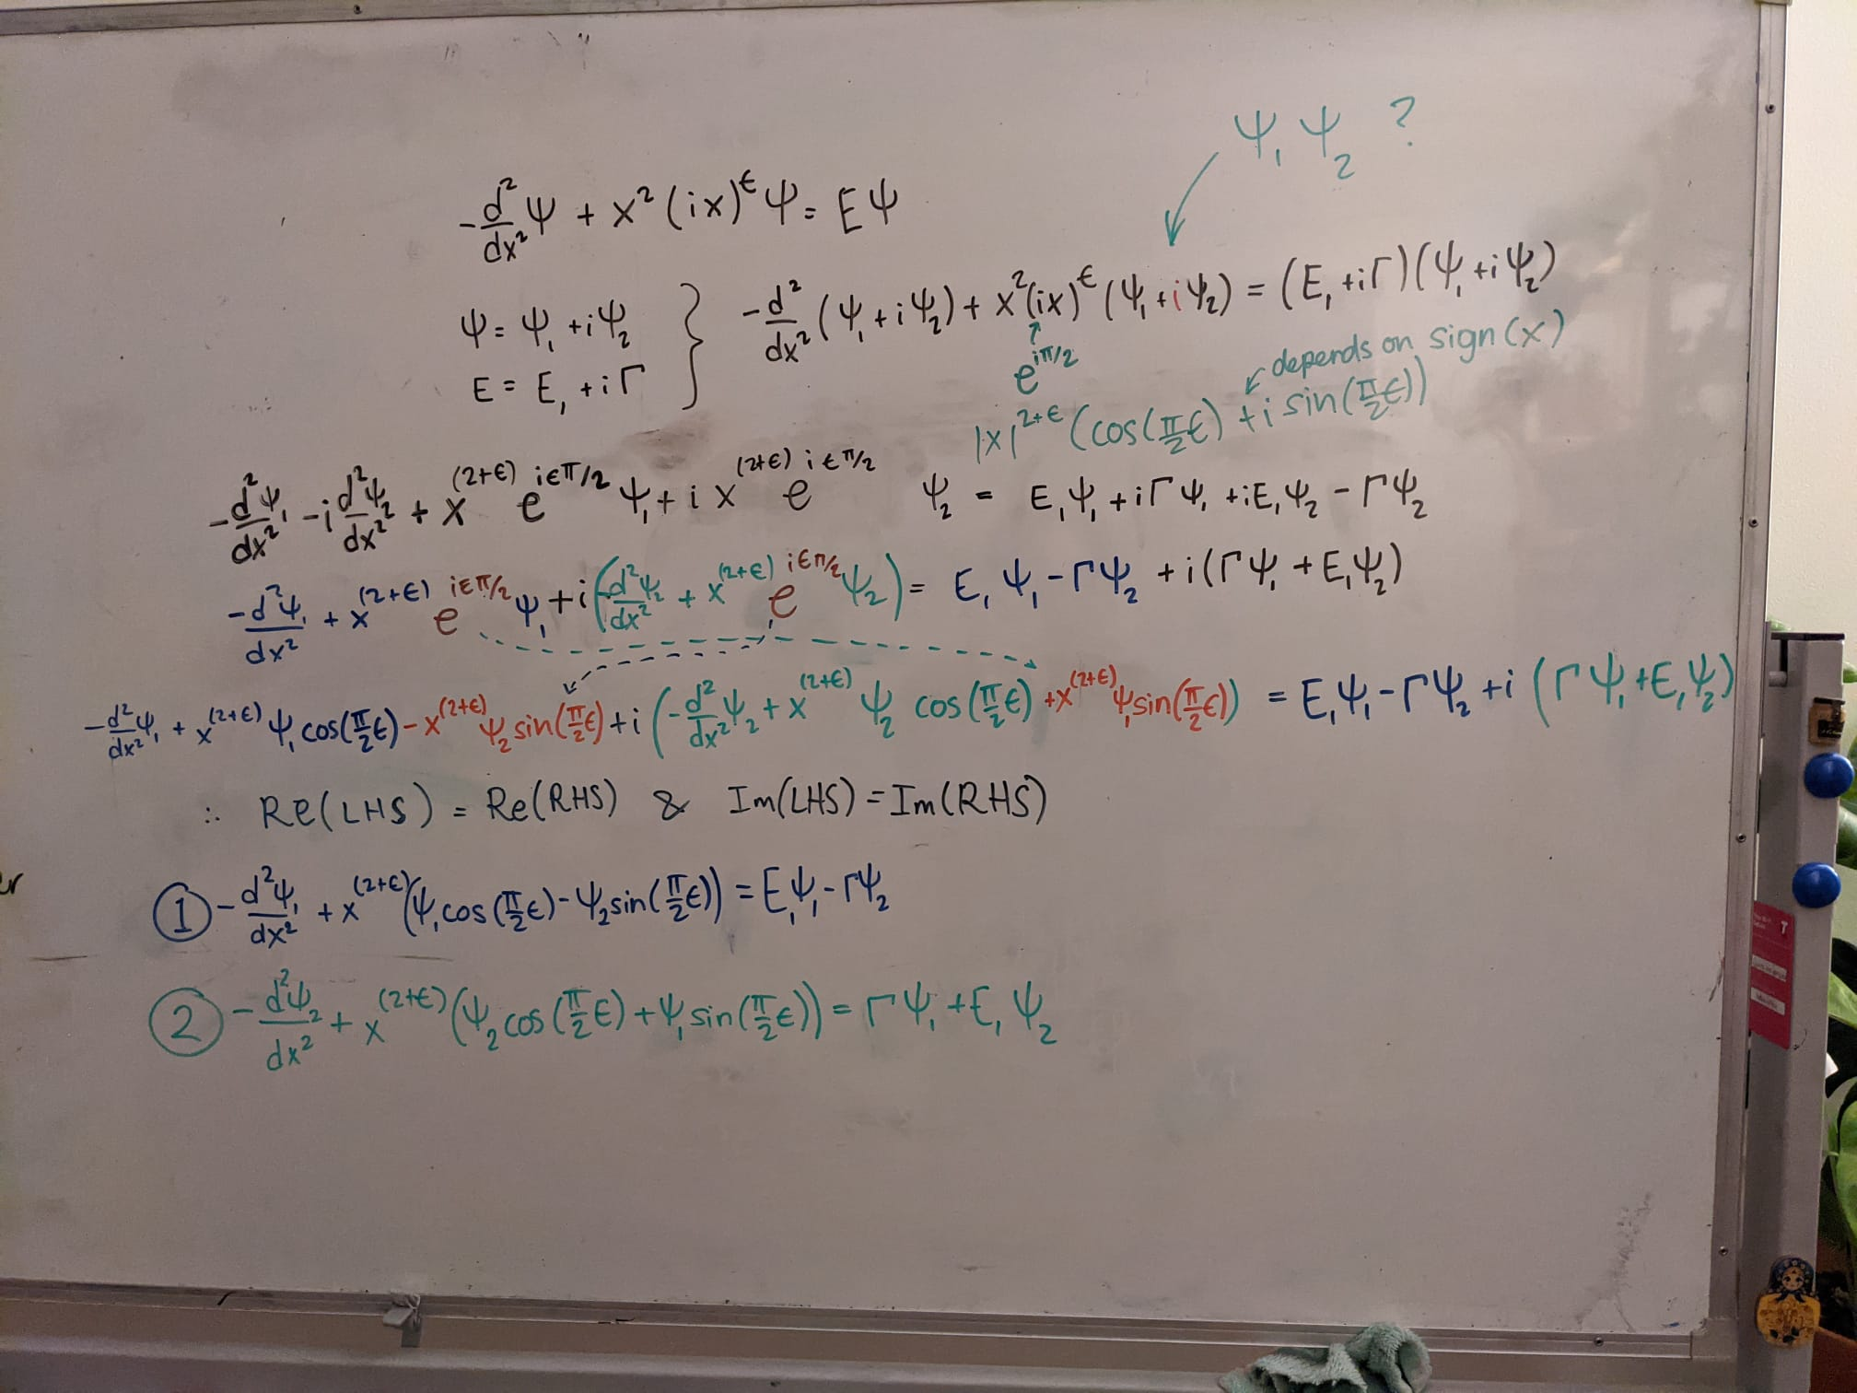

I went through this a couple of times and always got the same result.

Maybe this method is not actually what I need because I would have expected the $E_{1}$ and the $Γ$ values to be completely separate.

I wonder if I could use some kind alternative version of separation of variables?  
This is one separation of variables:

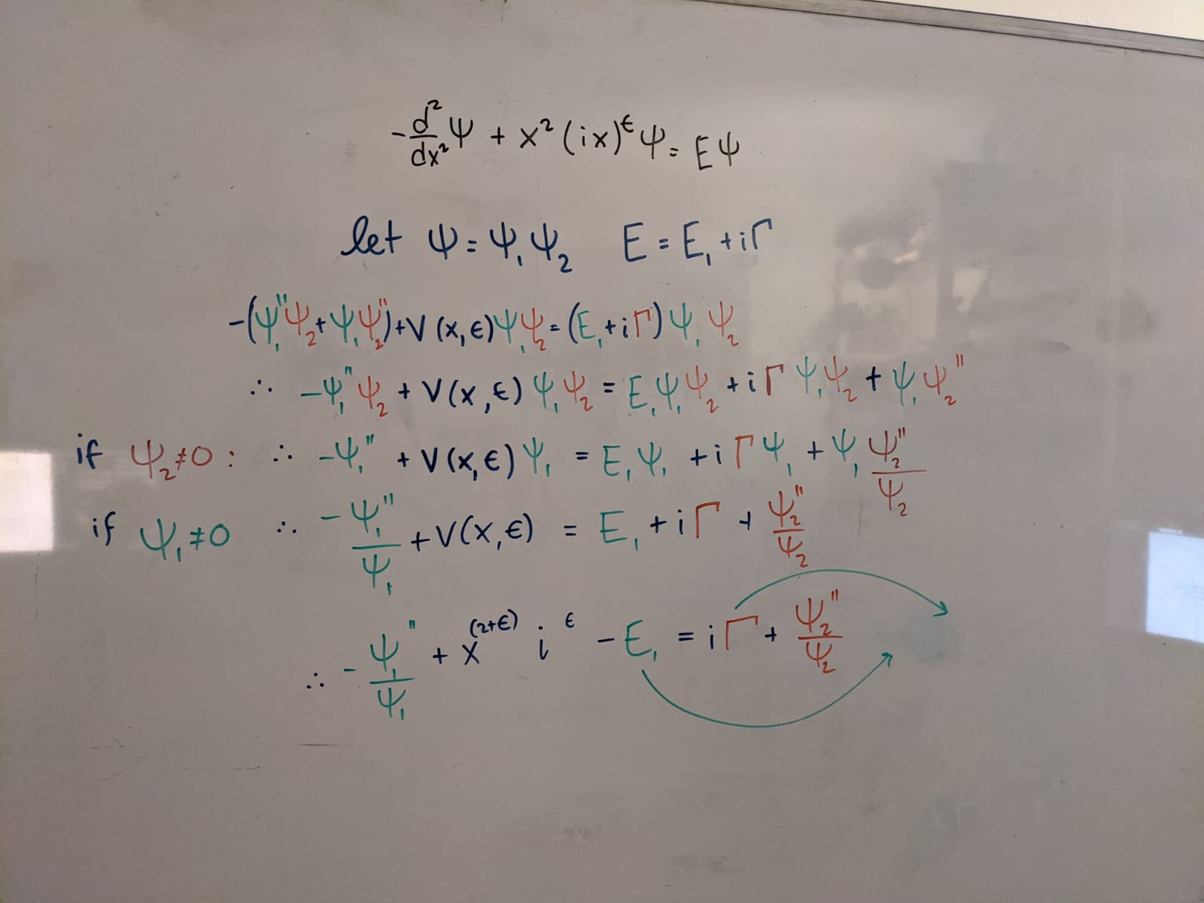

The equations should be set equal to a constant. But then what happens to the energy terms? Do they absorb the constant?

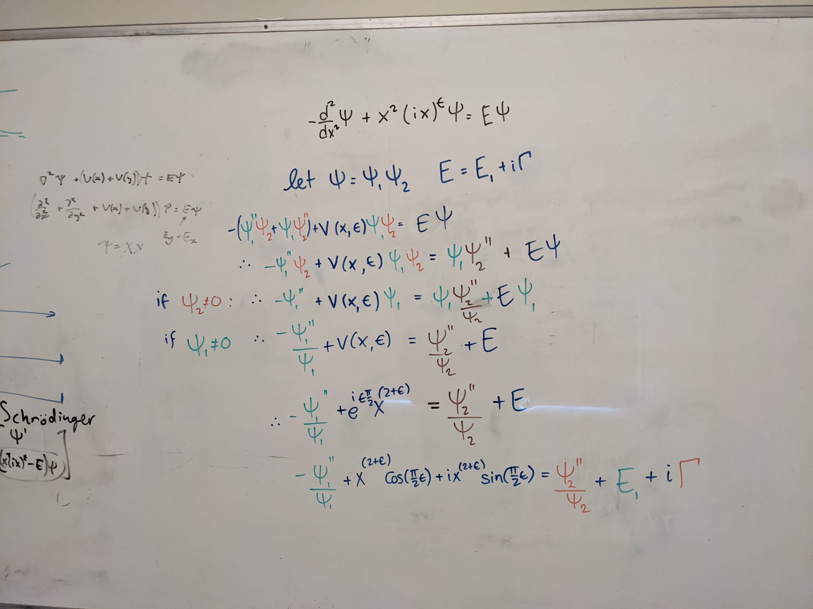

30/04/21

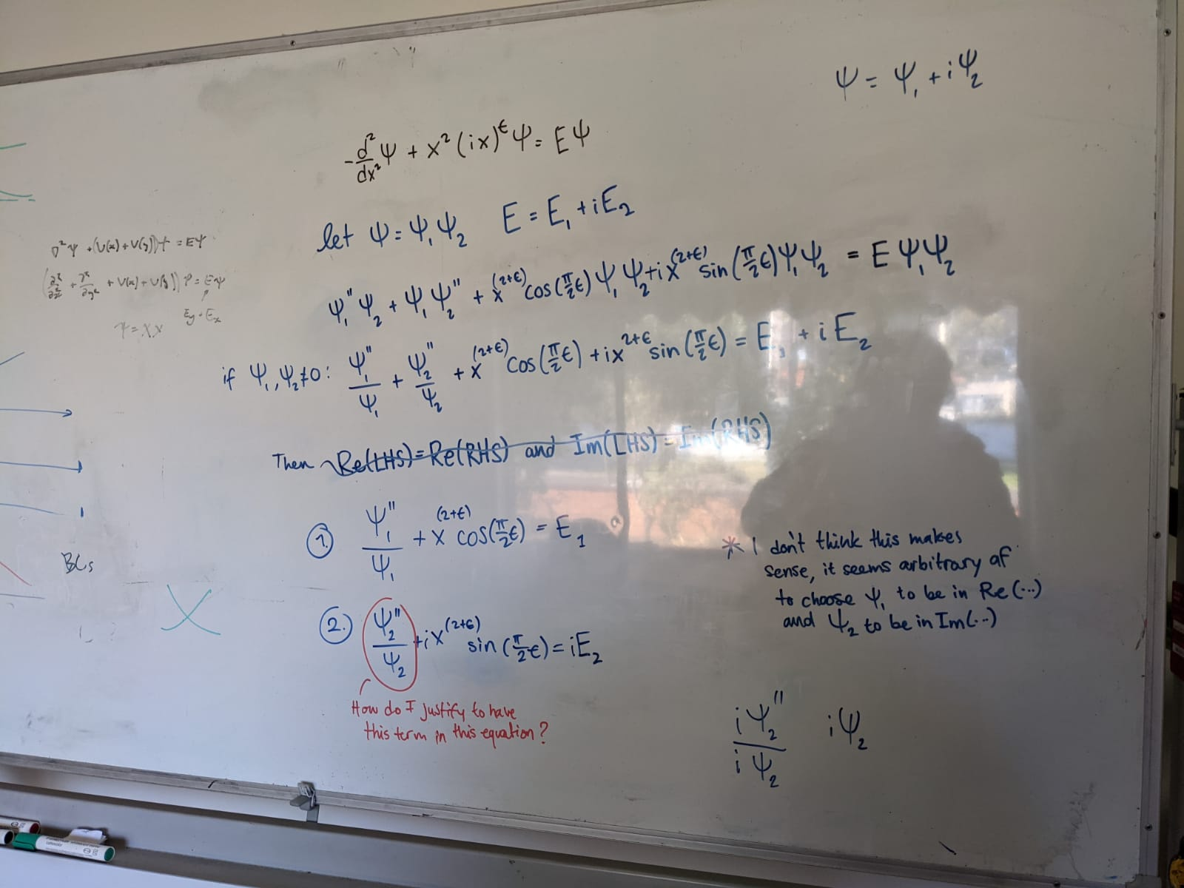

|  |  |
| --- | --- |
| Could I simply separate my equations based on the correspondence between $ψ_{1 }$, $E_{1}$ and $ψ_{2 }$ and $E_{2}$? Without having to separate them based on realness and imaginaryness?  In the last two lines of this whiteboard work I have 2 solutions that if added could perhaps provide a solution to the original equation. |  |

01/05/21

I asked J&M about my current issue and Jesper replied with this:

“...maybe think about it as a matrix equation: {{H11, H12},{H21,H22}}{psi1,psi2}-Gamma{{0,-1},{1,0}}{psi1,psi2}=E{psi1,psi2}. Now E is an eigenvalue. If you do the expansion in terms of N harmonic oscillator functions, then you will have a 2N x 2N matrix equation that needs to be solved. You will probably need to choose a value of both epsilon and Gamma and solve for E...”

#### Notes from Ashida

Hermitian Matrices (M) satisfy **NORMALITY**:

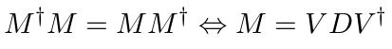

with D and V being the diagonal and unitary matrix, respectively.

(IF a matrix is normal THEN it’s eigenvectors can be chosen to be orthogonal to each other)

##### Eigenvectors of non-Hermitian matrices

To generalize orthogonality to non-Hermitian (or more precisely, non-normal) matrices, we should require $v_{1}$ to be an eigenvector of $M^{† }$ with eigenvalue ${λ_{1}}^{*}$ i.e.,

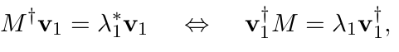

So that we have

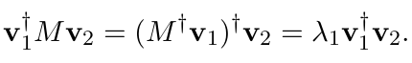

We call the eigenvector $v_{1}$ of $M^{†}$ a **left** eigenvector of $M$. while a conventional eigenvector of $M$ is a **right** eigenvector.

A notable feature of non-Hermitian matrices is that their eigenvectors themselves are generally non-orthogonal, ie. $〈r_{j'}|r_{j}〉≠δ_{j'j}$

**Bi-orthogonality** - refers to the generalisation of Hermitian orthogonality to non-Hermitian matrices.   
Specifically, there is only an orthogonal relation between **left** and **right** eigenvectors of a non-normal (non-normal) matrix M.

#### BI-ORTHOGONALITY?

#### Notes from Moiseyev

Unlike the standard situation where the eigenvectors of an Hermitian operator (matrix) form a **complete** **set** which can be used to expand a wave packet describing the system at a given time, in NHQM it might happen that the eigenfunctions make up an **incomplete** **set** since several (usually two) eigenvectors coalesce to generate a **self-orthogonal** state (Moiseyev 174).

##### The c-product

One of the basic postulates of quantum mechanics is that a solution of the time-dependent Schrödinger equation describes the studied system at any given time and so any measurable dynamical quantity can be evaluated from $|ψ(t)〉.$

A measurable dynamical property $O$, is represented by the corresponding operator $Ô$.   
In the Hermitian formalism of quantum mechanics:  
The projection of $|ψ(t)〉$ on a specific eigenstate of an operator $Ô$, denoted by $|n〉,$ provides the information on the **probability of measuring** in

a specific experiment **the corresponding eigenvalue of Ô**, labelled by $O_{n}$.  
The projection of $|ψ(t)〉$ on $|n〉$ is carried out by using the **scalar product** between any two square integrable analytical functions.

The mean value of the quantity Ō that will be measured in a series of identical experiments is given by the expectation value,

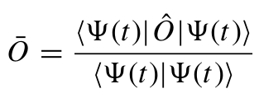

In order to differentiate between the conventional scalar product $〈· · | · · 〉$ Moiseyev labels the functional defined below   
as the **c-product** by (· · | · ·).   
Let us associate the eigenstates of the non-Hermitian operator $Ô_{θ}$ as $|{ψ^{θ}}_{n})$ with the eigenfunctions of the differential eigenvalue problem: $Ô_{θ}|{ψ^{θ}}_{n}) =$ ${λ^{ν}}_{n}|{ψ^{θ}}_{n})$
 .

It’s required that the c-product satisfies the orthogonality condition for the eigenstates of $Ô_{θ}$

$({ψ^{θ}}_{n'} |{ψ^{θ}}_{n})={δ^{}}_{n'n}$

With the c-product defined the continuous eigenvalue problem can be discretized

$O_{θ}{C^{θ}}_{n}=$ ${λ^{θ}}_{n}{C^{θ}}_{n}$,

${[{D^{θ}}_{m}]^{T}O}_{θ}=$ ${λ^{θ}}_{m}[{D^{θ}}_{m}]^{T}$,

${[{D^{θ}}_{m≠n}]^{T}C^{θ}}_{n}=$ $0$,

Where ${C^{θ}}_{n}$ and $[{D^{θ}}_{m}]^{T}$ are the right and left eigenvectors of the matrix $O_{θ}$

## Week 9 (03/05/21 – 09/05/21)

Aims:

1. Reproduce Fig 1 in Bender
2. **~~Understand how is it that complex eigenstates of NH systems are not orthogonal~~**
   1. ~~Maybe something to do with Bi-orthogonality?~~
3. Simulate a RF-CAP
   1. Omg getting to this is taking me forever :’(

Tasks:

1. **PLOT THE BROKEN SYMMETRY SECTOR OF THE SPECTRUM IN FIG 1.**
   1. **HOW TO SEPARATE MY EQUATION INTO TWO COUPLED EQUATIONS?**
      1. ~~Separation of variables?~~
      2. maybe think about it as a matrix equation: {{H11, H12},{H21,H22}}{psi1,psi2}-Gamma{{0,-1},{1,0}}{psi1,psi2}=E{psi1,psi2}. Now E is an eigenvalue. If you do the expansion in terms of N harmonic oscillator functions, then you will have a 2N x 2N matrix equation that needs to be solved. You will probably need to choose a value of both epsilon and Gamma and solve for E.
2. Continue Gao’s Hamiltonian analysis (using Benders methodology)
3. ~~FINISH progress report Due: Friday 7th May (week 9)~~

#### Solving a matrix equation

01/05/21

I asked J&M about my current issue and Jesper replied with this:

“...maybe think about it as a matrix equation: {{H11, H12},{H21,H22}}{psi1,psi2}-Gamma{{0,-1},{1,0}}{psi1,psi2}=E{psi1,psi2}. Now E is an eigenvalue. If you do the expansion in terms of N harmonic oscillator functions, then you will have a 2N x 2N matrix equation that needs to be solved. You will probably need to choose a value of both epsilon and Gamma and solve for E...”

03/05/21

Since I need to use harmonic oscillator eigenstates I should refresh my memory as to how to write their general form:

The TISE of the 1D harmonic oscillator is

$H|n〉=E|n〉$

$(\frac{p^{2}}{2m} + m^{2}ω^{2}x^{2})|n〉 =(n+\frac{1}{2})ħω|n〉$

$(N +\frac{1}{2})ħω|n〉 =E_{n}|n〉$

Where

$N =a^{†}a$ is the number operator;

$a^{†} = \frac{1}{\sqrt{2}}(\frac{x}{l_{0}}-\frac{ipl_{0}}{ħ})$ and $a = \frac{1}{\sqrt{2}}(\frac{x}{l_{0}}+\frac{ipl_{0}}{ħ})$ are the creation and annihilation operators respectively

And $l_{0}= \sqrt{\frac{ħ}{mω}}$ is the harmonic oscillator length

The states are written as $|n〉= \frac{(a^{†})}{\sqrt{n!}}|0〉$

How do I write the general form of the matrix elements?

If I do the expansion in terms of N harmonic oscillator eigenfunctions

$|ψ〉= \sum_{n=1}^{N}{}C_{n}|n〉$

Written in the spatial basis:

$0=〈x|a|0〉=〈x|\frac{1}{\sqrt{2}}(\frac{x}{l_{0}}+\frac{ipl_{0}}{ħ})|0〉= \frac{1}{\sqrt{2}}(\frac{x}{l_{0}}+l_{0}\frac{∂}{∂x})ψ_{0}(x)$

Where $ψ_{0}(x)=\frac{1}{π^{1/4}\sqrt{l_{0}}} e^{-x^{2}/(2{l_{0}}^{2})}$

Then the matrix elements of my complex hamiltonian matrix can be written as

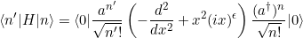

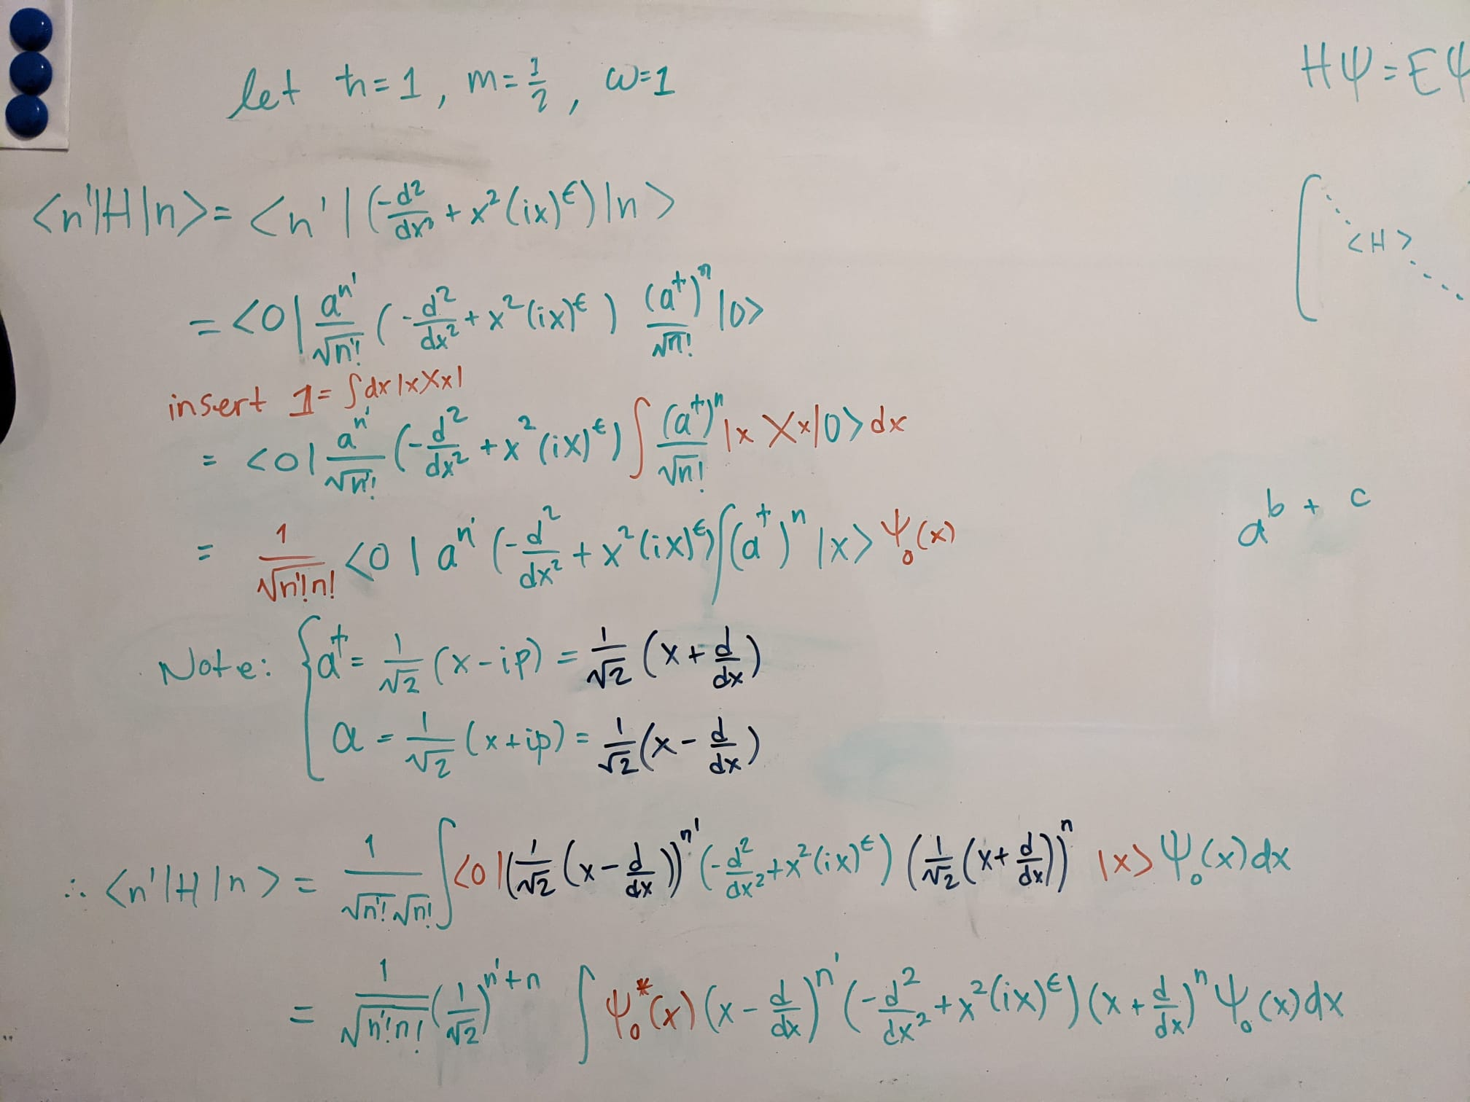

Not sure if this is the best way to do things yet.

Then I have to find the elements iteratively (n=1 $→N$) by using Mathematica (analytically) or Python (numerically).

If I am right then the matrix equation should look like this:

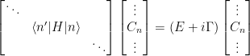

Didn’t I need a 2N x 2N matrix equation (according to Jesper) ??? yes… but I think he was talking about a slightly different setup which separated imaginary and real parts but I don’t think that I need to separate them per se with my method.

Also, I am still unsure about what the value of $Γ$ should be.

Jesper suggested that first I should try the case for $Γ$ =0 so I get the $ϵ$ =0 solutions, as well as all positive values.   
Then take $ϵ$ slightly negative and $Γ$ small

04/05/21

from wikipedia <https://en.wikipedia.org/wiki/Quantum_harmonic_oscillator>:

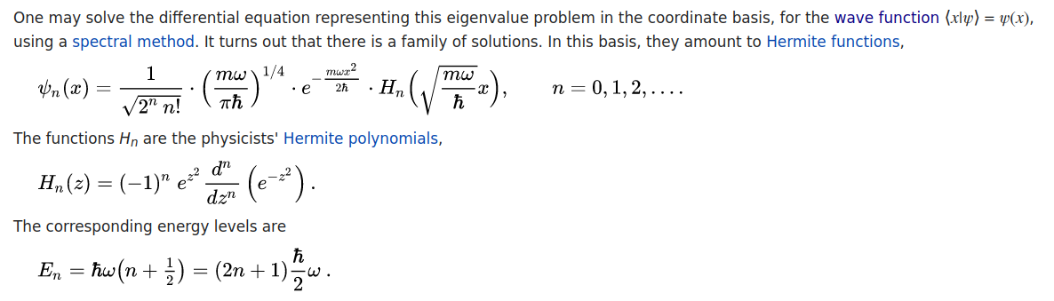

I am working with natural length and energy scales therefore in my equations I set

$ħ = 1, m = \frac{1}{2} , ω=1$

Therefore the H.O. eigenstates are:

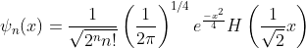

Previously, I worked out a coordinate space expression for my matrix elements:



If I write this in terms of $|n〉$ without using the creation and destruction operators I will be able to use the harmonic oscillator states as they are in wikipedia.

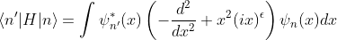

This expression looks a lot simpler to code! Yay!

Let me take a step back…

|  |
| --- |
| WHAT AM I ACTUALLY DOING?   1. Need to find the general form of the H.O. basis functions ✅    1. Write these in the coordinate basis ✅ 2. Decide how I am solving the equation ✅    1. Numerically?    2. Analytically? 3. How many functions am I using? [ ]    1. nN 4. Make the Hamiltonian matrix [ ] 5. Diagonalise the Hamiltonian matrix [ ]   If I try to solve the equation numerically i need to find:   1. A module in numpy for Hermite polynomials ✅    1. [scipy.special.eval_hermite](https://docs.scipy.org/doc/scipy/reference/generated/scipy.special.eval_hermite.html) |

05/05/21

MEETING DAY!

#### Code

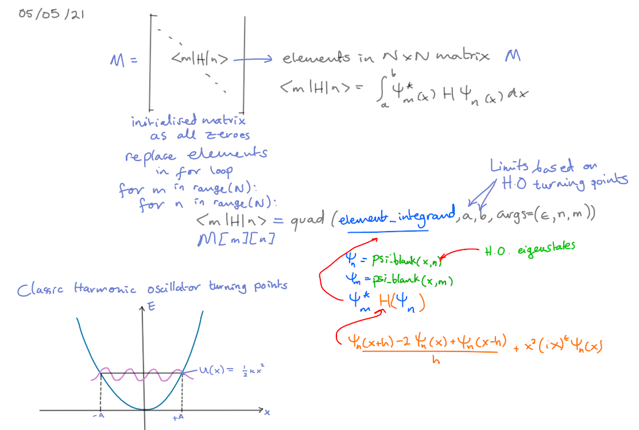

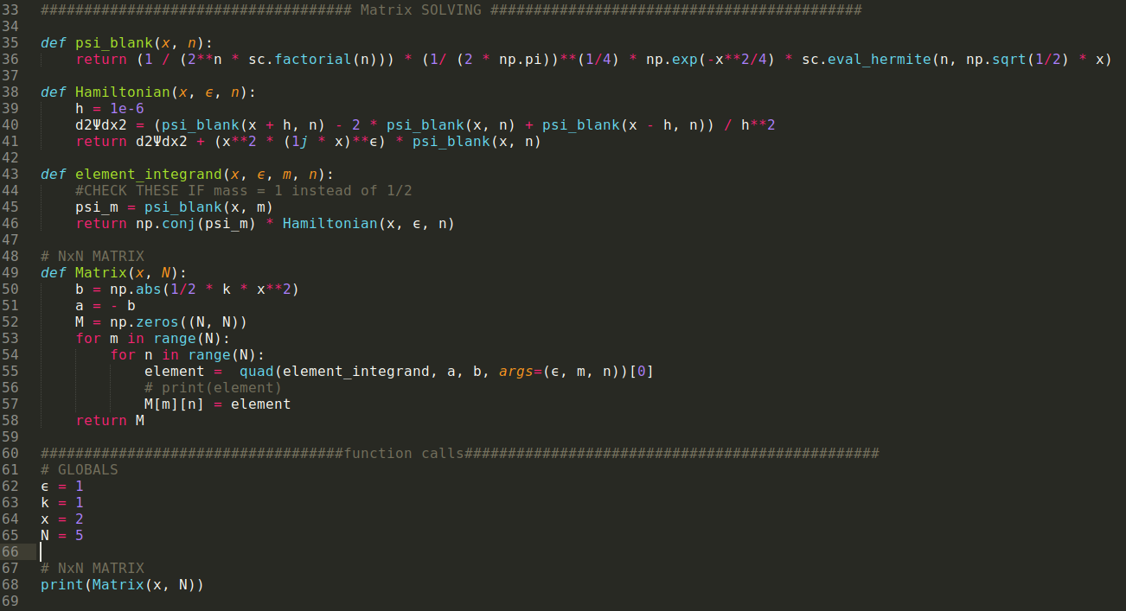

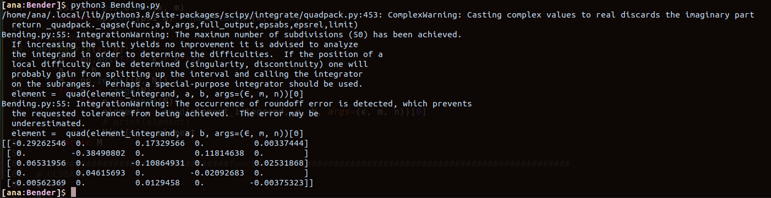

I need to figure out the IntegrationWarning error displayed in the terminal output above.  
Is my Integral diverging? The error remains if I change the limit upper bound on the number of subintervals used in the adaptive algorithm. The error disappears if I decrease the absolute error tolerance from the default value epsabs=1.49e-8 to epsabs=1.49e-04.

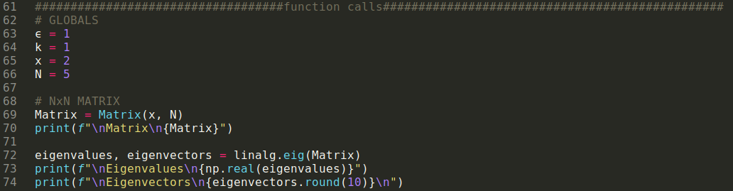

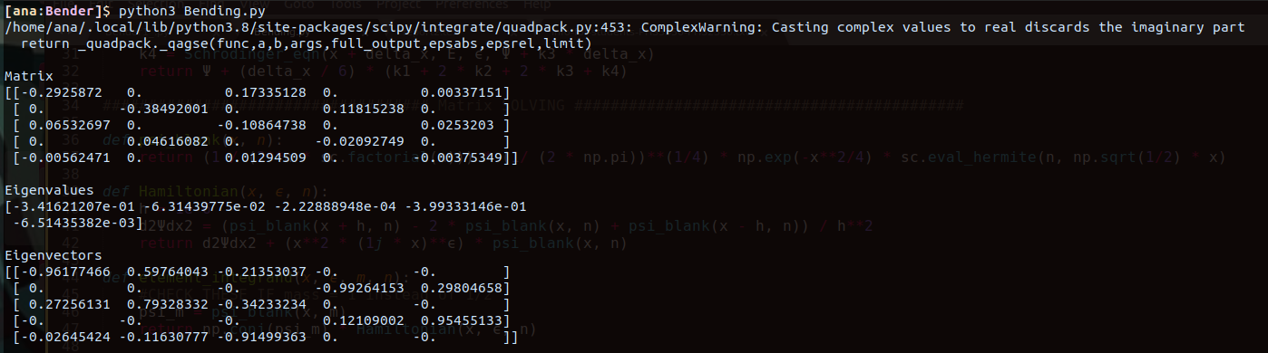

The only remaining error probably comes from the complexity of the Hamiltonian.

I spoke to Chris and he reminded me that I have to consider the turning points as functions of n

Since they change for each eigenstate of the harmonic oscillator.

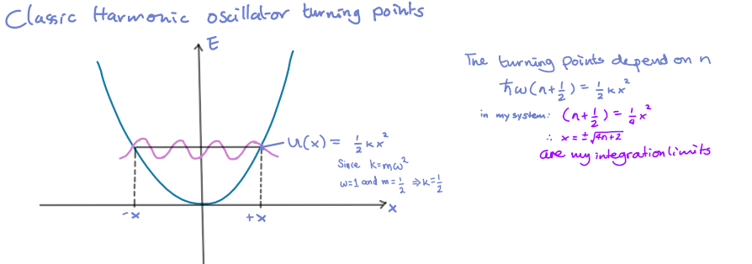

Another important factor is that I need to choose the largest integration region and so this depends on the state with the highest energy value.

Ie. if m>n then use x = $±\sqrt{4m+2}$ as the integration bounds.

The error I keep getting above

ComplexWarning: Casting complex values to real discards the imaginary part

return _quadpack._qagse(func,a,b,args,full_output,epsabs,epsrel,limit)

will likely be solved by using the complex_quad() function I wrote earlier instead of the simple quad()

This is how my matrix function has changed so far:

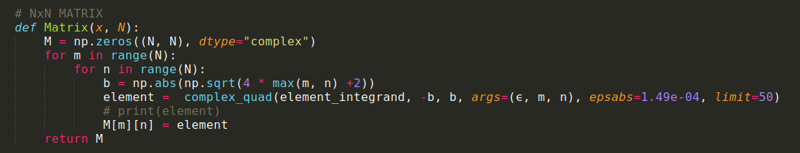

Also...

I added this to the top of my code to set the options that determine the way floating point numbers, arrays and other NumPy objects are displayed.

np.set_printoptions(linewidth=150)

In addition I’ve noticed that I am printing only the real part of the eigenvalues so… that needed to be corrected since I shouldn’t split these.

This is my function call and the output

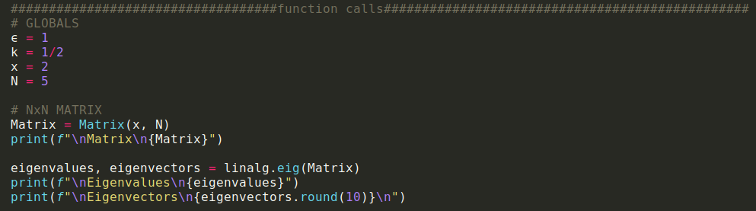

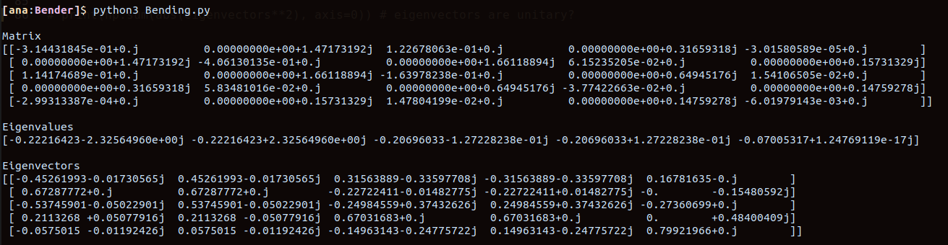

Yay, now my matrix is complex valued.

Wowwowowow hold your horses friend.  
I need to actually make sure the states have gone to zero in order to take advantage of using the H.O. states.   
The limits of integration must be much larger than the turning points of the H.O. so I can guarantee that the states have exponentially decayed to zero!

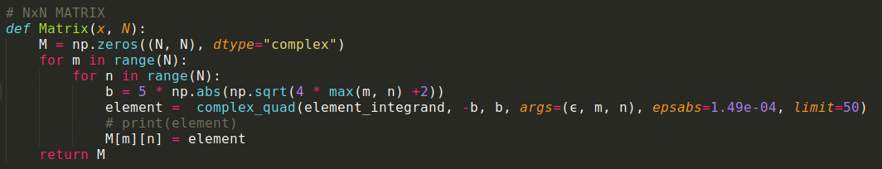

The integration limit b is now b = 5 * np.abs(np.sqrt(4 * max(m, n) +2))

The function calls are done with the exact same parameters as my previous call.

This is the new output:

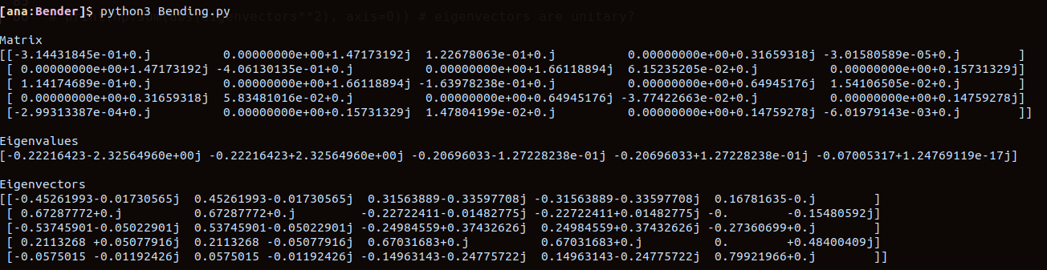

It looks the same as before..

What if I increase b to be b = 10 * np.abs(np.sqrt(4 * max(m, n) +2))

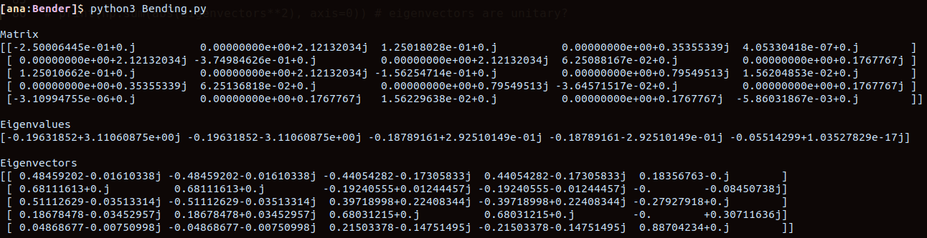

Cool, so things have changed a fair amount now.

If I change by increasing it to b = 15 * np.abs(np.sqrt(4 * max(m, n) +2))

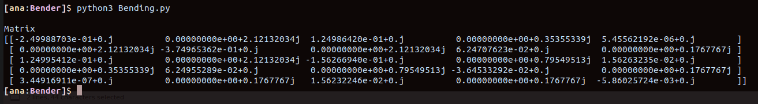

The matrix elements do not change that much anymore..

Let’s leave this for now as b = 10 * np.abs(np.sqrt(4 * max(m, n) +2))

If I increase N from the test value N = 5 then I will get more resolution in Harmonic oscillator space.

The more eigenstates I use the more degrees of freedom I have which means the more accurate I am in my calculation of the eigenenergies of the non-Hermitian Hamiltonian.

The thing is that if I increase the number of states used to make my matrix the number of eigenvalues will increase linearly with N.   
I only want to have the first 10 or so eigenvalues :/

In addition the eigenvalues in my output are mixed up in a real and complex eigenvalues list.

So I will have to separate them and sort the real ones in order with increasing energy. To later plot only the lowest ones.

First I want to run my code with N = 100 and check the running time

My base case is the case N = 5

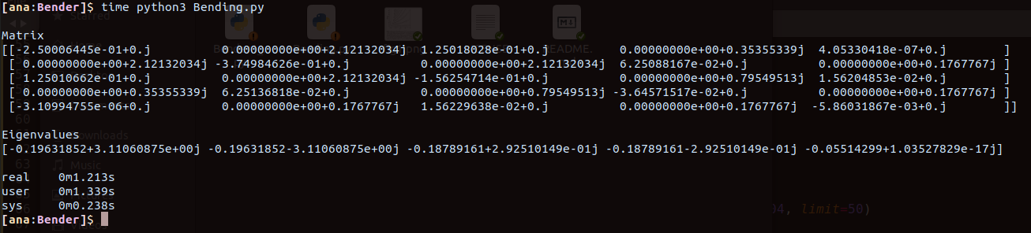

Testing N = 100

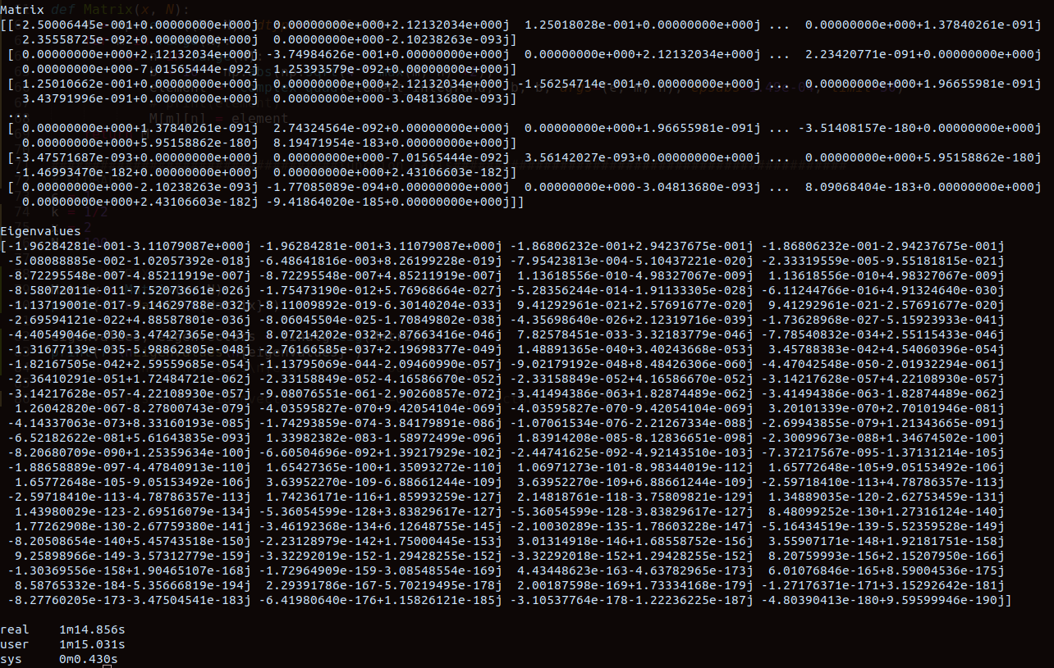

It’s slow.. But not awful

Testing N = 500

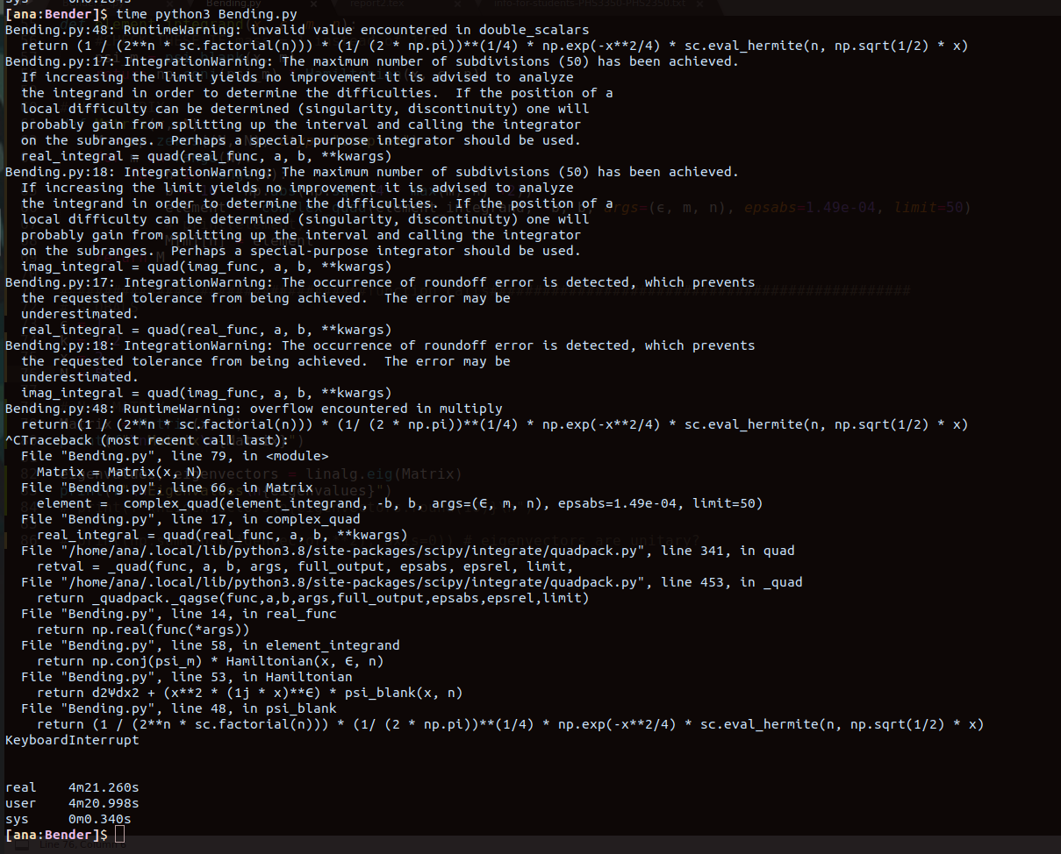

Okay! This kinda sucks. I wanted to get N to 1000 and it's looking like I have to dissect the way in which the states are written… The problem is probably in

def psi_blank(x, n):

return (1 / (2**n * sc.factorial(n))) * (1/ (2 * np.pi))**(1/4) * np.exp(-x**2/4) * sc.eval_hermite(n, np.sqrt(1/2) * x)

There might be an issue with the size of the state given that I am using 2**n and an n factorial in the denominator. I need to verify that sc.eval_hermite(n, np.sqrt(1/2) * x does actually give me something large to scale things adequately for large n.

I need to think about things for a bit.

07/05/21

How “large” are Hermite polynomials?



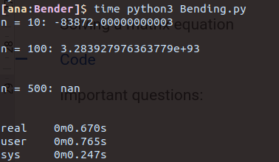

scipy.special.eval_hermite(*n*, *x*) blows up very fast!

I can try to re-write my basis states for large n using Stirling’s approximation:

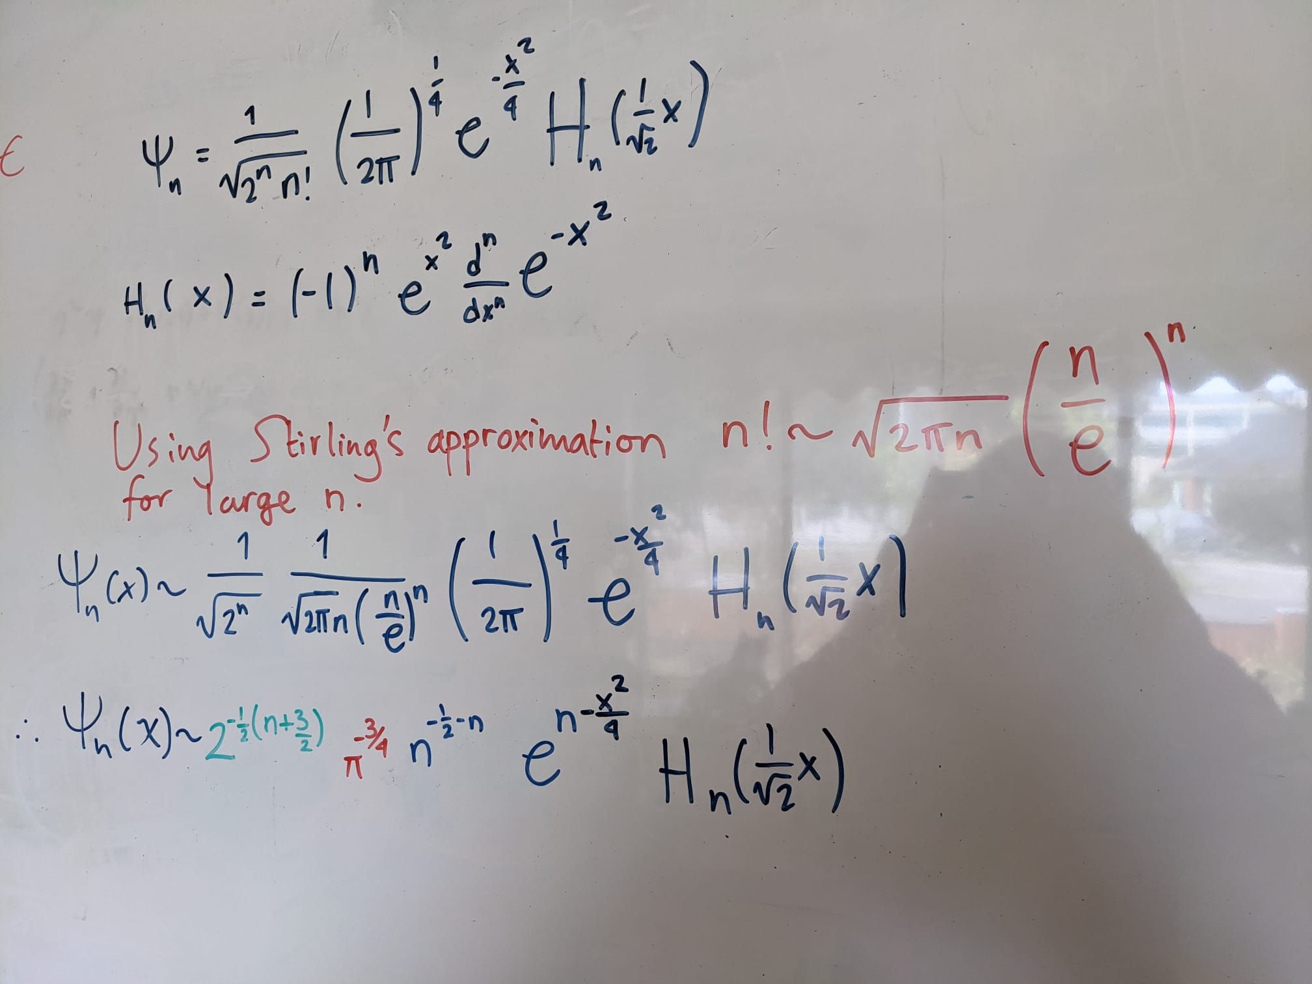



Testing:

N = 100

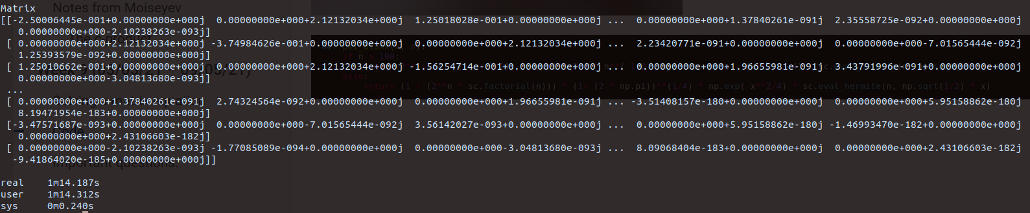

N = 500

Matrix doesn’t render.  
Bending.py:52: RuntimeWarning: invalid value encountered in double_scalars

return 2**(-1/2 * (n + 3/2)) * np.pi**-3/4 * n**(-1/2 - n) * np.exp(n - (x**2) / 4) * sc.eval_hermite(n, np.sqrt(1/2) * x)

How big are the parts used in   
psi_blank(x) ~ 2**(-1/2 * (n + 3/2)) * np.pi**-3/4 * n**(-1/2 - n) * np.exp(n - (x**2) / 4) * sc.eval_hermite(n, np.sqrt(1/2) * x)

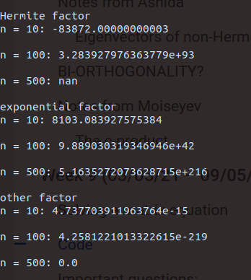

Why is the last result zero? Shouldn’t it be at least a very very small number?

AHH it turns out that the computer returns 0.0 when there is an **underflow** error.

While googling around about underflow in this calculation related to my inability to calculate higher order HO basis functions, I found this:  
<https://scicomp.stackexchange.com/questions/30896/generate-high-n-quantum-harmonic-oscillator-states-numerically>

Which lead to this:

<https://www.numbercrunch.de/blog/2014/08/calculating-the-hermite-functions/>

I’ve been reading H Bauke’s blog post and his work appears to be extremely relevant to my research.  
 In addition, the post that led me to H Bauke’s blog post has been extremely useful.

#### Calculating the Hermite functions

At high N values, the Hermite polynomials blow up and the normalising factor (**other factor**) becomes so small that underflow occurs.

H Bauke solves this by a recurrence relation definition for the Hermite polynomials:

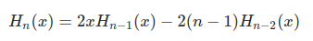

Where $H_{0}(x) = 1$ and $H_{1}(x) = 2x$.

The Hermite functions can now be written using this recurrence relation

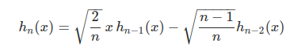

Thanks to stackoverflow poster  


His response to the original question was what made me more able to understand better the following code:

###### H Bauke’s Hermite function:

def h(n, x):

if n==0:

return ones_like(x)*pi**(-0.25)*exp(-x**2/2)

if n==1:

return sqrt(2.)*x*exp(-x**2/2)*pi**(-0.25)*exp(-x**2/2)

h_i_2=ones_like(x)*pi**(-0.25)

h_i_1=sqrt(2.)*x*pi**(-0.25)

sum_log_scale=zeros_like(x)

for i in range(2, n+1):

h_i=sqrt(2./i)*x*h_i_1-sqrt((i-1.)/i)*h_i_2

h_i_2, h_i_1=h_i_1, h_i

log_scale=log(abs(h_i)).round()

scale=exp(-log_scale)

h_i=h_i*scale

h_i_1=h_i_1*scale

h_i_2=h_i_2*scale

sum_log_scale+=log_scale

return h_i*exp(-x**2/2+sum_log_scale)

08/05/21

By using a modified version of Bauke’s code partly based on the post by stackoverflow user28077,  
 I’ve noticed that the Hermite polynomials I am using in my basis functions **underflow** as x = 0.

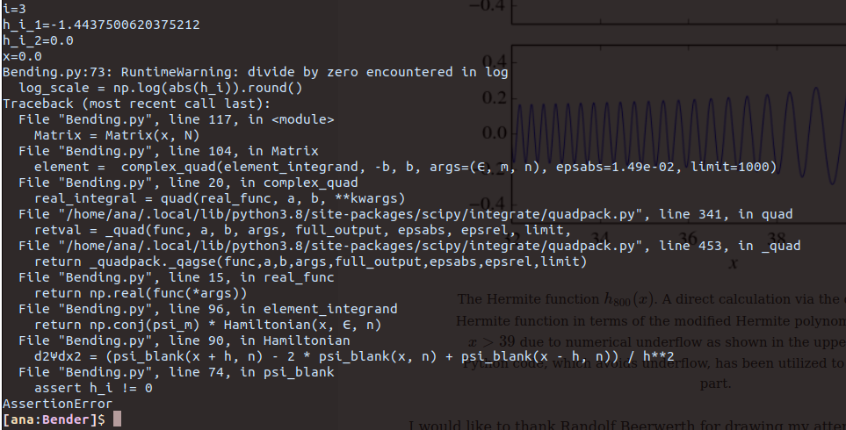

I think that this is due to Bauke’s “rescaled” recurrence relation definition

… h_i=sqrt(2./i)*x*h_i_1-sqrt((i-1.)/i)*h_i_2

h_i_2, h_i_1=h_i_1, h_i

log_scale=log(abs(h_i)).round()

It is the log_scale line that presents us with the issue since log(0) is undefined

An pseudo-code outline of what Bauke’s code is doing:

Define the Hermite function for some n, and x:

if n is 0:

Make a numpy object similar to x but with one(s) as entry(ies) multiplied by pi^(-0.25) exp(-x**2/2)

if n==1:

The code in this line has a typo!

return sqrt(2.)*x*exp(-x**2/2)*pi**(-0.25)*exp(-x**2/2)

The code continues and makes a numpy object similar to x but with one(s) as entry(ies) multiplied by pi^(-0.25) and another numpy object also similar to x but scaled by pi^(-0.25) and sqrt 2  
 h_i_2=ones_like(x)*pi**(-0.25)

h_i_1=sqrt(2.)*x*pi**(-0.25)

This numpy object is similar to x and full of zeros. I think this is used to convert the calculation into some log space calculation somehow. I do not understand this very well.

sum_log_scale=zeros_like(x)

for n > 2:

Define the recurrence relation for the modified Hermite polynomial

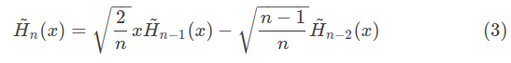  
 Redefine the modified Hermite polynomials by increasing n

(this makes the newly calculated $H_{n}$ the new $H_{n-1}$ and the old $H_{n-1}$ into the new $H_{n-2}$)

Take the log of the absolute value of $H_{n}$

log_scale=log(abs(h_i)).round()

Exponentiate the negative of log_scale

scale=exp(-log_scale)

To create a scaling factor for all modified Hermite polynomials

h_i=h_i*scale

h_i_1=h_i_1*scale

h_i_2=h_i_2*scale

I don’t understand this line well enough, I guess this is Bauke’s solution to the underflow issue.

sum_log_scale+=log_scale

Return function and multiply by the gaussian factor

return h_i*exp(-x**2/2+sum_log_scale)

My version of Bauke’s hermite function:

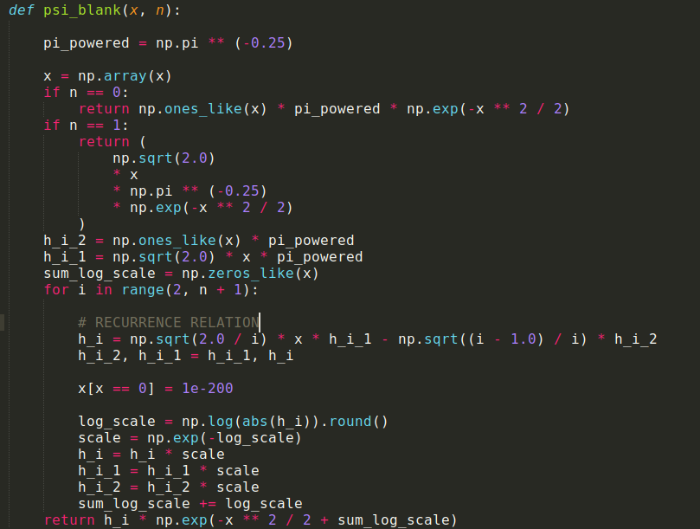

I ditched my working with natural length and energy scales to match Bauke’s code better. I guess this is done at the expense of losing some accuracy.

The H.O. eigenstates are now:

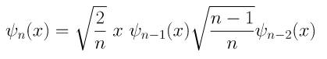

I have a conditional indexed statement for the case when I use arrays’ of x values (for example I would use a linspace object to plot the hermite functions.)

Since my underflow issues occur with x=0 then I set the x==0 to be instead a very small number.

I must check if I am actually obtaining some hermite functions for larger N=300 with the modified code from Bauke.

Previously I wasn’t getting any results for N>100.

This is my function call as a plot

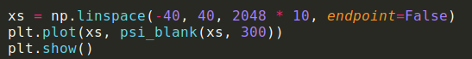

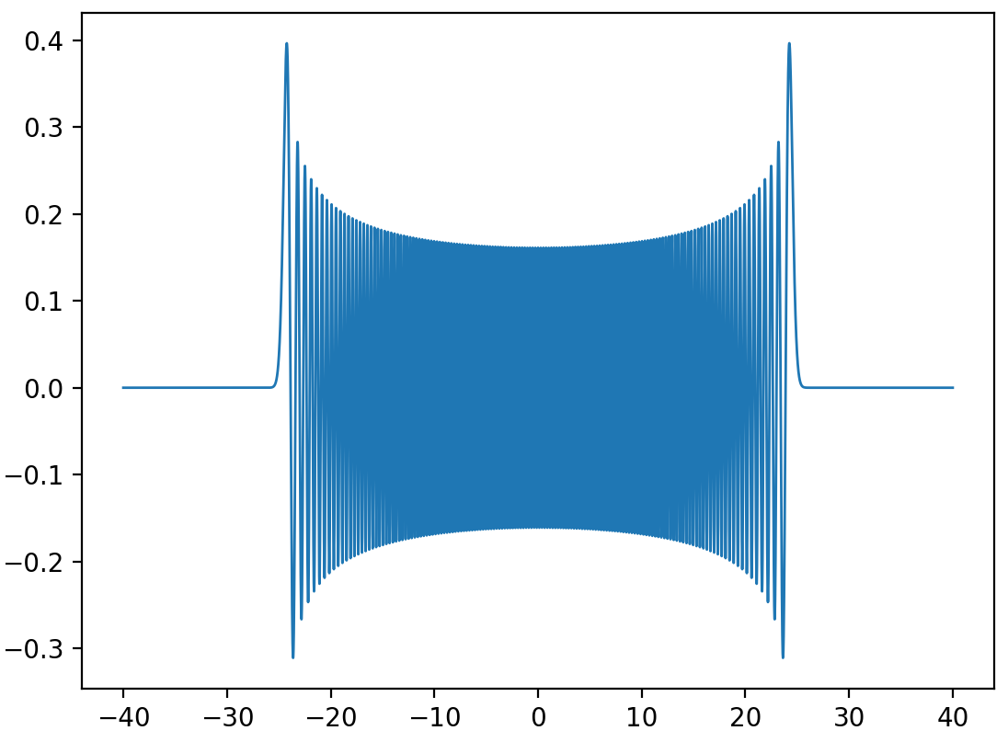

This is totally a harmonic oscillator eigenfunction for large N! YAY

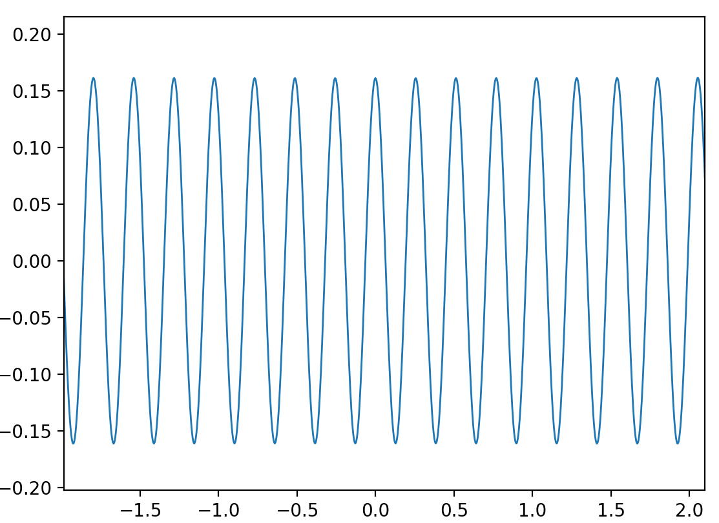   
and there are no discontinuities at x = 0 thanks to my fix.

I probably could reconsider the limits of integration to save time.

This is a plot of the complex Hamiltonian operating on the wavefunction

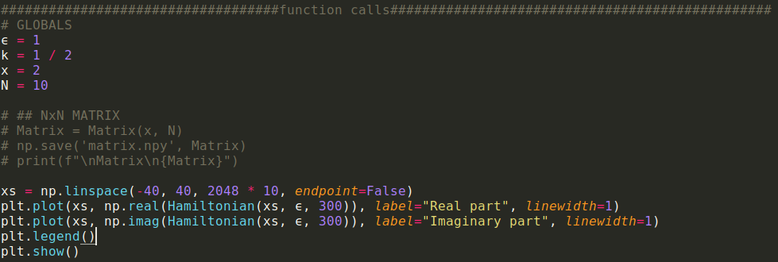

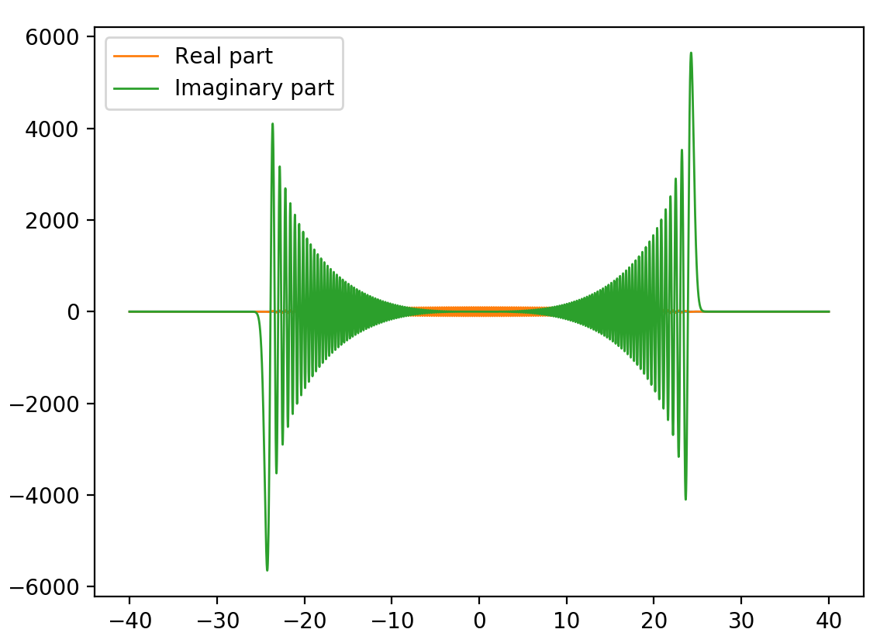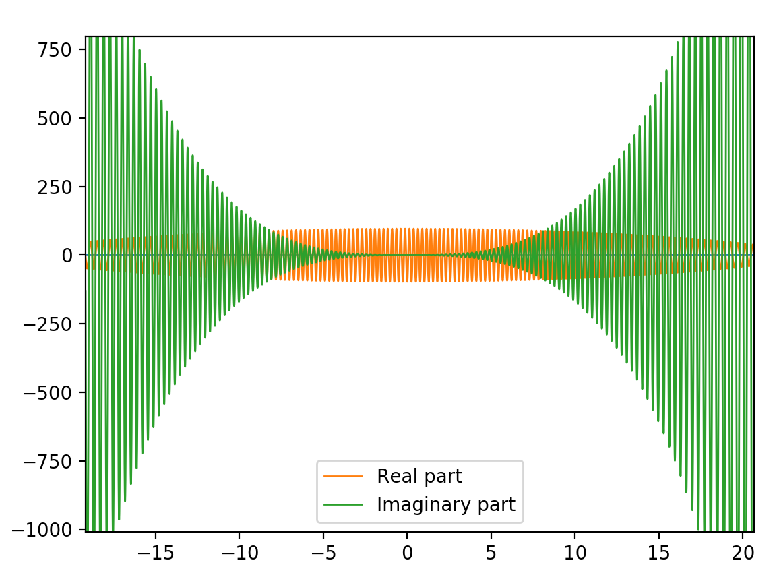

Real part wiggles near the centre but decays as we move to the edges.

#### Optimization

These are plots of the integrand in



I want to use these to figure out the most optimal choice for the integration limits

Given that currently I am using b = np.abs(np.sqrt(4 * max(m, n) + 2))

The integration limits change depending on the values of m and n.  
I want to minimize the integration limits as much as possible to save time on the algorithm.

|  |  |
| --- | --- |
| For m = 30 and n = 30    Function behaviour close-up | For m = 300 and n = 300    Function behaviour close-up |
| For m = 30 and n = 300    Function behaviour close-up | For m = 300 and n = 30    Function behaviour close-up |

From these plots I can see that my integration limits are definitely larger than they need to be.

The difference between the turning point and the x-point after which my functions decay to ~1e-12 requires that I set my new “turning point” to be a function of the min(m,n) and in addition that I add two units more to this point.

Ie. The new turning point is: b = np.abs(np.sqrt(4 * min(m, n) + 2)) + 2

Since the Hermite functions are up and running I’ve tried to calculate the matrix for the following parameters

# GLOBALS

ϵ = 1

k = 1 / 2

x = 2

N = 130

The issue I’ve encountered is that due to the complexity of the algorithm. The algorithm I wrote is $N^{3}$.

Therefore the time elapsed per run is huge.

Here is a picture of the elapsed time for each loop required in my algorithm (loops for m and n respectively )

  
Considering that I have to do the calculations for a large N and repeat several times for $ϵ ∈ [-1,0)$ I am kinda screwed with the computational time I require to get my diagonalisable matrices.

Need to think about this for a while and see if there is a solution to this problem, otherwise I’ll have to try to solve the equation analytically. Even then I am unsure If I will not run into more problems.

09/05/21

I don’t think I can optimize the code by myself. I was chatting to Chris about this and he said that I would have to write some cython code in order to compile the function using C instead of using a more high level language loop. He very kindly offered to help me and wrote some cython code for me.



This is the function to be compiled in C:

ho.pyx

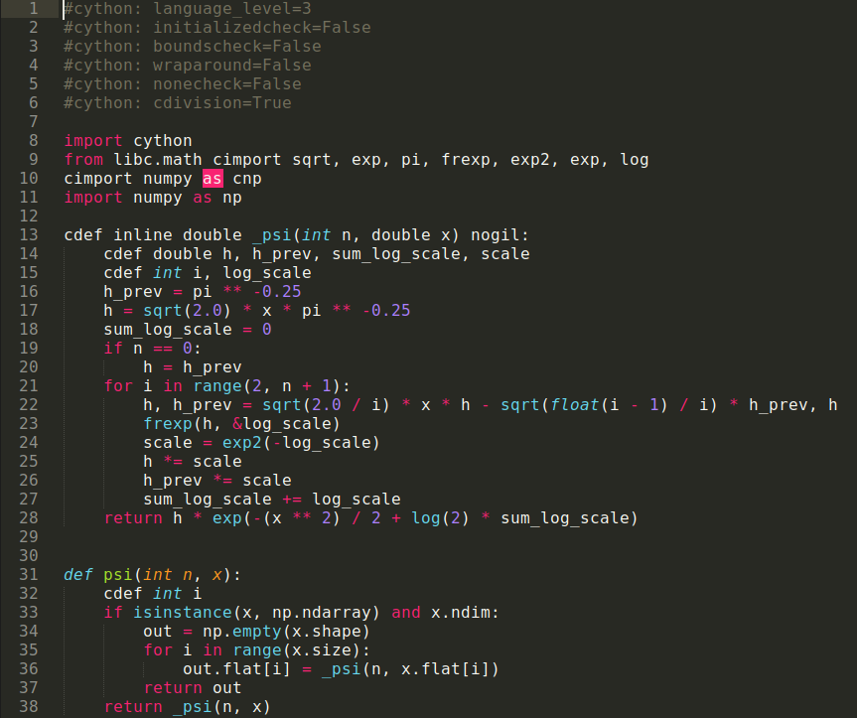

The algorithm is still the same complexity as before but the main speed up is due to the C compiling.

Chris even wrote a test.py file that he used to compare the speed of his compiled function vs the standard python function that I wrote.

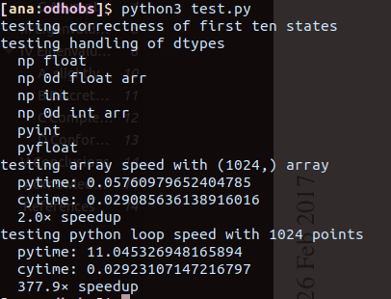

The code tests the correctness and speed of the calculation of HO basis states using an array of x values (size: (1024,)) and the basis states calculated for 1024 different x values. Basically a vectorised calculation and a single point calculation comparison for each of my python and his cython. His results absolutely destroy mine. His individual x calculations are ~378✕ faster than mine!

Let’s see if I can do some calculations for some negative $ϵ$ values now that the algorithm is faster!  
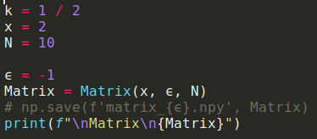

This call throws an error about x = 0 raised to a negative power.

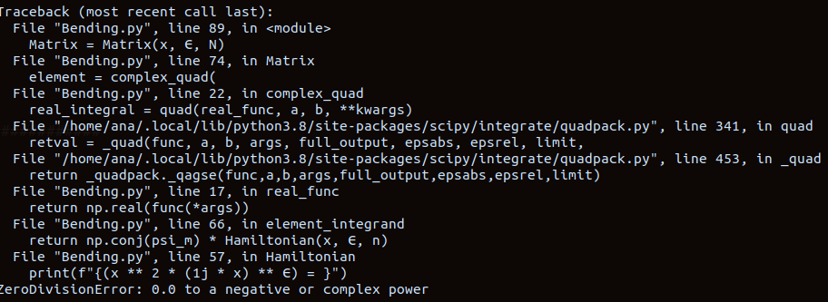

It probably can be fixed like this

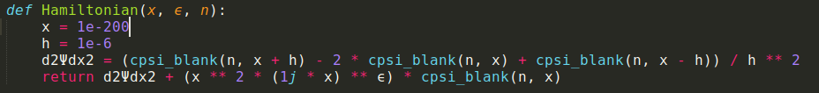

I will run this now

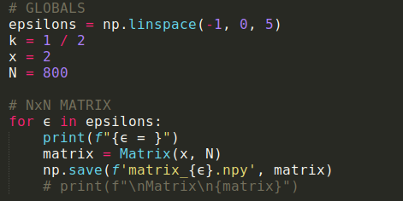

#### Important questions:

* How do I use Meera’s suggestion for my Hamiltonian: $-\frac{d^{2}}{dx^{2}}+x^{2 }+ x^{2}+((ix)^{ϵ} -1)x^{2}$?
* What does broken symmetry mean in this context?

## Week 10 (10/05/21 – 16/05/21)

~~Aims:~~

1. ~~Reproduce Fig 1 in Bender~~
2. ~~Start preparing TALK (12 minutes)~~
   1. Due week 11 for tqm group presentation
   2. Due Week 12 Thursday 27/05 9:45am

Tasks:

1. **~~PLOT THE BROKEN SYMMETRY SECTOR OF THE SPECTRUM IN FIG 1.~~**
2. Continue Gao’s Hamiltonian analysis (using Benders methodology)

10/05/21

It has been around 10 hours since I started to evaluate matrix elements for $ϵ=-1$.

I am planning to stop the loop as soon as this matrix finishes to be constructed and I want to test if the matrix has been saved correctly before I even continue with the other cases of $ϵ.$

I’ve noticed a strange pattern in the outermost loop evaluation.

The progress bars show that whenever the computer is calculating the matrix elements that have Hermite functions with even m values the progression of n values is slower than when m are odd.

I was able to screenshot 19 frames of the even m progress as opposed to only 3 frames for odd m (due to the calculation speed).

EVEN m  


ODD m



I am thinking that I should plot the states and see what is going on in these specific instances.  
The quad function might be faster when it encounters zeros and it probably extrapolates the results for most n values.

Finally the matrix for $ϵ=-1.0$ was calculated and I have verified that the eigenvalues of the matrix can be calculated.  
 To do this I’ve written the following code:  
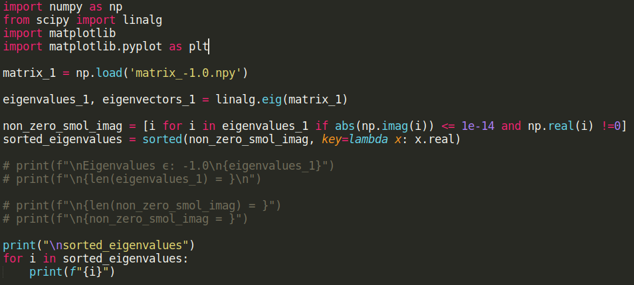

The output is a sorted list of 46 elements with negligible imaginary parts.. I am not entirely sure that this is the final form of this block of code but it’s a start, I’ll see what needs to change when I have other matrices.  
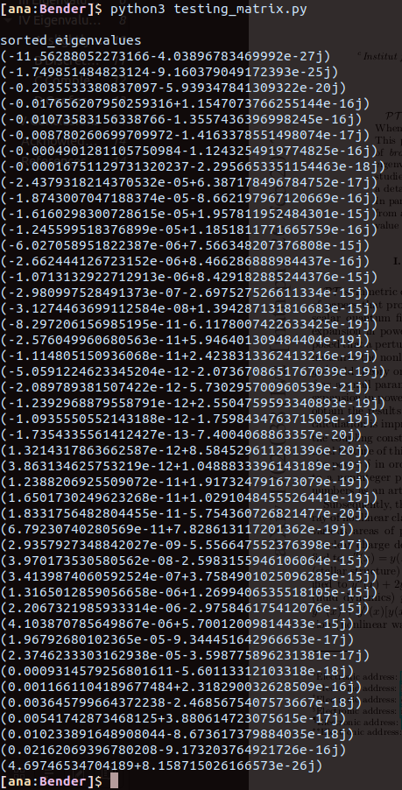

11/05/21

#### Bug fixes

I discovered that my last fix to raising x == 0 to a negative power by setting x == 1e-200 was actually not the right fix.  
Since I am using quad to integrate over several values of x between the modified turning points of the classical harmonic oscillator, setting the strict single value of x within the Hamiltonian function I use in my integrand made my states to exclusively use x == 1e-200 for every value of x.  
I discovered this by comparing the sorted eigenvalues of matrices $ϵ =-1.0$ and $ϵ=-0.75$ and discovering that they were identical!  
Tragic because that means that I've wasted 2 days for a calculation of the same thing over and over.

|  |  |
| --- | --- |
|  |  |

Anyway, at least I discovered the issue and fixed it.

Another issue I fixed in this block was assigning a to a variable named psi_n the calculated eigenstate cpsi_blank(n, x)

This should reduce the computation of the Hamiltonian function by a factor of 0.25 since within this function there were 4 function calls and I now have only 3.

The newest Hamiltonian function in my code takes an x as input and it locally redefines it as an np.array object which can then be indexed with an array of Booleans for the following condition: If some of the values in the array are zeroes the indexing notation reassigns the value 1e-200 to those values to avoid any divisions by zero.

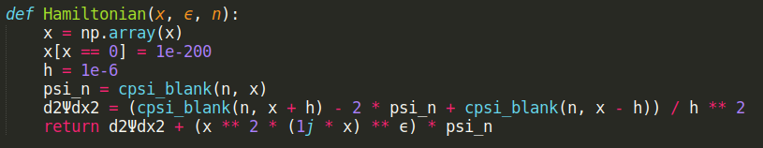

I decided to run my code with a smaller N value (N = 100) to verify that everything is running correctly with minimal computational time waste.  
(something I should’ve done from the start…)

Another observed side effect from this new fix is that now there is no discrepancy between the calculation speed between the odd and even m values.

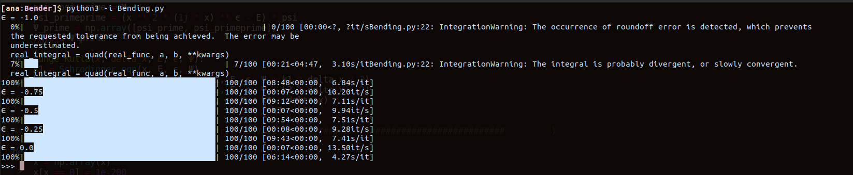

Ugh, my Hamiltonian function was missing a negative sign on the second derivative...

I tried plotting some sorted eigenvalues and they didn’t look quite right.

I’ve fixed the issue and this is the result for 5 values of epsilon in the desired interval

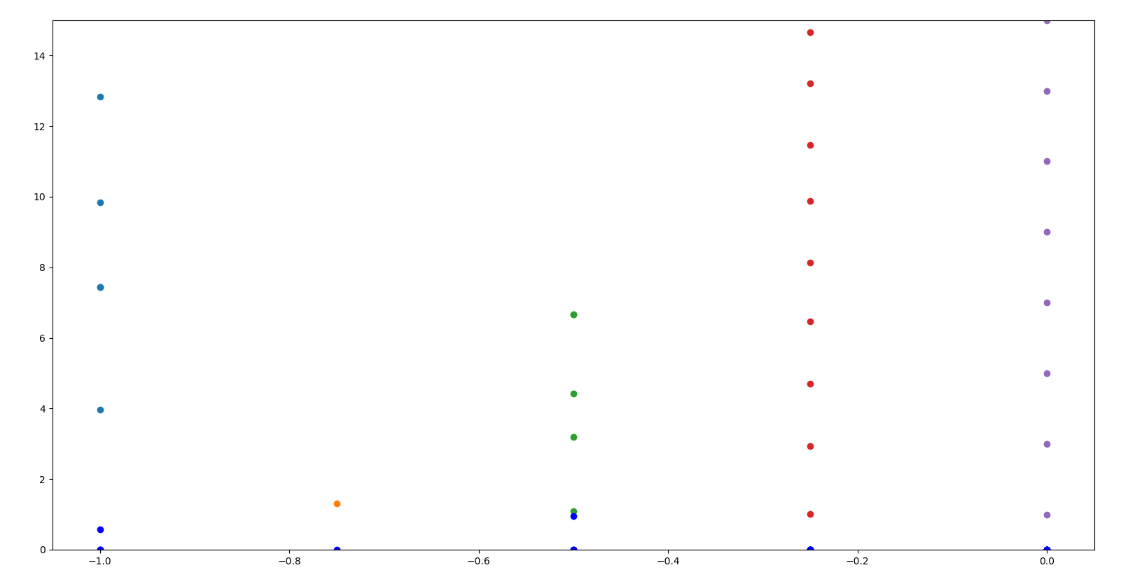

The dark blue dots are the imaginary parts of each of the complex eigenvalues in the interval, the other colours represent the real parts (unfortunately Python chooses lighter blue to represent the real parts of the eigenvalues corresponding to epsilon -1… but the blue value is a bit different.).  
This plot looks very promising. It is super similar to FIG 3. in the following paper:  
r by CM Bender et al: <http://dx.doi.org/10.1103/PhysRevA.95.052113>

#### Behavior of eigenvalues in a region of broken-PT symmetry

Abstract (Bender et al. 1)

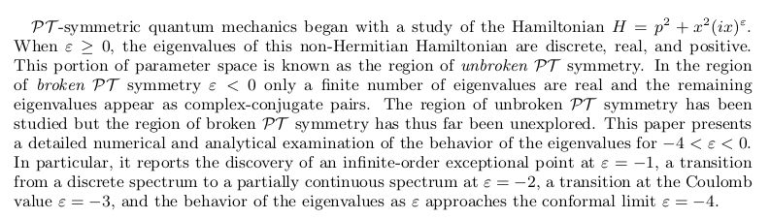

Notes from (Bender et al.):

A quantum-mechanical potential of form ${x̂}^{2} (i x̂)^{ϵ}$ does not necessarily lead to complex eigenvalues because the quantity *ix* is PT invariant. Indeed, the non-Hermitian PT -symmetric Hamiltonian.

$H = {p̂}^{2} + {x̂}^{2} (i x̂)^{ϵ}$

has the property that its eigenvalues are entirely real, positive, and discrete when ε ≥ 0.

A particularly interesting feature of PT -symmetric Hamiltonians is that they often exhibit a transition from a parametric region of unbroken PT symmetry in which all of the eigenvalues are real to a region of broken PT - symmetry in which some of the eigenvalues are real and the rest of the eigenvalues occur in complex-conjugate pairs. This transition occurs in both the classical and the quantized versions of a PT -symmetric Hamiltonian, and has been observed in numerous laboratory experiments (Bender et al. 1)

###### Exceptional points

Essentially nothing has been published regarding the analytic behavior of the complex eigenvalues as functions of ε in the region of broken PT- symmetry.

However, it is known that there is a sequence of negative real values of ε lying between −1 and 0 at which pairs of real eigenvalues become degenerate and split into pairs of complex-conjugate eigenvalues. These special values of $ϵ$ are known as **exceptional points** (Bender et al. 2).

In general, eigenvalues usually have square-root branch-point singularities at exceptional points.

The distinct eigenvalues of a Hamiltonian may correspond with the sheets of a Riemann surface. Interestingly, it is possible to vary the

parameters of a Hamiltonian in laboratory experiments and thus to observe experimentally the effect of encircling exceptional points.

The figure from Bender’s that I’ve been working displays an analytic continuation for the broken symmetry region ($ϵ<0$) to the real eigenvalues in the unbroken symmetry region ($ϵ≥0$). Bender’s Figure 1. Also displays an ***infinite-order exceptional point*** at $ϵ=-1$ (Bender et al. 2).

###### Infinite-order exceptional point

At $ϵ=-1$ there is an elaborate **logarithmic** spiral (double-helix) of eigenvalues:

|  |
| --- |
| **What happens in this logarithmic singularity?**  The real part of each complex conjugate pair of eigenvalues that is formed at exceptional points between $ϵ=-1$ and $ϵ = 0$ approaches +∞ like as ε approaches −1. In contrast, **the imaginary parts of each pair of eigenvalues vanish logarithmically at ε = −1.**  As ε goes below −1, the real parts  of the eigenvalues once again become finite and the imaginary parts of the eigenvalues rise up from 0. As ε goes from just above to just below −1, the imaginary parts of the eigenvalues appear to undergo discrete jumps but in fact they vary continuously as functions of (Bender et al. 2). |

###### Eigenvalue Behaviour as $ϵ→-1$ (Bender et al. 3).

The TISE for the PT-symmetric non-Hermitian Hamiltonians I am studying are characterised by boundary conditions imposed on the eigenfunctions requiring that $ψ(x) → 0$ exponentially rapidly as |x| → ∞ in a pair of **Stokes wedges** in the complex-x plane. This subsection explains the locations of these Stokes wedges.

It is necessary to introduce a branch cut chosen to run from 0 to ∞ in the complex-x plane along the positive imaginary axis because this choice respects the PT symmetry of the Hamiltonian. This is because PT symmetry translates into left-right symmetry in the complex-x plane (mirror symmetry with respect to the

imaginary-x axis)

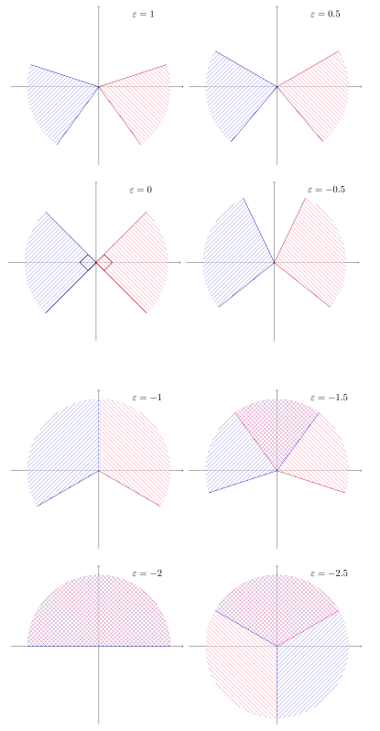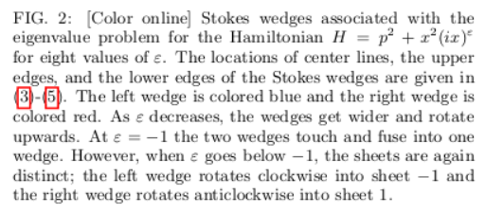

**At the special value ε = −1 the logarithmic Riemann surface collapses to a single sheet; the wedges fuse and are no longer separated. As a result there are no eigenvalues at all (the spectrum is null)**

###### Numerical behaviour of eigenvalues as $ϵ$ decreases below 0 (Bender et al. 4).

In Figure 1. In Bender it may seem that the real eigenvalues disappear pairwise at special isolated values of ε. BUT in fact the eigenvalues do not disappear; rather, each pair of real eigenvalues fuse. These eigenvalues convert into a complex-conjugate pair of eigenvalues.

At this transformation point both the real and the imaginary parts of each pair of eigenvalues vary continuously; the real parts remain nonzero and the imaginary parts move away from zero as ε goes below the transition point.

|  |  |
| --- | --- |
|  |  |

The calculation of my $N×N$ matrices ($N=100$) took me around 40 minutes so I decided to calculate 100 matrices for different epsilon values in the interval … hopefully these calculations will be done by tomorrow morning.

This is the code I’ll run tonight.

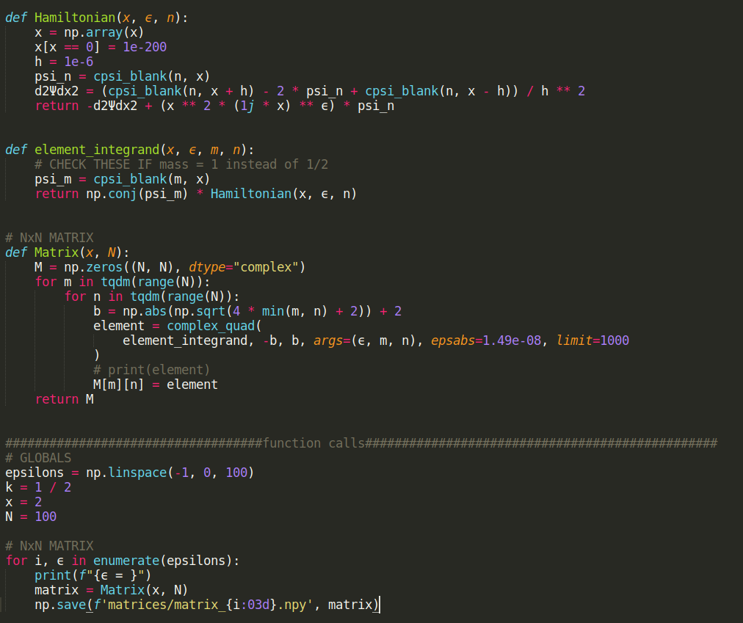

|  |
| --- |
| WHAT AM I ACTUALLY DOING?   1. Need to find the general form of the H.O. basis functions ✅    1. Write these in the coordinate basis ✅ 2. Decide how I am solving the equation ✅   Numerically   1. How many functions am I using? ✅   N=100   1. Make the Hamiltonian matrices (100 matrices) ✅ 2. Diagonalise the Hamiltonian matrices ✅ 3. Plot eigenvalues as functions of $ϵ$ ✅   Plot real and imaginary parts to simulate fig 3. above |

12/05/21

MEETING DAY!

My code finally finished running, these are the time stats:

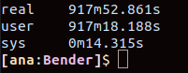

This is the broken symmetry region!

|  |  |
| --- | --- |
|  |  |

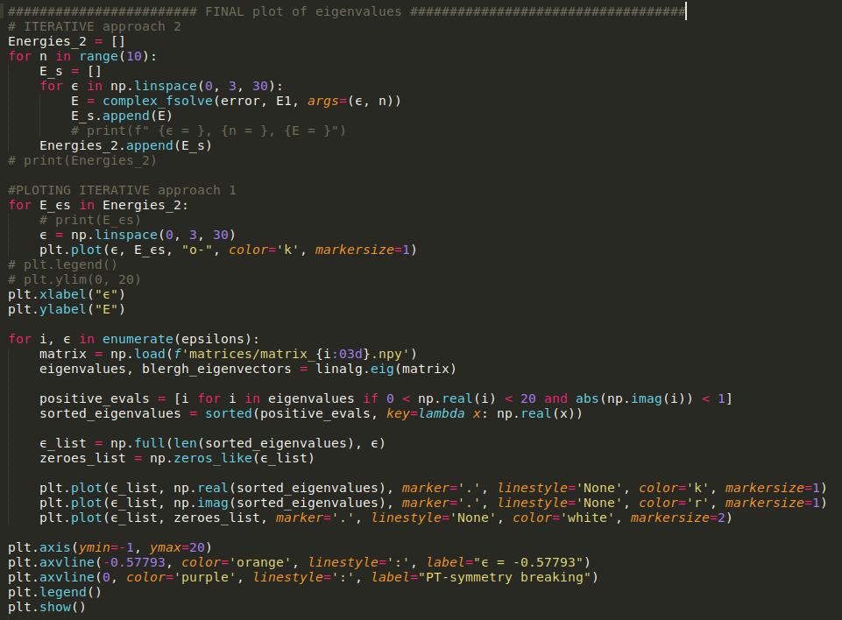

#### My rendition of Bender’s figure 1.

|  |  |
| --- | --- |
|  | My numerics appears to break as $ϵ→-1$ |

If I plot only the real parts (ie. without any selection criteria for the imaginary parts)

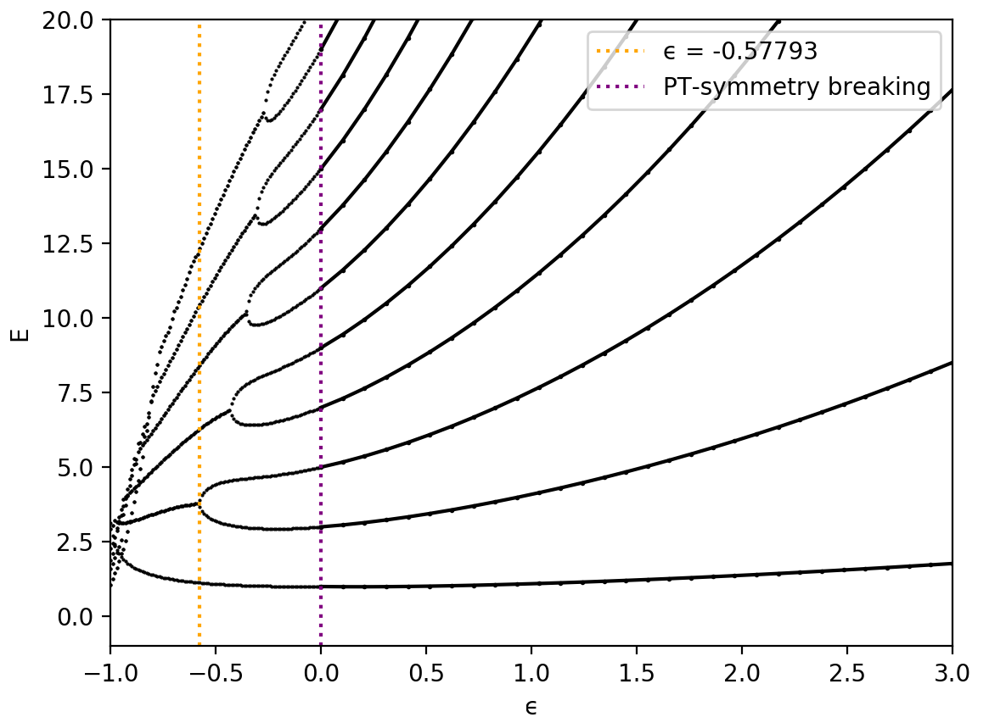

As I stated before numerics seem to fail the closer $ϵ→-1$.

##### Figure 1. Final form

After trial and error The final condition imposed on the indexing is



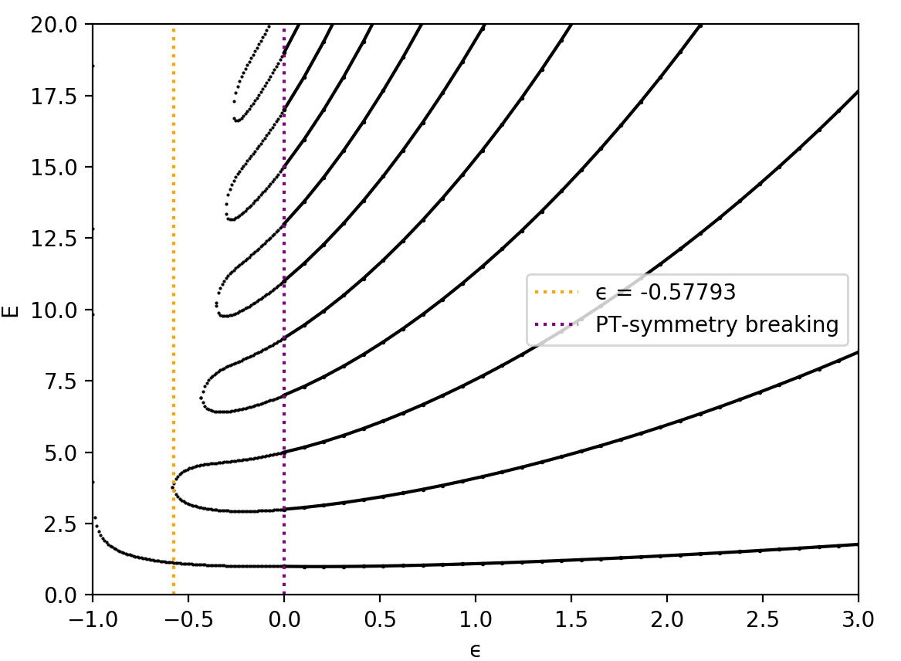

13/05/21

#### Eigenvectors

The question in everyone’s minds is are the eigenvectors of these matrices orthogonal?

15/05/21

After a lot of thought, much confusion and many bugs… I wrote this working function.

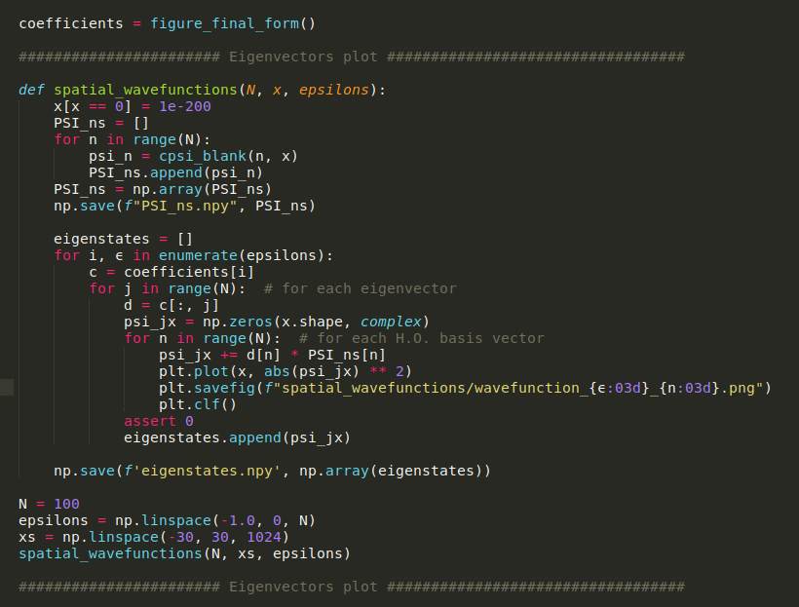

Here I calculate and plot the eigenstates for each epsilon value in my 100 $ϵ$ between -1 and 0.

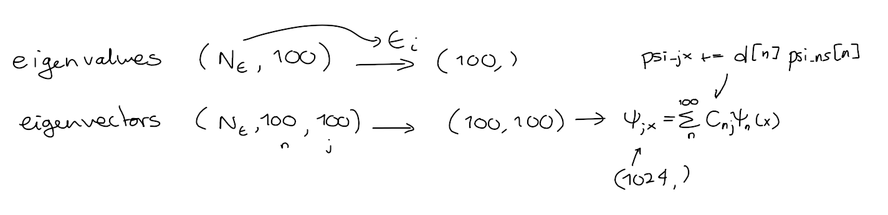  
This is a gif for the case



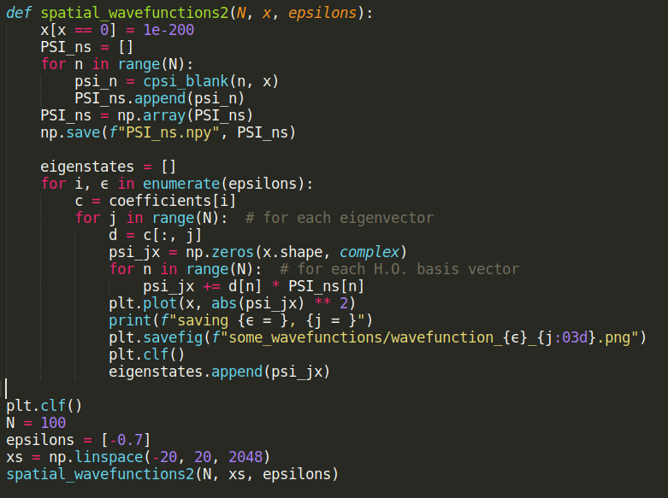

Whoops, I corrected a bug with my indentation, and the labelling of my files. Also, I am now testing a different epsilon value because $ϵ=-1$ is a bit of a special case and I want something less infinite-order-exceptional-point-y.

These are two eigenstates for the case $ϵ=-0.7$

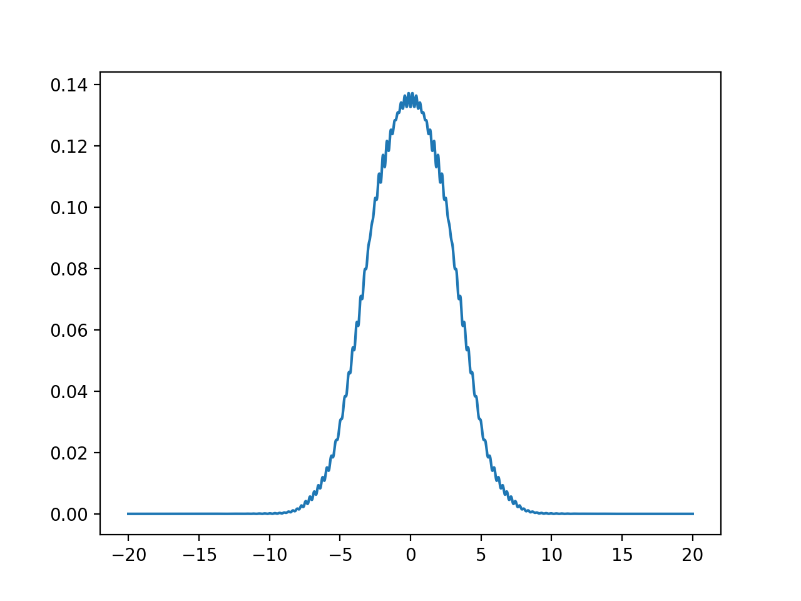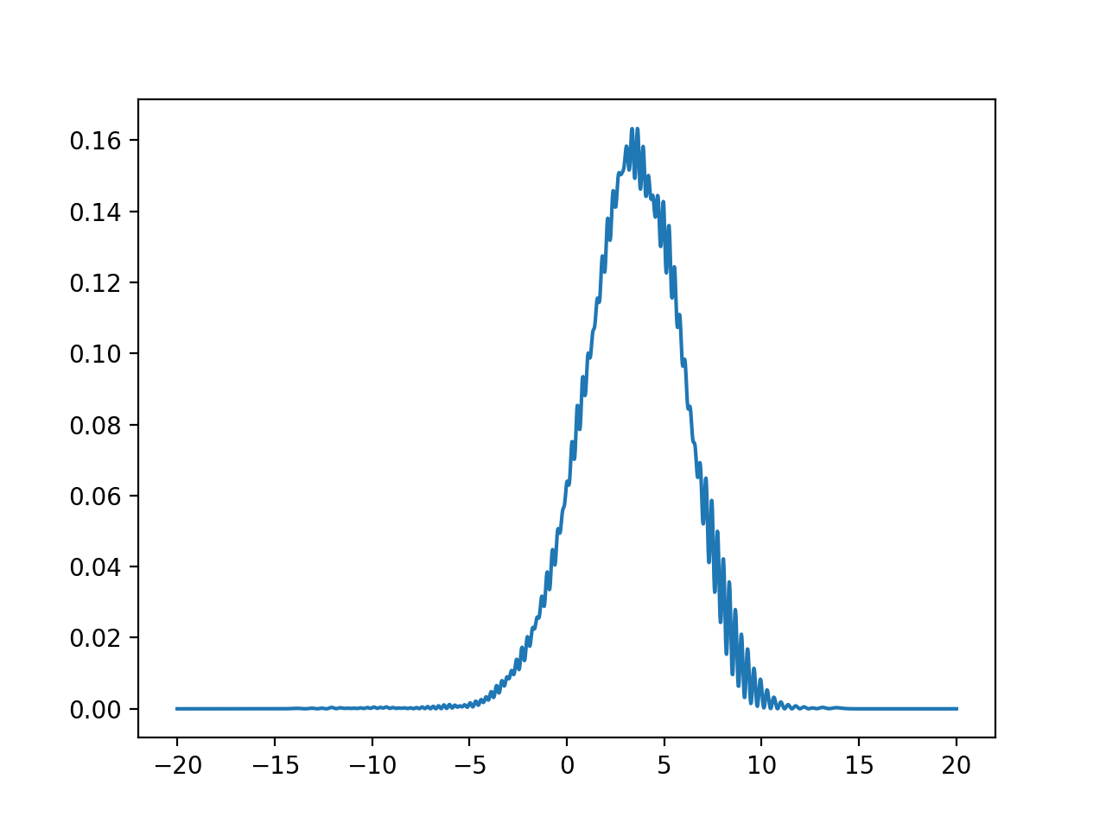

These randomly chosen eigenstates don’t look orthogonal!

What about I run the same code but for $ϵ=-0.4$? Just so I can see the states for an epsilon value that is on the other side of the exceptional point.

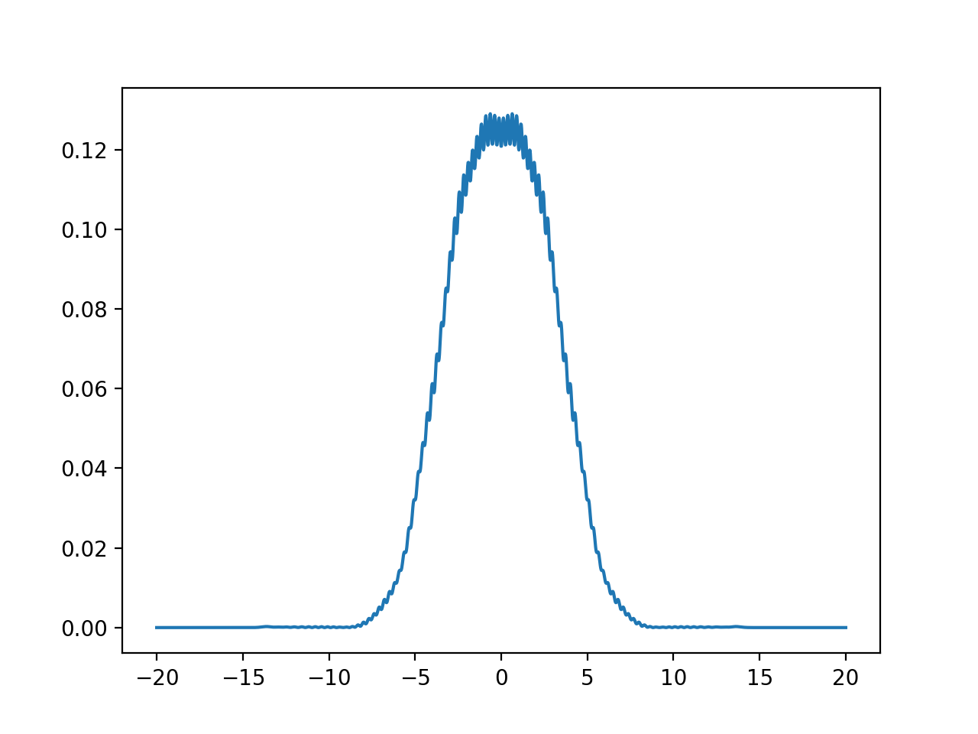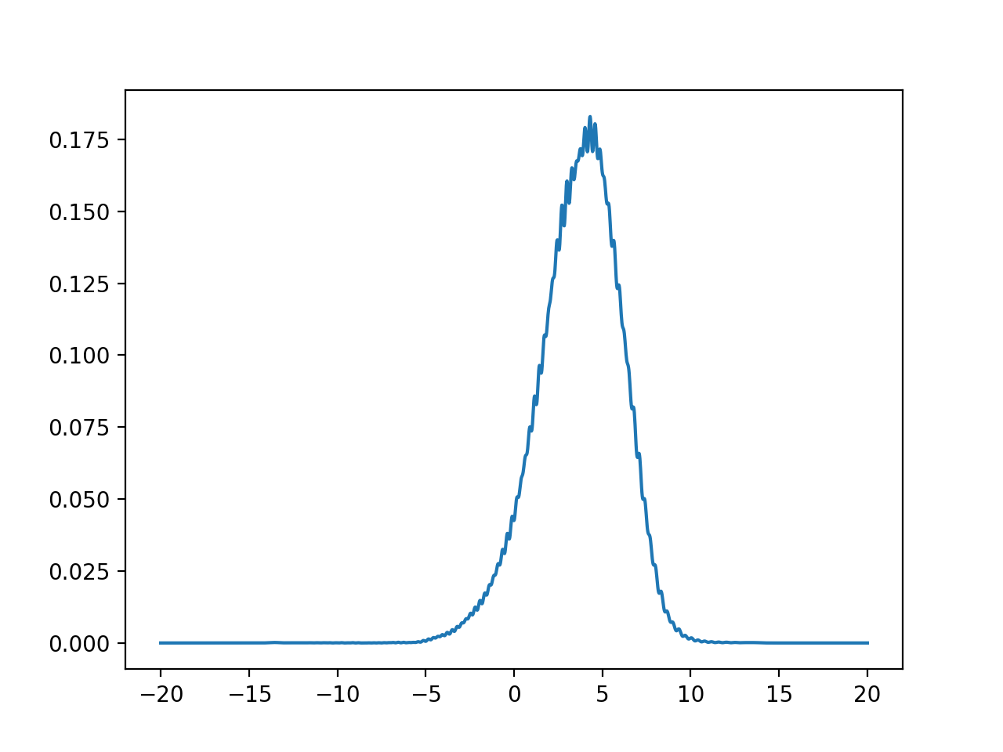

Bit of aliasing but these states also don’t look orthogonal

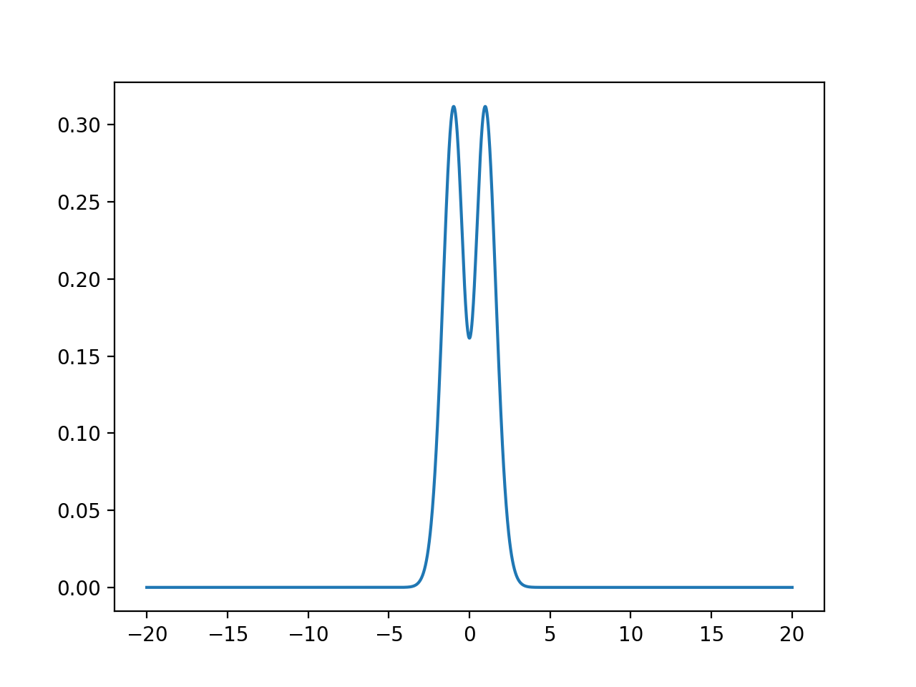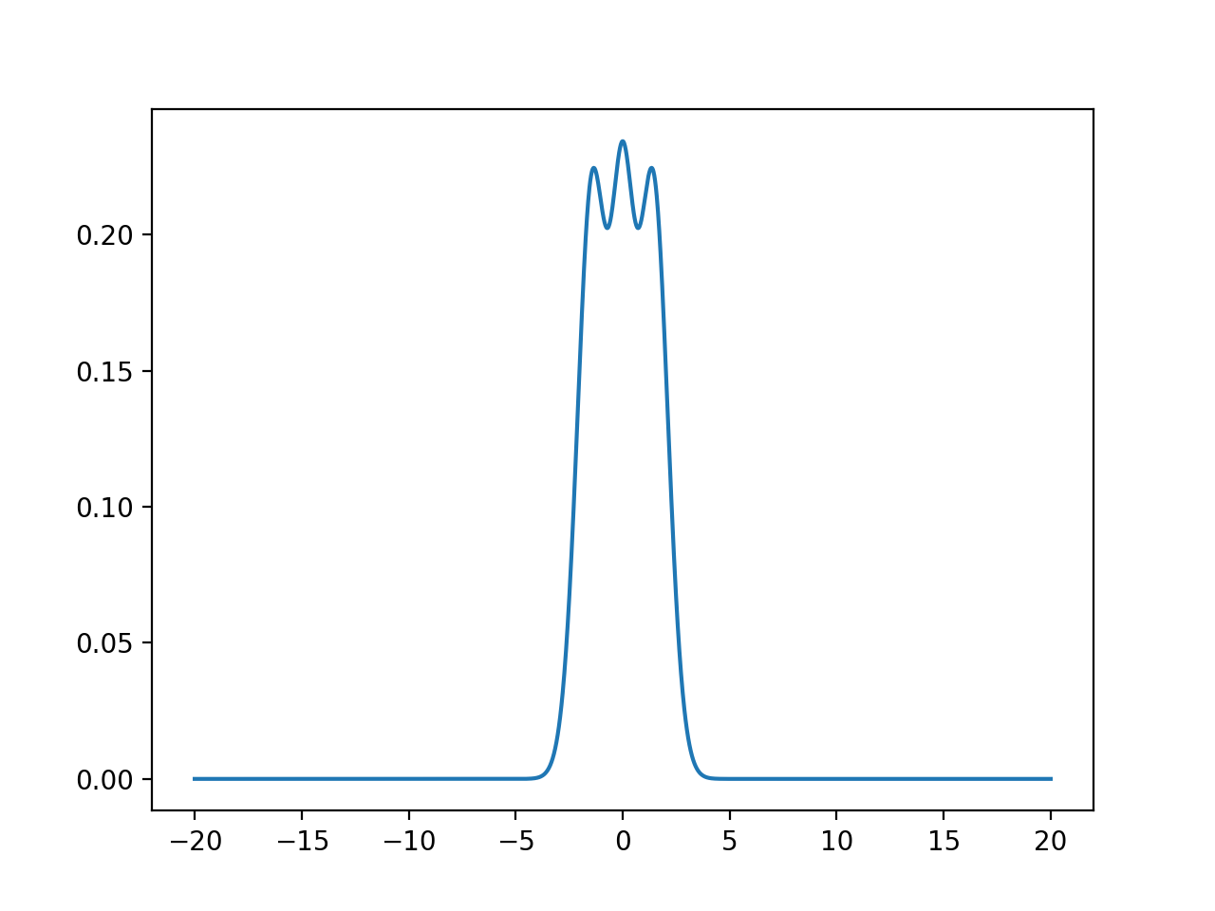

HEYYYY I think I know these guys…They look like my old first and second excited state buddies…

Time for a sanity check. HERE I plotted the first and second excited states of the $ϵ=0$

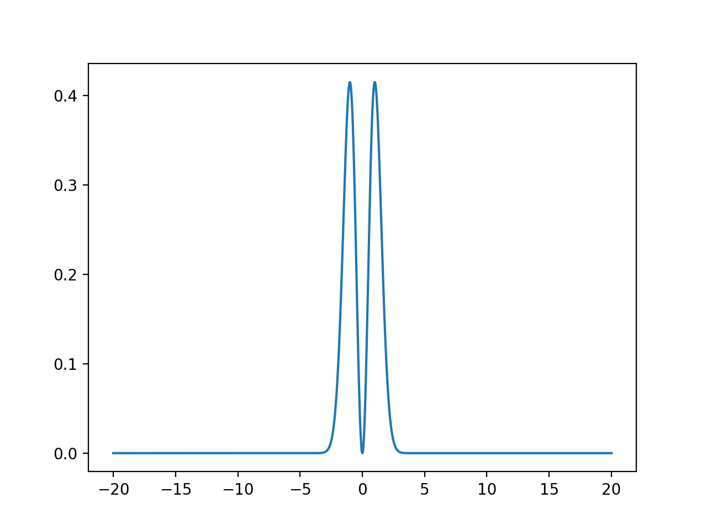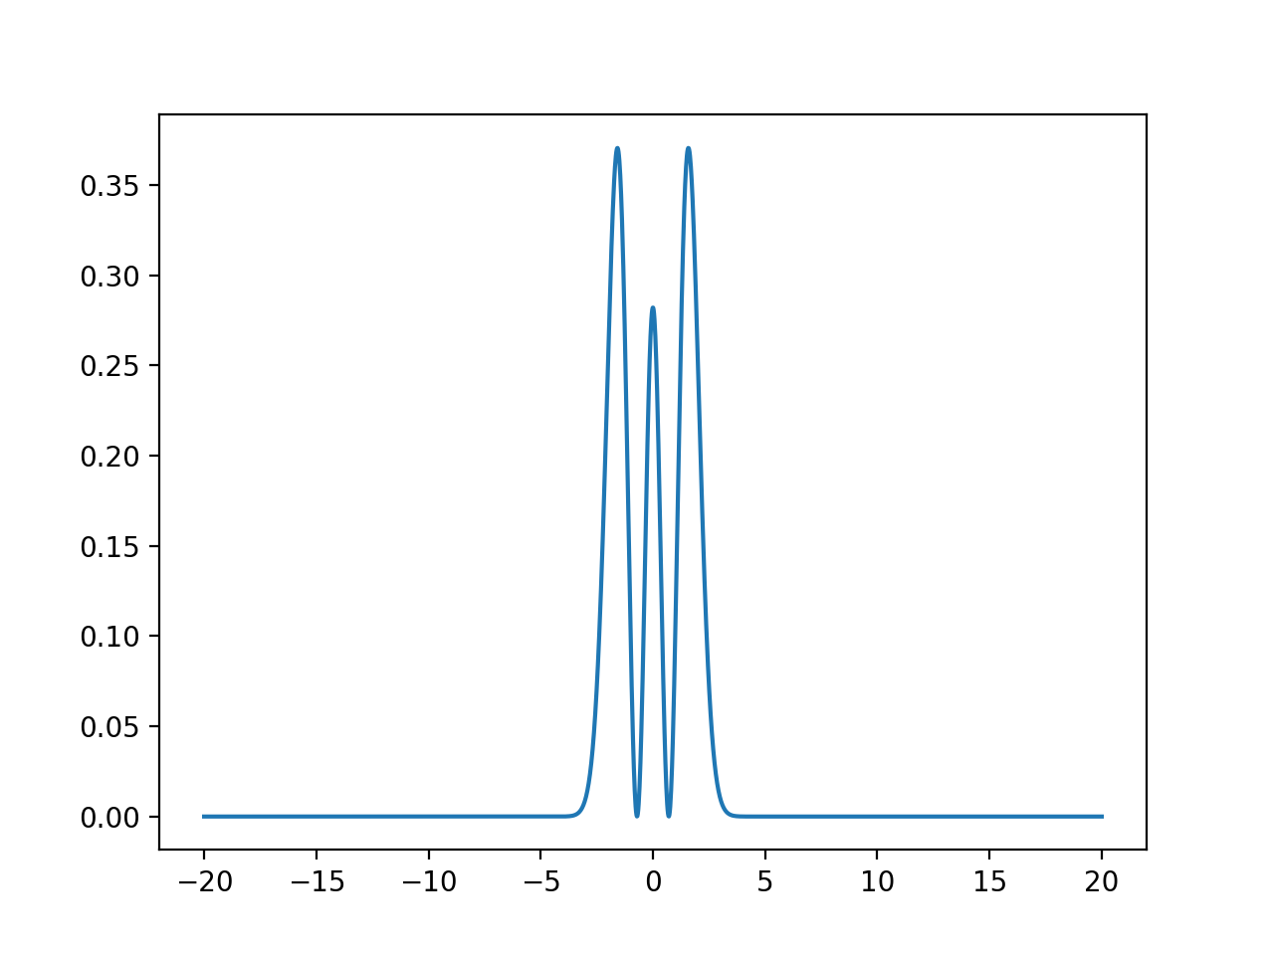

Everything looks like it's working fine.

The end goals of this exercise are:

1. Verify if the eigenvectors are orthogonal

IT DOESN’T LOOK LIKE THEY ARE ORTHOGONAL IN GENERAL…

But I could be wrong because Im doing an inner product in my head and that’s basically my “orthogonality test”.

So take this diagnosis with a grain of salt

1. Observe the coalescent behaviour of the states at the EPs

This code is too exhaustive.., there are too many states here… I am only interested in the (possibly 11) lowest energy states for each $ϵ.$

Therefore I need to come up with a way to order the states so I can be sure of their correspondence to the eigenvalues I already sorted.

16/05/2021

**Jesper’s suggestion**

“...I was just wondering if for your presentation you could create some animations that illustrate how the wave functions change as you move along the solutions in your energy vs epsilon diagram? For instance, I would be very curious to see how a state wave function continuously becomes another excited state. I'm still not sure that I see how a node would appear in the wave function, does this happen at precisely the exceptional point?”

Therefore, I want to check out how the eigenstates change as $ϵ$ changes. I want to see how the eigenstates behave as I cross the EP $ϵ$.  
Here I want to sort the eigenstates using the second and third elements of the eigenvalue axis.

This is tricky… and I don’t know how to do it yet.

I do this because I know that these eigenstates certainly coalesce at the EP.

To plot my eigenstates and obtain a sensical plot when I combine the eigenstates in a plot, I must normalise the states by

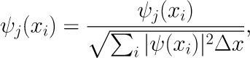

Where  are the individual points forming the wavefunction.

Since the eigenstates might be returned with an arbitrary phase. In order to avoid ugly discontinuities in my plot frames I want to eliminate these arbitrary phases by multiplying the state by the exact opposite phase factor.

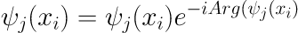

## Week 11 (17/05/21 –23/05/21)

Aims:

1. ~~Prepare TALK (12 minutes)~~
   1. Due week 11 for tqm group presentation
   2. Due Week 12 Thursday 27/05 9:45am

Tasks:

1. **~~Figure out how to plot the first and second excited states~~**
2. ~~Make animation~~

18/05/2021

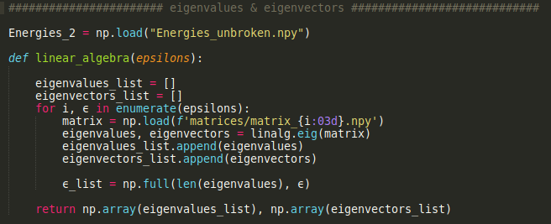

Chris taught me a neat way to use boolean arrays in my indexing.

This allows me to conditionally select the elements in an array that satisfy the conditions I may want.

np.argsort() is great because it allows me to extract the indexes of my filtered eigenvalue array, and with these indexes I can sort my filtered eigenvectors so they map to the filtered eigenvalues.

My algorithm follows this path:

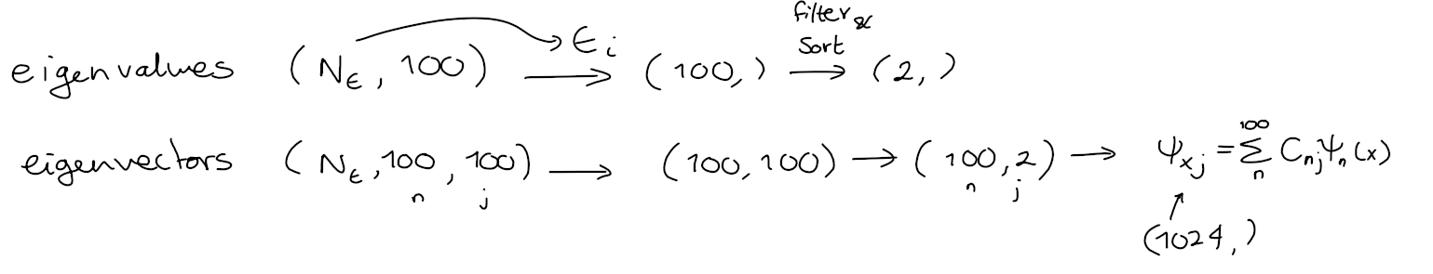

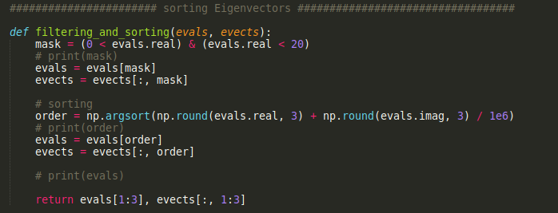

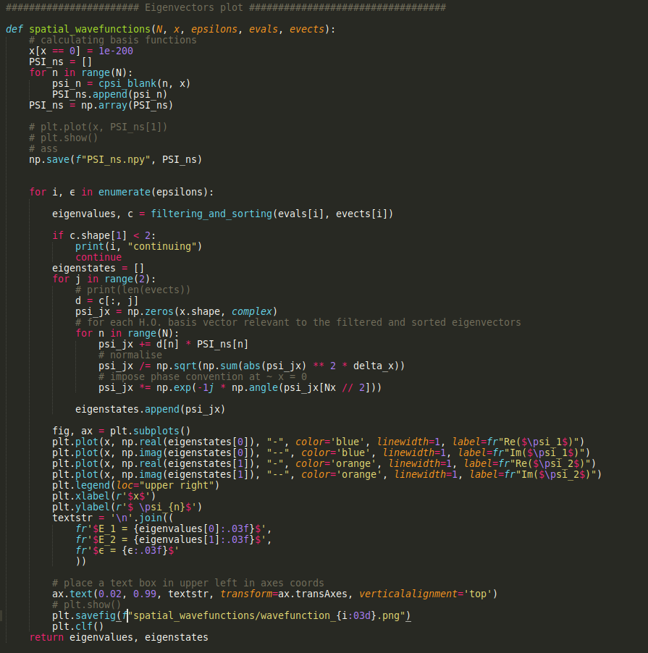

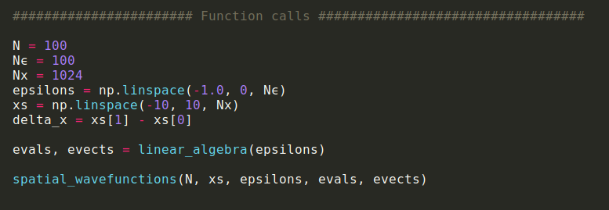

Here is my animation of the wavefunction behaviour of the first two excited states. I decided to not include values lower than $ϵ = -0.8$.

Because they are not actually representative of the wave functions due to the broken appearance of my numerics below this epsilon value.

The wave functions also look like they have some discontinuous steps at certain epsilon values but have no idea why that is.

In addition, the final wave functions look like they aren’t decaying to zero and I think that might be because of the scaling of the HO basis states.



20/05/21

Today I had my first in-person meeting with the TQM group.  
In addition I presented my research project to them as a practice presentation for the event next week.

The group asked me a lot of questions and gave me really good feedback.

I’ve modified my presentation slides according to most of the suggestions I received.

Also, I want to try to fix my latest wave functions animation.

Maybe I can try using the correctly normalised HO states for my equation since I didn’t use the natural length and energy scales as I required in my TISE.

## Week 12 (24/05/21 –30/05/21)

Aims:

Practice practice practice TALK (get to 12 minutes)  
 Due Week 12 Thursday 27/05 10am

Tasks:

1. **~~Understand why animation of eigenstates has shifted 0-value and if this is leading to deformed states (?)~~**
2. ~~Fix animation if necessary~~

This is the eigenstates animation using only the absolute value squared eigenstates



This animation is a lot clearer when crossing the EP epsilon. Since the eigenstates get transformed more neatly from complex conjugate pair eigenenergies to the first and second energy level eigenstates of the systems.

The issue that I see here is that there is a very strong asymmetry in the first excited state.

24/05/21

#### The length scale of the HO eigenstates

I am pretty certain that I made a mistake previously when considering the natural length scale of my problem.

Previously I thought that

$ħ = 1, m = \frac{1}{2} , ω=1$

The H.O. eigenstates should be:



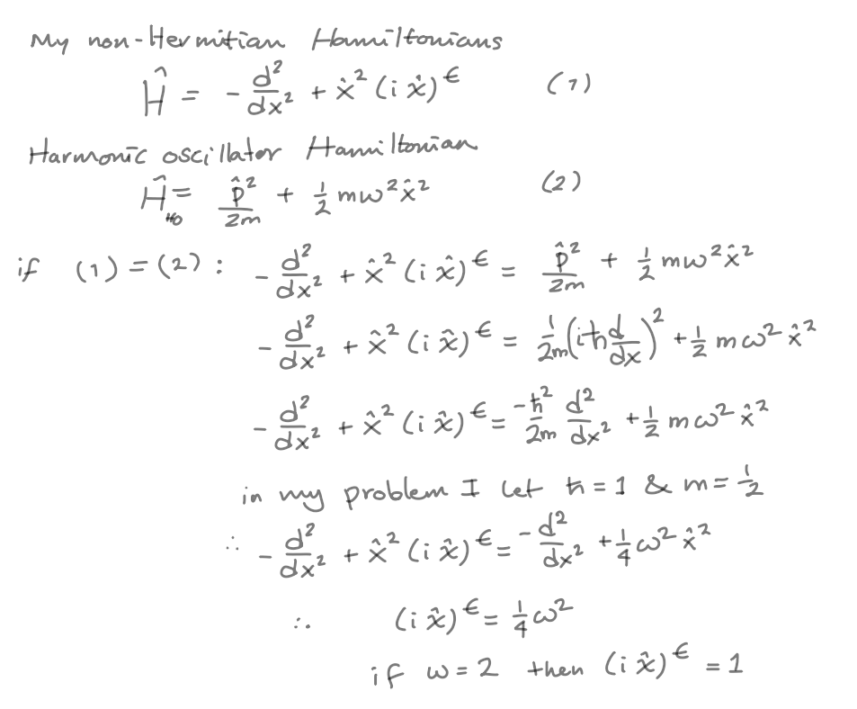

Fortunately this error didn’t actually get through my computations, since I ended up using the regular expressions for the HO eigenstates (not scaled in x for my TISE)



From wikipedia: [Quantum harmonic oscillator: Natural length and energy scales](https://en.wikipedia.org/wiki/Quantum_harmonic_oscillator#Natural_length_and_energy_scales)

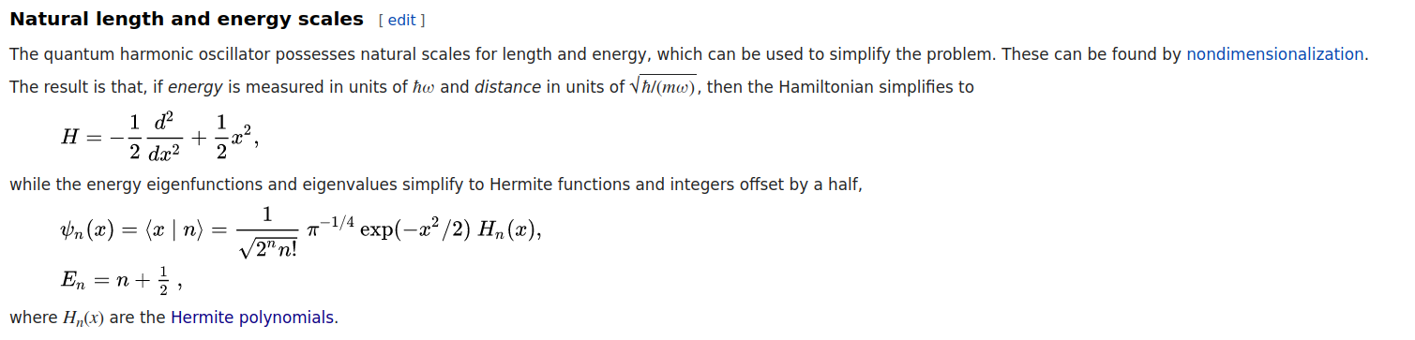

This means that in the natural scale of the HO states : $\frac{mω}{ћ}= 1$

If I go ahead and use my assumed values for $ħ = 1, m = \frac{1}{2} , ω=2$

Then $\frac{mω}{ћ}= 1$ is satisfied.

Therefore I can conclude that I require the unscaled HO basis in order to solve my TISE (as it is in the screenshot above)

**This means that the strange shift of zero in my original animation for the first and second excited states of my parametric family of Hamiltonians remains an unsolved mystery.**

26/05/21

#### Bug fix

I think I finally located the source of my asymmetrical states!

I had a simple bug. I was normalising and imposing my phase convention too early in the n loop

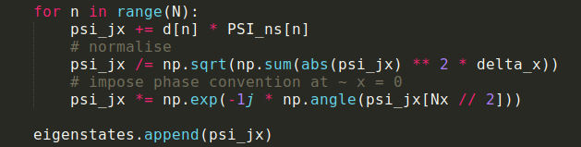 ---> 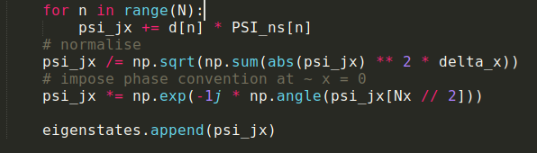

YAY success! I am finally seeing the HO eigenstates when epsilon is zero.

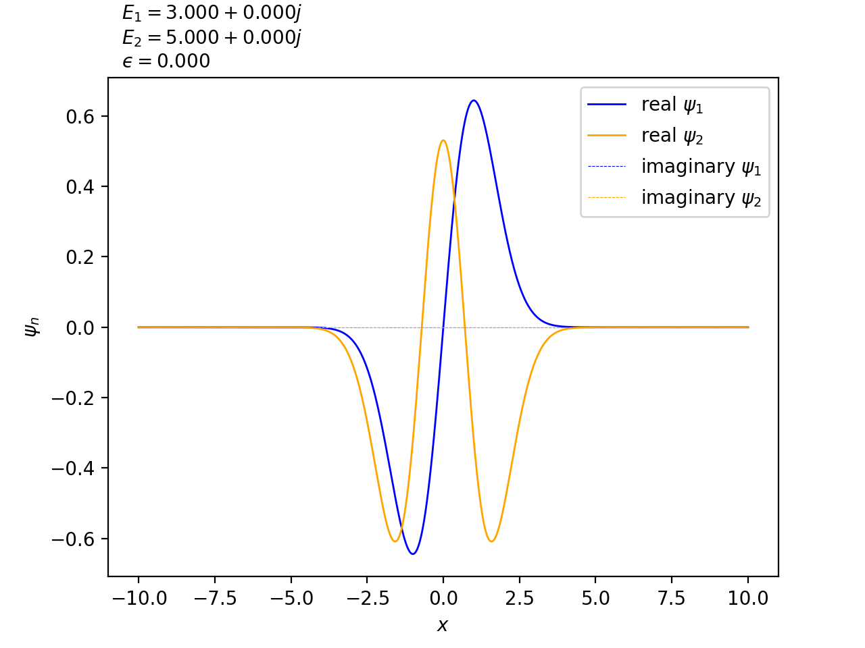

This is the animation of the wave functions as epsilon changes



This is the animation of the probability densities of the wavefunctions



## Week ∞ (06/06/21 –12/06/21)

Aims:

1. Finish Report 3
   1. Orthogonality of eigenfunctions
      1. Check inner products of wavefunctions for cases $ϵ= -0.7$ and $ϵ= -0.4$

Tasks:

1. ~~Submit Logbook~~
2. ~~Submit Report 3~~

09/06/21

Bibliography

ANU. “Playing quantum billiards with light and matter.” *phys.org*, Science X Network, 13th October 2015, https://phys.org/news/2015-10-quantum-billiards.html. Accessed 16th March 2021.

Bauke, Heiko. “Calculating Hermite functions.” *Number Crunch - A computational science blog*, 21st August 2014, https://www.numbercrunch.de/blog/2014/08/calculating-the-hermite-functions/. Accessed 7th May 2021.

Bender, Carl M., et al. “Behaviour of eigenvalues in a region of broken-PT symmetry.” *Physical Review A*, vol. 95, no. 5, 2017, http://dx.doi.org/10.1103/PhysRevA.95.052113. Accessed 10 May 2021.

Bender, C. M. “Making sense of non-Hermitian Hamiltonians.” *Reports on Progress in Physics*, vol. 70, p. 947.

Gao, T., et al. “Observation of non-Hermitian degeneracies in a chaotic exciton-polariton billiard.” *Nature*, vol. 526, (2015), pp. 554–558.

Moiseyev, N. *Non-Hermitian Quantum Mechanics*. Cambridge University Press, 2011.

Press, W. H., et al. *Numerical Recipes 3rd Edition: The Art of Scientific Computing*. 3 ed., 40 W. 20 St. New York, NY United States, Cambridge University Press, 2007. *Numerical Recipes Bookreader Home*, http://numerical.recipes/book/book.html. Accessed April 2021.

Sorrell, M. “Complex WKB Analysis of a PT Symmetric Eigenvalue problem.” 2007, https://arxiv.org/pdf/math-ph/0703030.pdf. Accessed 2 April 2021.